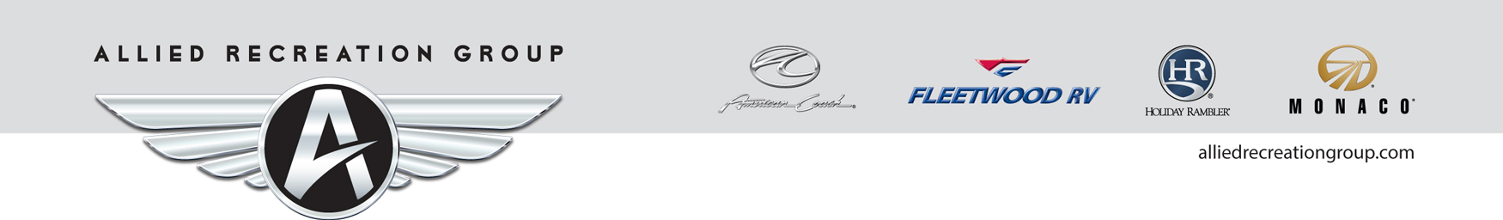

Allied Recreation Group, Inc.
1010 Commerce Dr. P.O. Box 1007
Decatur, Indiana 46733
(800) 509-3417

IMPORTANT RECALL INFORMATION #150708ARG
August 2015

TO: ALL ALLIED RECREATION GROUP DEALER PRINCIPALS,
SERVICE MANAGERS AND PARTS MANAGERS

SUBJECT: RECALL CAMPAIGN #150708ARG
Propane Tank Regulator

Allied Recreation Group, Inc., on behalf of its manufacturing center located in Decatur, Indiana, is requesting your assistance in conducting a voluntary recall notification campaign in accordance with the United States National Traffic and Motor Vehicle Safety Act and the Canada Motor Vehicle Safety Act.

Allied Recreation Group, Inc. (ARG), has decided that a safety defect which relates to motor vehicle safety exists in certain model year 2016 motor homes produced between May 18, 2015 and July 7, 2015:

Class A:
Fleetwood Flair
Fleetwood Storm
Fleetwood Terra SE
Holiday Rambler Admiral
Monaco Trek
Class C:
Fleetwood Jamboree Sport
Fleetwood Tioga Montara
Fleetwood Tioga Ranger

We are notifying the owners of the affected units in order to correct the problem. A copy of the letter sent to owners of record is attached for your information.

WHAT IS THE PROBLEM?
On motor homes affected by this recall, a propane gas tank regulator designed for vertical use may have been installed instead of the specified horizontal-style regulator. An incorrect regulator has vent openings that face horizontally when installed on the subject vehicles, potentially allowing moisture to accumulate inside of the regulator. Under certain temperature conditions this moisture could freeze, which may result in improper operation of the regulator. If the regulator fails to operate properly, excessive pressure may build up inside of it, potentially resulting in a propane gas leak and posing the risk of fire in the presence of an ignition source, resulting in property damage, personal injury, and/or death.

WHAT SHOULD YOU DO?
Owners of the above mentioned motor homes have been asked to contact an Allied Recreation Group dealer to have the described defect remedied. In the event that you are contacted by a customer, please verify eligibility by referring to the serial number range listed in the attached Recall Service Bulletin #150708ARG prior to beginning repairs.

Once repairs are completed, have the customer sign your dealership’s Internal Repair Order. Warranty labor claims are to be submitted electronically to Allied Recreation Group. Customers will not be charged for these repairs.

If you have one of these vehicles in your inventory, you will be mailed a Safety Recall Notice for that specific motor home. Allied Recreation Group dealers are required to make repairs to stock units on dealer lots prior to sale or lease.

Federal Law (Section 154 of the National Highway Traffic and Motor Vehicle Safety Act) of 1966 requires that: If you have received a notice of recall or failure to comply from Allied Recreation Group, Inc., or any component manufacturer, you must repair or otherwise correct the defect on vehicles remaining in your inventory according to the notification before selling or leasing the vehicles. Any vehicle lessor receiving this recall notice must forward a copy of the notice to the lessee within ten days.

Please review this entire package with your parts and service staff to familiarize them with the step-by-step procedure and implement the Voluntary Recall Campaign.

Thank you for helping Allied Recreation Group with its continuing efforts to maintain customer satisfaction. If you have any questions, please contact your Allied Recreation Group Service Center.

Sincerely,

ALLIED RECREATION GROUP, INC.

Attachments: Recall #150708ARG Customer Letter
Recall #150708ARG Service Bulletin

