Indian Uprising Model Car Show
Presented by
IPMS/C.A.R.S. in Miniature
in conjunction with the
Indian Uprising All Pontiac Car Show
Model show will be open to all makes & models!

Saturday, July 31, 2010
and
Sunday, August 1, 2010
at the
DuPage County Expo Center in St. Charles, Illinois

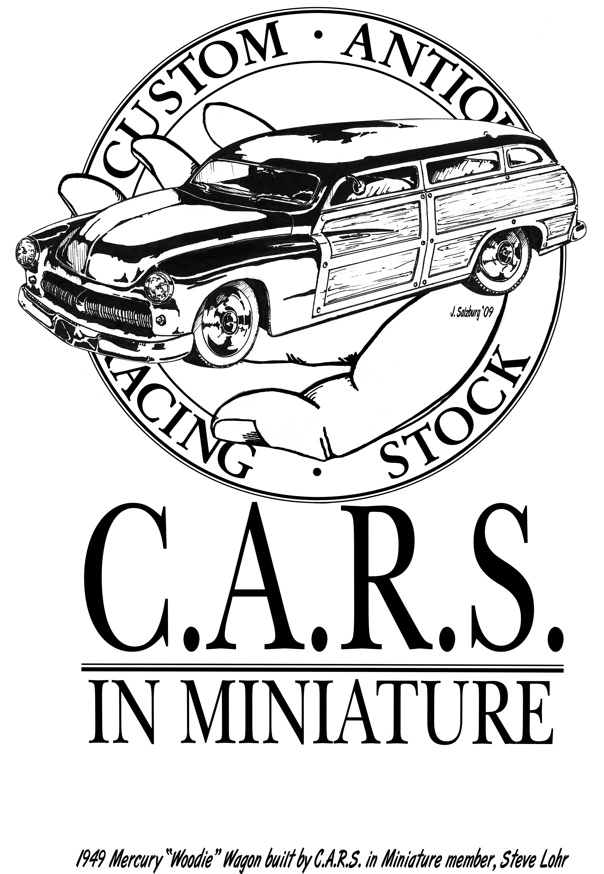
Registration
9am – 4pm Saturday
8am – 11am Sunday
Judging
11am Sunday
Awards
2pm Sunday

A judged show with 20 trophies to be awarded, including Custom & Modified, Stock, Race, Juniors, Best Female Modeler, & 3 Pontiac awards!

For more information, go to the C.A.R.S. in Miniature home page at
http://cars.carsandracingstuff.com
or e-mail csincora@gmail.com
Indian Uprising Model Car Show
Presented by
IPMS/C.A.R.S. in Miniature
in conjunction with the
Indian Uprising All Pontiac Car Show
Model show will be open to all makes & models!

Saturday, July 31, 2010
and
Sunday, August 1, 2010
at the
DuPage County Expo Center in St. Charles, Illinois

Registration
9am – 4pm Saturday
8am – 11am Sunday
Judging
11am Sunday
Awards
2pm Sunday

A judged show with 20 trophies to be awarded, including Custom & Modified, Stock, Race, Juniors, Best Female Modeler, & 3 Pontiac awards!

For more information, go to the C.A.R.S. in Miniature home page at
http://cars.carsandracingstuff.com
or e-mail csincora@gmail.com

