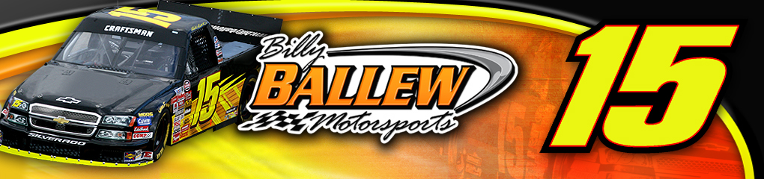
re

For Further Information or Interview Requests Contact:
Sandra Vorse
(704) 264-9548
SandraVorse@aol.com

Driver: Shane Sieg
Owner: Billy Ballew
Crew Chief: Doug George
Truck: No.15 Swift Transportation Chevrolet Silverado

Event Information
NASCAR Craftsman Truck Series - Race 18 of 25
New Hampshire 200
New Hampshire Int’l Speedway
(200 laps, 211.6 miles)
3:00pm ET

Broadcast schedule
- Live televised broadcast on SPEED at 2:30pm ET
- Live radio coverage begins at 2:45pm ET on MRN & Sirius Satellite Radio

Shane Sieg NASCAR Craftsman Truck Series Results at the New Hampshire International Speedway
Year | St | Fin | Laps | Money | Status | Led
2004 | 33 | 23 | 199/200 | $8,265 | running | 0
2003 | 24 | 16 | 200/200 | $9,815 | running | 0
2 Starts | 28.5 | 19.5 | 399/400 | $8,265 |  | 0
 |  |  | 99.8%

2007 No. 15 Billy Ballew Motorsports NCTS Race Statistics:
Site | ST | FIN | Laps | Money | Status | Led
Daytona | 33 | 11 | 100/100 | $12,615 | running | 0
Fontana | 15 | 20 | 100/100 | $13,975 | running | 0
Atlanta | 13 | 30 | 95/130 | $7,950 | accident | 0
Martinsville | 19 | 36 | 37/253 | $7,217 | engine | 0
Kansas | 31 | 16 | 166/167 | $15,100 | running | 0
Lowe’s | 17 | 19 | 136/136 | $10,800 | running | 0
Mansfield | 13 | 21 | 250/250 | $8,100 | Running | 0
Dover | 18 | 35 | 1/200 | $10,475 | accident | 0
Texas | 8 | 18 | 166/169 | $14,025 | running | 0
Michigan | 5 | 15 | 100/100 | $14,100 | running | 0
Milwaukee | 22 | 24 | 196/200 | $9,175 | running | 0
Memphis | 5 | 12 | 200/200 | $12,000 | running | 0
Kentucky | 2 | 8 | 150/150 | $17,250 | running | 2
ORP | 22 | 16 | 201/201 | $11, 425 | running | 0
Nashville | 6 | 20 | 149/150 | $8,650 | running | 0
*Bristol | 35 | 33 | 118/200 | $7,225 | handling | 0
**Gateway | 13 | 16 | 160/160 | 12,100 | running | 0
Totals | 16.3 | 20.6 | 2325/2866 | $180,757 | 4 DNF | 2
 |  |  | 81.1%
Daytona - Nashville Bill Lester, *Nate Monteith **JR Norris

Primary Sponsor
Swift Transportation

About Shane Sieg

Name: Rodney Shane Sieg
Residence: Tucker, GA
Birth Place: Atlanta, Ga
Birth Date: August 23, 1982
Weight: 140 lbs. Height: 5’6”
Age when started racing: 8
Favorite track: Texas Motor Speedway

      - Best racing experience: The NASCAR Craftsman Truck Series race at Las Vegas when we ran so well winning the Picking Up Places Award.
- Worst racing experience: Not making the NASCAR Busch Series Race at Rockingham.
Billy Ballew Motorsports New Hampshire International Speedway Statistics:
Year | Start | Fin | Driver | Laps | Total Laps | Led | Money | Status
2006 | 9 | 3 | Kyle Busch | 200 | 200 | 45 | $26,100 | Running
2005 | 16 | 7 | Kyle Busch | 200 | 200 | 4 | $9,825 | Running
2004 | 8 | 20 | Shane Hmiel | 199 | 200 | 47 | $9,890 | Running
2003 | 31 | 25 | Robby Benton | 150 | 200 |  | $9,265 | Oil Pump
2002 | 13 | 12 | Rich Bickle | 205 | 207 |  | $10,065 | Running
5 Starts | 15.4 | 13.4 |  | 954 | 1007 | 96 | $65,145 | 1 DNF

Georgia Driver Shane Sieg in with Ballew at Loudon -Shane Sieg looks to have his second start in the 2007 NASCAR Craftsman Truck Series this weekend at the New Hampshire International Speedway in Loudon, New Hampshire. Georgia driver, Sieg, will be piloting the No. 15 Swift Transportation Chevy Silverado in the 18th race of the 2007 season Saturday, September 15th for Billy Ballew Motorsports. Sieg had his first start of 2007 in Bristol driving for Bobby Dotter in the No. 08.

Sieg will be making his first start for Billy Ballew, the Georgia businessman and team owner, Saturday in the 200 lap, 211.6 mile race. Although debuting for Ballew this weekend, Sieg has two previous NASCAR Craftsman Truck Series starts in Loudon, New Hampshire with a best finish of 16th in 2003. Sieg has 24 career starts in the NASCAR Craftsman Truck Series and two starts in the NASCAR Busch Series. Ballew has five previous starts on the 1.06-mile race track in New Hampshire with a best finish of third in 2006 with Kyle Busch behind the wheel.
“It is a great opportunity for me to drive Billy Ballew’s equipment,” Sieg said. “His trucks have the reputation of being fast and I’m looking forward to seeing what we can do in the No. 15 Swift Transportation Silverado. Loudon is a great track to race on with the flat corners and fast straights so it should be an exciting race for the drivers and the fans. I can’t thank Swift Transportation enough for sponsoring us in New Hampshire. They are a great company to work with and I hope I can get the Silverado upfront and consistent throughout the 200 lap race.”

Swift transportation operates the largest truckload fleet in the United States combining strong regional operations, an expedited transcontinental operation, various specialty and dedicated offerings and a comprehensive intermodal package. The principal commodities that we transport include retail and discount department store merchandise, manufactured goods, paper products, non-perishable and perishable food products, beverages and beverage containers and building materials.

The New Hampshire 200 NASCAR Craftsman Truck Series race is slated to begin at 3:00pm ET and will be televised live on SPEED beginning at 2:30pm ET. Live radio coverage begins at 2:45pm ET on MRN & Sirius Satellite Radio.

For more information on Billy Ballew Motorsports and Shane Sieg visit www.billyballewmotorsports.com or www.shanesieg.com.
# # # #

