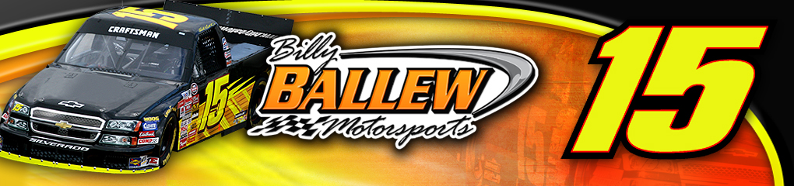
re

For Further Information or Interview Requests Contact:
Sandra Vorse
(704) 264-9548
SandraVorse@aol.com

Driver: Bill Lester
Team: Billy Ballew Motorsports
Owner: Billy Ballew
Crew Chief: Doug George
Truck: No. 15 Bowen Family Homes Chevrolet Silverado

Event Information
NASCAR Craftsman Truck Series
Race 13 of 25
Kentucky Speedway
Built Ford Tough 225
Saturday, July 14, 2007.
8:00pm ET
150 laps, 225 miles
Broadcast schedule
- Live televised broadcast on SPEED at 7:30pm ET
- Live radio coverage begins at 8:00pm ET on MRN & Sirius Satellite Radio

Bill Lester Kentucky Speedway Statistics:
Year | ST | FIN | Laps | Money | Status | Led
2002 | 3 | 14 | 149/150 | $ 14,740 | running | 0
2003 | 9 | 12 | 150/150 | $ 14,940 | running | 0
2004 | 22 | 29 | 138/153 | $ 11,290 | running | 0
2005 | 1 | 22 | 148/151 | $ 14,240 | running | 1
2006 | 8 | 28 | 146/150 | $ 11,390 | running | 0
5 Starts | 8.6 | 21 | 731/754 | $ 66,600 | 0 DNF | 1
 |  |  | 77.2%

Billy Ballew Motorsports Kentucky Speedway Statistics:
Year | ST | FIN | Driver | Laps | Total Laps | Money | Status
2006 | 15 | 21 | Kevin Grubb | 149 | 150 | $11,790 | Running
2005 | 30 | 15 | Blake Feese | 151 | 151 | $15,140 | Running
2004 | 16 | 34 | Shane Hmiel | 50 | 153 | $10,790 | Suspension
2003 | 10 | 13 | Mike Skinner | 149 | 150 | $14,840 | Running
2002 | 22 | 15 | Rich Bickle | 148 | 150 | $14,940 | Running
5 Starts | 18.6 | 19.6 |  | 647 | 754 | $67,500 | 1 DNF
 |  |  |  | 85.8%

Primary Sponsor
Bowen Family Homes
Associate Sponsors:
RedTop Auto Auction
Larry Thacker Construction

About Bill Lester

Birthplace: Washington DC
Birthdate: February 6
Resides: Atlanta, GA
Wife: Cheryl
Children: Alex & Austin
Education: Bachelor of Science Degree in Electrical Engineering and Computer Science, University of California, Berkeley

2007 Bill Lester - No. 15 NASCAR Craftsman Truck Series
Race by Race Statistics:
Site | ST | FIN | Laps | Money | Status | Led
Daytona | 33 | 11 | 100/100 | $12,615 | running | 0
Fontana | 15 | 20 | 100/100 | $13,975 | running | 0
Atlanta | 13 | 30 | 95/130 | $7,950 | accident | 0
Martinsville | 19 | 36 | 37/253 | $7,217 | engine | 0
Kansas | 31 | 16 | 166/167 | $15,100 | running | 0
Lowe’s | 17 | 19 | 136/136 | $10,800 | running | 0
Mansfield | 13 | 21 | 250/250 | $8,100 | Running | 0
Dover | 18 | 35 | 1/200 | $10,475 | accident | 0
Texas | 8 | 18 | 166/169 | $14,025 | running | 0
Michigan | 5 | 15 | 100/100 | $14,100 | running | 0
Milwaukee | 22 | 24 | 196/200 | $9,175 | running | 0
Memphis | 5 | 12 | 200/200 | $12,000 | running | 0
Totals | 16.6 | 21.4 | 1547/2005 | $140,842 | 3 DNF | 0
 |  |  | 77.2%

Qualifying May Hold Key for Lester at KentuckyWhile Bill Lester and the Billy Ballew Motorsports team have endured several highs and lows this season, there is one track that always puts a smile on Lester’s face – Kentucky Speedway. Lester holds the track record at the 1.5-mile speedway from the 2005 NASCAR Craftsman Truck Series race at the track with a speed of 178.141 mph. Lester earned back a pole the previous week at the Kansas Speedway before he went on to his record-setting run at Kentucky.

Lester has made five starts at Kentucky, two of those starts were from the top-three (2002, 2005) and two additional starts came within the top-10. While his starting positions at Kentucky have been impressive, Lester’s best finish at the track was 12th back in 2003 leaving the Chevrolet Silverado driver looking to improve upon that finish this weekend behind the wheel of his No. 15 Bowen Family Homes truck.

“I like Kentucky, it’s a great track,” said Lester. “I had back-to-back pole starts in Kansas and Kentucky in 2005, but our finish didn’t warrant our start. Some mechanical issues foiled a top-10 finish and I’d really like to go back there this weekend and bring one home for this Billy Ballew Motorsports team. This team has put together a great Silverado for us this weekend and with our progress starting to show on the track for all the hard work we’ve put in, I’m excited to see what we can do on the 1.5-mile tri-oval Saturday night.”

Georgia based sponsors will once again jump onboard to support the Georgia based driver and team owner Billy Ballew. Bowen Family Homes, who not only builds homes in Georgia but in Texas and Florida as well, will serve as the primary sponsor of the No. 15 Chevrolet Silverado. RedTop Auto Auction in Cartersville and Larry Thacker Construction based in Woodstock, GA will serve as associate sponsors.

"We're always looking for support, it's not a secret," Lester said. "Billy (Ballew) has done so much to gain support for this team week in and week out and I have to thank Bowen Family Homes, RedTop Auto Auction and Larry Thacker Construction for sponsoring us last minute. We're trying to put together enough sponsorship so that we are solid throughout the season. Our plan is to run the whole year. We're trying to indicate to potential sponsors that there's an excellent opportunity to get in with this championship caliber team.”

"The fact of the matter is, I would be much more pleased if more minority-owned and/or minority-directed companies would get involved with the sport, but black corporate America has not been receptive to NASCAR. It's a very challenging set of circumstances. We have reached out to a vast number of companies; for some reason or other they haven't gotten into the mix yet. If Billy Ballew or I had thin skin we both would have given up a long time ago and so far neither of has even considered that.”

The Built Ford Tough 225 NASCAR Craftsman Truck Series race is slated for Saturday, July 14, 2007. The 150 laps, 225 mile race will begin at 8:00pm ET. Live televised coverage begins on SPEED at 7:30pm ET with live radio broadcast on MRN and their affiliate stations beginning at 7:45pm ET.

For more information on Billy Ballew Motorsports and Bill Lester visit www.BillyBallewMotorsports.com and www.BillLester.com. ####

