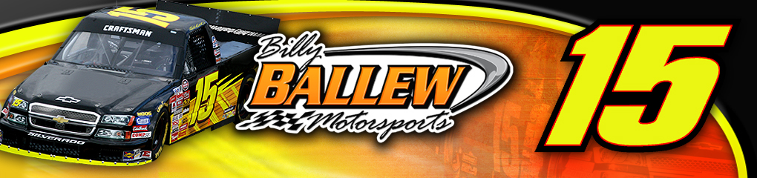
re
For Further Information or Interview Requests
Please Contact:
Sandra Vorse (704) 264-9548
SandraVorse@aol.com

Driver: Bill Lester
Team: Billy Ballew Motorsports
Owner: Billy Ballew
Crew Chief: Doug George
Truck: No. 15 Christian Debt Consolidation Chevrolet Silverado

Event Information
NASCAR Craftsman Truck Series
Race 12 of 25
Memphis Motorsports Park
O’Reilly 200
Saturday, June 30, 2007.
9:00pm ET
200 laps, 200 miles
Broadcast schedule
- NCTS Qualifying will be televised live on SPEED at 6:00pm ET
- Live televised broadcast on SPEED at 8:30pm ET
- Live radio coverage begins at 9:00pm ET on MRN & Sirius Satellite Radio

Bill Lester Memphis Motorsports Park Statistics:
Year | St | Fin | Laps | Money | Status | Led
2002 | 31 | 17 | 200/200 | $ 12,065 | running | 0
2003 | 14 | 26 | 128/200 | $ 8,990 | running | 0
2004 | 23 | 23 | 200/200 | $ 8,290 | running | 0
2005 | 12 | 35 | 63/202 | $ 8,115 | crash | 0
2006 | 18 | 25 | 201/202 | $ 8,665 | running | 0
5 Starts | 20 | 25 | 792/1004 | $ 46,125 | 1 DNF | 0
 |  |  | 78.9%

Billy Ballew Motorsports Memphis Motorsports Park Statistics:
Year | ST | FIN | Driver | Laps | Total Laps | Money | Status
2006 | 14 | 8 | Kevin Grubb | 202 | 202 | $11,465 | Running
2005 | 19 | 24 | Martin Truex Jr. | 197 | 200 | $7,740 | Running
2004 | 12 | 5 | Shane Hmiel | 205 | 205 | $10,415 | Running
2003 | 27 | 14 | Rich Bickle | 175 | 200 | $8,065 | Trans
2002 | 6 | 10 | Rich Bickle | 200 | 200 | $11,975 | Running
5 Starts | 16 | 12 |  | 979 | 1007 |  | 1 DNF
 |  |  |  | 97.2%

About Bill Lester

About
Bill Lester

Birthplace: Washington DC
Birthdate: February 6
Resides: Atlanta, GA
Wife: Cheryl
Children: Alex & Austin
Education: Bachelor of Science Degree in Electrical Engineering and Computer Science, University of California, Berkeley

2007 Bill Lester - No. 15 NASCAR Craftsman Truck Series
Race by Race Statistics:
Site | St | Fin | Laps | Money | Status | Led
Daytona | 33 | 11 | 100/100 | $12,615 | running | 0
Fontana | 15 | 20 | 100/100 | $13,975 | running | 0
Atlanta | 13 | 30 | 95/130 | $7,950 | accident | 0
Martinsville | 19 | 36 | 37/253 | $7,217 | engine | 0
Kansas | 31 | 16 | 166/167 | $15,100 | running | 0
Lowe’s | 17 | 19 | 136/136 | $10,800 | running | 0
Mansfield | 13 | 21 | 250/250 | $8,100 | Running | 0
Dover | 18 | 35 | 1/200 | $10,475 | accident | 0
Texas | 8 | 18 | 166/169 | $14,025 | running | 0
Michigan | 5 | 15 | 100/100 | $14,100 | running | 0
Milwaukee | 22 | 24 | 196/200 | $9,175 | running | 0
Totals | 17.6 | 22.3 | 1347/1805 | $128,842 | 3 DNF | 0
 |  |  | 74.6%

Lester Looks to Commemorate 10 Years at MMP with a Solid Run Saturday Night
This week the Memphis Motorsports Park will celebrate its 10th year of NASCAR Racing when the NASCAR Craftsman Truck Series takes the track Saturday night. Bill Lester will be a part of that celebration while piloting the No. 15 Christian Debt Consolidation Billy Ballew Motorsports Chevrolet Silverado in the O’Reilly 200.
Lester has five starts at the 3⁄4-mile oval of Memphis Motorsports Park with a best starting position of 12th in 2005 and a best finish of 17th in 2002. Billy Ballew Motorsports also has five starts at the track minutes from Graceland and world-famous Beale Street with a best start of sixth and a best finish of second, both in 2004.
“Congratulations to the Memphis Motorsports Park,” Lester said. “Ten years of NASCAR racing – the tracks first race was a Craftsman Truck Series race, which makes the day even more profound with us running there this weekend. I like Memphis, from the facilities to the fans, plus the area attractions are always enjoyable. The track itself can be grueling where someone else's mistake can ruin your day making you hotter then the summer Tennessee weather. The track has some bumps, but both corners really make it difficult. Turns one and two are really fast like Richmond and turns three and four are slower and much sharper. It’s difficult to get the truck to handle the same at both ends of the race track. Memphis creates a pretty good challenge for the crew chief and then it’s up to the driver to try to make up the difference and drive the truck so it will handle well at both ends. In general it seems the Memphis Motorsports Park specifically favors veteran drivers and we’ve been working on our short-track program so we look to be competitive there this weekend.”
Billy Ballew Motorsports welcomes back Christian Debt Consolidation as the primary sponsor this weekend of the No. 15 Craftsman Truck. Christian Debt Consolidation and its affiliate 501 (C) (3) non-profit servicing agent, CCMS, brings over 21 years of combined experience and services to meet customers’ financial obligations.
CCMS has established relationships with over 11,000 creditors and companies to offer value-added program and services. CDC has become very active within their own family of employees, clients, and communities. CDC is dedicated to educating and empowering the consumer through seminars, community outreach efforts, our educational website, and newsletters. CDC is proud of their mission and confident in their reputation.

Look for Bill Lester and the No. 15 Billy Ballew Motorsports team to be one of the favorites this weekend for the O’Reilly 200 (200 laps, 150 miles) at the Memphis Motorsports Park Saturday, June 30, 2007. The 12th race of the 25 race season is slated to begin at 9:00pm ET. SPEED will broadcast Bud Pole qualifying live beginning at 6:00pm ET with race coverage starting at 8:30pm ET. MRN Radio and their affiliate stations begin live coverage at 9:00pm ET.

For more information on Billy Ballew Motorsports and Christian Debt Consolidation visit www.BillyBallewMotorsports.com and www.christiandebtconsolidation.org.

####

