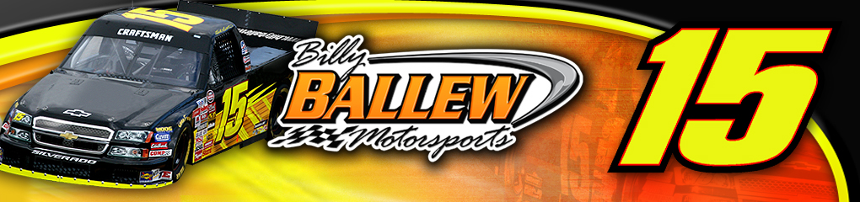
re
For Further Information or Interview Requests
Please Contact:
Sandra Vorse (704) 264-9548
SandraVorse@aol.com

Driver: Bill Lester
Team: Billy Ballew Motorsports
Owner: Billy Ballew
Crew Chief: Doug George
Truck: No. 15 Billy Ballew Motorsports Chevrolet Silverado

Event Information

NASCAR Craftsman Truck Series
Race 11 of 25
The Milwaukee Mile
Toyota Tundra Milwaukee 200, Friday June 22, 2007.
9:00pm ET
200 laps, 200 miles

Broadcast schedule
- Live televised broadcast on SPEED at 8:30pm ET
- Live radio coverage begins at 4:00pm ET on MRN & Sirius Satellite Radio

Bill Lester Milwaukee Mile Statistics:
Year | St | Fin | Laps | Money | Status | Led
2002 | 16 | 18 | 200/203 | $ 9,665 | running | 0
2003 | 23 | 12 | 198/200 | $ 10,215 | running | 0
2004 | 27 | 34 | 138/205 | $ 7,065 | crash | 0
2005 | 14 | 15 | 198/200 | $ 10,815 | running | 0
2006 | 15 | 15 | 200/200 | $ 8,865 | running | 0
5 Starts | 19.0% | 18.8% | 934/1008 | $ 46,625 | 1 DNF | 0
 |  |  | 92.7%

Billy Ballew Motorsports Milwaukee Mile Statistics:
Year | S | F | Trk | Driver | Laps | Total Laps | Money | Status
2006 | 11 | 29 | 15 | Kyle Krisiloff | 197 | 200 | $7,640 | Running
2006 | 3 | 12 | 51 | Johnny Sauter | 200 | 200 | $8,665 | Running
2005 | 24 | 19 | 15 | Martin Truex Jr. | 197 | 200 | $7,740 | Running
2004 | 5 | 12 | 15 | Shane Hmiel | 205 | 205 | $10,415 | Running
2003 | 14 | 27 | 15 | Rich Bickle | 175 | 200 | $8,065 | Trans
2002 | 23 | 11 | 15 | Rich Bickle | 202 | 203 | $10,400 | Running
5 | 13.3 | 18.3 |  |  | 1176 | 1208 | $52,925
 |  |  |  |  | 97.4%

About Bill Lester

About
Bill Lester

Birthplace: Washington DC
Birthdate: February 6
Resides: Atlanta, GA
Wife: Cheryl
Children: Alex & Austin
Education: Bachelor of Science Degree in Electrical Engineering and Computer Science, University of California, Berkeley

2007 Bill Lester - No. 15 NASCAR Craftsman Truck Series
Race by Race Statistics:
Site | St | Fin | Laps | Money | Status | Led
Daytona | 33 | 11 | 100/100 | $12,615 | running | 0
Fontana | 15 | 20 | 100/100 | $13,975 | running | 0
Atlanta | 13 | 30 | 95/130 | $7,950 | accident | 0
Martinsville | 19 | 36 | 37/253 | $7,217 | engine | 0
Kansas | 31 | 16 | 166/167 | $15,100 | running | 0
Lowe’s | 17 | 19 | 136/136 | $10,800 | running | 0
Mansfield | 13 | 21 | 250/250 | $8,100 | Running | 0
Dover | 18 | 35 | 1/200 | $10,475 | accident | 0
Texas | 8 | 18 | 166/169 | $14,025 | running | 0
Michigan | 5 | 15 | 100/100 | $14,100 | running
Totals | 17.2 | 22.1 | 1151/1605 | $114,357 | 3 DNF | 0
 |  |  | 71.71%

Wisconsin More Then Another Race Weekend for Billy Ballew Motorsports

West Allis, WI (June 20, 2007) -The NASCAR Craftsman Truck Series heads to The Milwaukee Mile this weekend for the Toyota Tundra Milwaukee 200 race Friday, June 22, 2007. For Billy Ballew Motorsports, heading to Wisconsin is more than another week on the road. For five team members including one of Billy Ballew Motorsports crew chiefs, Richie Wauters, Wisconsin means home.

Wauters, his brother, the hauler driver, chief mechanic, fabricator and the rest of the Wisconsinites will all have family in attendance cheering on Bill Lester who will pilot the No. 15 Billy Ballew Motorsports Chevrolet Silverado in the 11th race of the 25 race season.

“I’d really like to have a great finish in Milwaukee,” Lester said. “These guys work so hard on this Billy Ballew Motorsports Team and with a lot of them hailing from Wisconsin, it would be great to have a top finish for them at home this week. The team has really been working well together. It’s exciting to see our progress show with some solid starts and finishes we’ve had these last couple weeks. Billy’s equipment is incredible and I’m really looking forward to giving it all we have in Milwaukee Friday night.”

Billy Ballew Motorsports, who also fields the No. 51 Chevrolet Silverado in the NASCAR Craftsman Truck Series, has six previous starts in five years at The Milwaukee Mile. The team’s best start is third with Johnny Sauter in 2005 and a best finish of 11th in 2002 with Rich Bickle behind the wheel. Lester has five previous starts in the Craftsman Truck Series with a best start of 14th in 2005 and a best finish of 12th in 2003.

“I’m looking forward to Milwaukee,” Lester said. “The track in Milwaukee reminds me more of a road course. It’s tough to pass, there isn’t much banking and the truck just cuts a big whole in the air. You really need good down force there which requires more driver input than the super speedway tracks.”

The Toyota Tundra Milwaukee 200 (200 laps, 200 miles) is slated to begin at 9:00pm ET with live televised coverage on SPEED beginning at 8:30pm ET. Live radio coverage begins at 9:00pm ET on MRN & Sirius Satellite Radio.

For more information on Billy Ballew Motorsports and Bill Lester visit www.BillyBallewMotorsports.com and www.BillLester.com.

####

