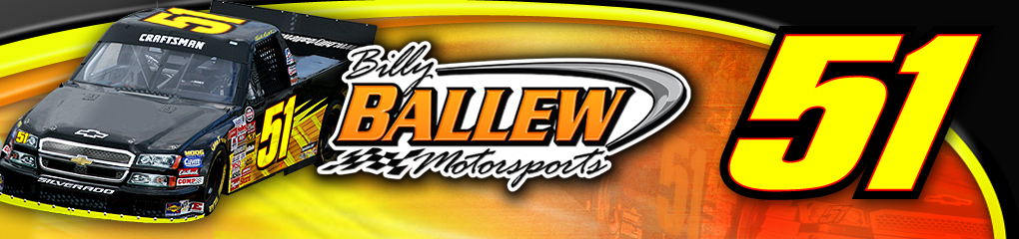
re
For Further Information or Interview Requests
Please Contact:
Sandra Vorse (704) 264-9548
SandraVorse@aol.com

Driver: Kyle “Rowdy” Busch
Team: Billy Ballew Motorsports
Owner: Billy Ballew
Crew Chief: Richie Wauters
Truck: No. 51 Flanders Beef Patties Chevrolet Silverado

Event Information
NASCAR Craftsman Truck Series
Race 10 of 25
Michigan 200
Michigan International Speedway
Saturday, June 16, 2007
3:00pm ET
100 laps, 200 miles

Broadcast schedule
- Live televised broadcast on SPEED at 2:30pm ET
- Live radio coverage begins at 3:00pm EDT on MRN & Sirius Satellite Radio

Kyle Busch Michigan International Speedway Statistics:
 | St | Win | Top 5 | Top 10 | Ave St | Ave Fin | Lap | % | Led | DNF | Winning
NASCAR Nextel Cup | 4 | 0 | 0 | 1 | 11.8 | 26.2 | 542 /729 | 74.3% | 40 | 1 | $3,420,362
Busch Series | 2 | 1 | 1 | 1 | 6 | 7.5 | 253 /253 | 100% | 87 | 0 | $74,705
Craftsman Truck | 1 | 0 | 1 | 1 | 1 | 2 | 100 /100 | 100% | 17 | 0 | $33,550

Billy Ballew Motorsports Michigan International Speedway Statistics:
Year | ST | Fin | Truck | Driver | Laps | Led | Money | Status
2006 | 35 | 32 | 15 | Kyle Krisiloff # | 100 |  | $9,965 | Running
 | 36 | 34 | 51 | Martin Truex Jr. | 96 |  | $9,890 | Accident
2005 | 1 | 2 | 15 | Kyle Busch | 100 | 17 | $33,550 | Running
2004 | 20 | 8 | 15 | Shane Hmiel | 100 |  | $12,825 | Running
2003 | 10 | 15 | 15 | Mike Skinner | 99 |  | $12,415 | Running
 | 20.4 | 18.2 |  |  | 495/500 | 17 | $78,645 | 1 DNF
Track Record held by Kyle Busch, 39.645 seconds, 181.612 mph set in 2005

Primary Sponsor
Flanders Beef Patties

About Kyle “Rowdy” Busch

Birthday: 5/2/85
Height: 6’1”
Weight: 171lbs
Hometown: Las Vegas, NV
Resides: Mooresville, NC

2007 No. 51 NASCAR Craftsman Truck Series Race by Race Stats
Site | St | Fin | Laps | Money | Status | Driver
Martinsville | 15 | 33 | 148/253 | $7,217 | engine | Paul Menard
Kansas | 28 | 33 | 71/167 | $10,450 | suspension | Kelly Sutton
Lowe’s | 6 | 11 | 134/134 | $9,275 | running | Kyle Busch
Mansfield | DNS |  |  |  |  | Kelly Sutton
Dover | 4 | 12 | 199/200 | $12,600 | running | Kyle Busch
Texas | 21 | 33 | 6/169 | $10,225 | accident | Kelly Sutton
Totals: 5 Starts | 14.8 | 24.4 | 359/703 | $49,767 | 3 DNF

Primary Sponsor: Flanders Beef Patties

Ballew and Busch Ready for a NCTS Battle in Brooklyn
Brooklyn, MI (June 13, 2007) -Kyle Busch will be once again piloting the No. 51 Flanders Beef Patties Billy Ballew Motorsports Chevrolet Silverado in Saturdays Michigan 200 NASCAR Craftsman Truck Series event. Busch and Ballew hope to bring home the win after such a strong performance in Dover where Busch was in contention for the win until a tire forced him to give up the lead and go down pit road.
Busch has one previous start at the Michigan International Speedway for Billy Ballew Motorsports; in 2005 Busch not only took the pole for the Craftsman Series race he broke the track record with a time of 39.645 seconds and a speed of 181.612 mph, which still stands today.
“I’m looking forward to going back to Michigan with Billy Ballew,” Busch said. “Michigan is a racy track with room for three and four wide racing. I hadn’t raced in the truck there since 2005 where we had a pole and a second place finish. We are bringing my favorite truck; we drove it in Dover a few weeks ago and it was strong. Chassis 11 has already brought us three wins before, hopefully it will again this weekend.”
Flanders Beef Patties will be back as the primary sponsor on the No. 51 Billy Ballew Motorsports NASCAR Craftsman Truck. Flanders Beef Patties is headquartered and produced in Waycross, GA and is the No. 1 selling economy beef patties in the United States. The product is sold in 49 states in all major grocery retailers and independent grocery retailers across the country. Flanders Beef Patties was also the primary sponsor at the Dover International Speedway.

“We are excited about having Flanders Beef Patties back on board the No. 51 truck this week,” Ballew said. “We came so close in Dover for the win and it would be great to put Flanders in Victory Lane this weekend in Michigan. Kyle is a talented racecar driver and if anyone can put the truck there, he can. It should be an exciting weekend for both teams with Lester in the No. 15 having a solid run last week and a great qualifying effort. So hopefully we’ll be able put them both out front.”

The NASCAR Craftsman Truck Series drivers take to the track for the Michigan 200 (100 laps, 200 miles) at the Michigan International Speedway Saturday, June 16 at 3:00pm ET. Live television coverage begins on SPEED at 2:30pm ET with MRN Radio and their affiliate stations coverage starting at 3:00pm ET.

####

