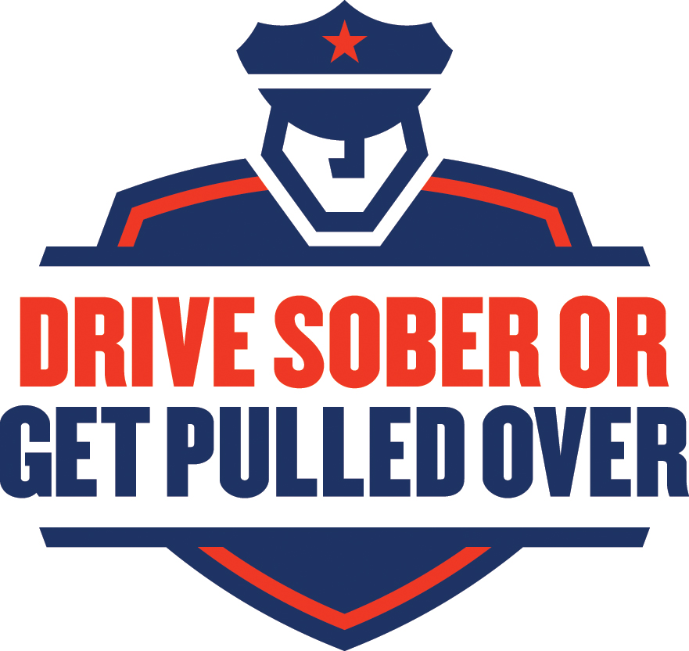

Fourth of JULY 2015
TALKING POINTS/fact sheet
ENFORCEMENT VERSION

“Drive Sober or Get Pulled Over”: [Local Law Enforcement Organization] Is Cracking Down on Drunk Driving This July Fourth

- The Fourth of July holiday is a favorite time of year for many Americans. Backyard parties, good food, and fireworks. But the celebrating unfortunately turns deadly when people drive after drinking alcohol. Drunk driving is a preventable problem on Independence Day each year in the United States.

- In 2013, Forbes magazine named the Independence Day holiday “the most dangerous holiday of the year.”

- This year, the Fourth comes on a Saturday, so Friday, July 3, is the Federal holiday and observance. That means the Fourth of July weekend starts at 6 p.m. Thursday and extends to 5:59 a.m. Monday morning, July 6.

- In 2013, there were 512 people killed in motor vehicle traffic crashes over the Fourth of July holiday (6 p.m. July 3rd through 5:59 a.m. July 8th). Of those fatalities, 199 (39%) occurred in crashes that involved at least one driver or motorcycle operator with a blood alcohol concentration of .08 grams per deciliter or higher.

- During the July Fourth holiday period in 2013, the rate of alcohol impairment among drivers involved in fatal crashes was over three times higher at night than during the day.

- In fatal crashes during the July Fourth period in 2013, more than one-fifth (21%) of involved drivers or motorcycle operators had BACs of .15 or higher—almost twice the legal limit.

- During the Fourth of July 2013 holiday period, almost half (45%) of the young drivers (18 to 34 years old) killed in motor vehicle traffic crashes were alcohol-impaired (BAC of .08 g/dL or higher).

- This Fourth of July, law enforcement in [local area] is taking part in a crackdown to put an end to drunk driving. The “Drive Sober or Get Pulled Over” campaign will mean increased enforcement with zero tolerance for those who drive impaired.

- Throughout the region, drivers should expect to see the police out in force, cracking down on drunk driving through increased sobriety checkpoints, roving and saturation patrols, and other enforcement efforts.

- Unfortunately, these enforcement campaigns are necessary—drunk driving is an epidemic in our nation. In 2013, there were 10,076 people killed in drunk-driving crashes. That’s almost one third of all traffic fatalities nationwide.

- In all 50 States and the District of Columbia, it’s illegal to drive with a BAC of .08 g/dL or higher. In fatal crashes in 2013, almost one in seven drivers (14%) had BACs at or above .15 g/dL – almost twice the legal limit.

- Insert local stats here (if available).

- The tragic reality is that drunk driving isn’t a new concern: during the Fourth of July holiday periods from 2009 to 2013, there were 750 people killed in impaired-driving crashes.

- And from 2012 to 2013, the number of overall drunk-driving-crash fatalities decreased by 2.5 percent in the United States—from 10,336 people killed in 2012 to 10,076 in 2013.

- Of the 10,076 people who died in alcohol-impaired-driving crashes in 2013, 6,515 (65%) were drivers with BACs of .08 or higher. The remaining fatalities consisted of 2,724 motor vehicle occupants (27%) and 837 nonoccupants (8%).

Make a Plan to Get Home Safely This Fourth of July. “Drive Sober or Get Pulled Over.”

If you drive drunk, you not only put your life and the lives of others at risk, you could face a DUI arrest. The average DUI costs $10,000, making it difficult to recover financially.

Arrested drunk drivers face jail time, the loss of their driver licenses, higher insurance rates, and dozens of other unanticipated expenses from attorney fees, fines and court costs, car towing and repairs, lost time at work, etc.

Avoid Drunk Driving Altogether.

- Plan a safe way home before the fun begins.
- Before drinking, designate a sober driver.
- If you’re impaired, use a taxi, call a sober friend or family member, or use public transportation so you are sure to get home safely.
- Use you community’s sober ride program [Insert your local sober ride program specifics here].
- If you see a drunk driver on the road, don’t hesitate to contact [Local Law Enforcement]. and
- Remember, Drive Sober or Get Pulled Over. If you know someone who is about to drive or ride while impaired, take their keys and help them make other arrangements to safely get to where they are going.

Whether you’ve had way too many or just one too many, it’s never worth the risk to drive impaired. There’s always another way home. This Fourth of July, if law enforcement pulls you over for drunk driving, you will be arrested.

For more information about the Drive Sober or Get Pulled Over campaign, visit www.TrafficSafetyMarketing.gov.
###

11262b-032315-v3

