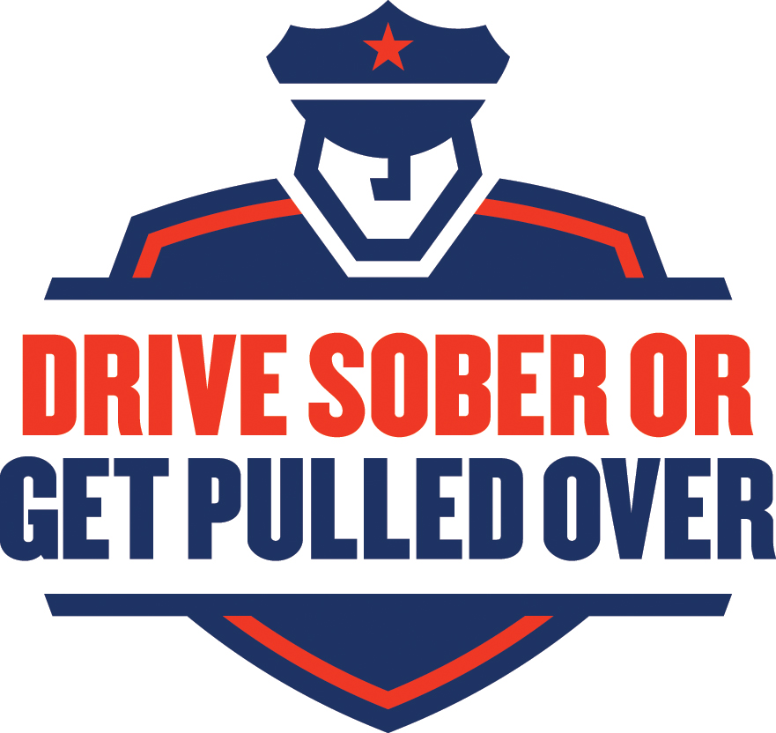
Fourth of July 2015

Sample News Release

Enforcement Version

FOR IMMEDIATE RELEASE: [Date]

CONTACT: [Name, Phone Number, E-mail]

Note: Before filling in the names of the organization and organization spokesperson, you MUST contact them to obtain their permission to use their names in this press release, and you must get their approval for the language used in their quotes, and any changes or additions they may require. Only after this is done can you send out the press release.

This Fourth of July, ‘Drive Sober or Get Pulled Over’ by

[Local Law Enforcement Organization]

[City, State] – The Fourth of July is one of America’s favorite holidays. And why not? Families and friends gather to celebrate our country with food, parades, parties, picnics and fireworks.

And yet there is a very dark side to this great holiday. For many, the celebration includes alcohol, but the holiday quickly goes from festive to fatal when people choose to drive after drinking. From 2009-2013, nearly 40 percent of ALL traffic fatalities over the Fourth of July period occurred in alcohol-impaired-driving crashes. In 2013, Forbes magazine named the Independence Day holiday “the most dangerous holiday of the year.”

Over the Fourth of July holiday period in 2013 alone (6 p.m. July 3rd to 5:59 a.m. July 8th), there were 199 people killed in alcohol-impaired-driving crashes on our nation’s roads.

To crack down on drunk driving this Fourth of July, [State/City/Area] law enforcement will be out in full force, aggressively targeting those who put lives in danger.

“[Local law enforcement organization] is ramping up their enforcement to make our roads safer this Fourth of July,” said [local leader]. “For everyone’s sake, don’t drink and drive or you will be arrested. The ‘Drive Sober or Get Pulled Over’ campaign means zero tolerance for drunk driving—no excuses.”

Data from the National Highway Traffic Safety Administration shows that 10,076 people were killed in drunk-driving crashes in the United States in 2013—representing almost a third of all crash fatalities. By comparison, during the July Fourth period that year, 39 percent of all crash fatalities involved alcohol-impaired drivers.

In every state, it is illegal to drive with a blood alcohol concentration (BAC) of .08 grams per deciliter (g/dL) or higher, yet people continue to break the law and drive drunk. And the rate of high-BAC impaired driving is astounding. In fatal crashes during the July Fourth period in 2013, more than one-fifth (21%) of involved drivers or motorcycle operators had BACs of .15 or higher—almost twice the legal limit.

NHTSA data also reveals that 35 percent of young drivers (18 to 34 years old) were driving drunk (BAC of .08 or higher) in fatal crashes over the July Fourth period in 2013. Motorcycle operators are also overrepresented as the highest percentage of alcohol-impaired drivers in fatal crashes. In 2013, more than one-quarter (27%) of motorcycle operators in fatal crashes had BACs of .08 or higher.

Drunk drivers are more common at night, too. Over the July 4th holiday in 2013, more than two fifths (42%) of the drivers in nighttime fatal crashes (6 p.m. to 5:59 a.m.) were alcohol-impaired, as compared to 13 percent of drivers in fatal crashes during the day.

“This Fourth of July holiday, you can show your patriotism by helping to make [local area] roads safer for everyone,” said [local leader]. “Remember,” [he/she] warned, “to Drive Sober or Get Pulled Over. It’s as simple as that.”
Law enforcement is not messing around this Independence Day: if you’re caught driving drunk, you will be arrested. And keep in mind that aside from putting your life and the lives of others at risk, driving impaired can also lead to serious consequences. A DUI arrest can mean time in jail, loss of your license, and steep financial expenses; the average DUI costs about $10,000.
[Local Leader or Organization] recommends these simple tips to prevent drunk driving.

- Plan a safe way home before the fun begins.
- Before drinking, designate a sober driver.
- If you’re impaired, use a taxi, call a sober friend or family member, or use public transportation.
- Use your community’s sober ride program [Insert your local sober ride program specifics here].
- If you happen to see a drunk driver on the road, don’t hesitate to contact [Local Law Enforcement].
- If you know someone who is about to drive or ride while impaired, take your friend’s keys and help your friend make other arrangements to get to where he or she is going safely.

For more information about the Drive Sober or Get Pulled Over campaign, visit www.TrafficSafetyMarketing.gov.
###
11262a-032315-v3

