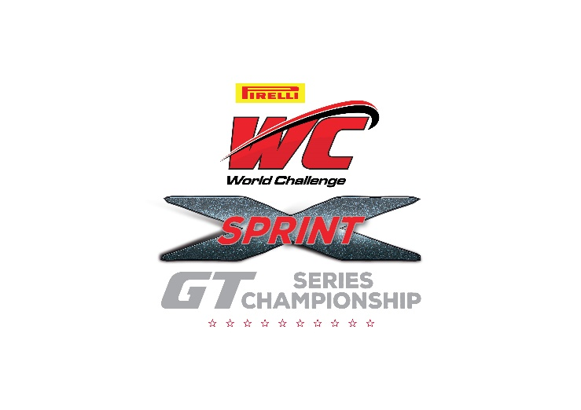
For Immediate Release

WC Vision Announces Pirelli World Challenge
Sprint-X GT Championships Starting in 2016

Denver, Colo. (May 27, 2015) - WC Vision announced today it will be launching an extended sprint format series in addition to its existing Sprint format racing series in 2016.

The new added and stand-alone championship will be named the Pirelli World Challenge Sprint-X GT Championship Series.

The extended Sprint-X races will take place at the 2016 Pirelli World Challenge headliner events, with the inaugural race scheduled for the season opener at Circuit of the Americas, March 4-6, 2016.

The Sprint-X races will be 60 minutes in length and features mandatory driver and tire changes. The extended sprint races will run as separate race during the Series' “headliner” event weekends in addition to the existing sprint format championship. The series anticipates many existing teams to run Sprint-X as well as the existing championship.

“The series has been studying the concept for the last 18 months and see this as a natural evolution of the Pirelli World Challenge standing start sprint format brand and part of our long-term business envelopment plans," said WC Vision President and CEO Scott Bove. "An extended sprint race format within our existing sprint racing brand offers our customers, fans and partners more of what they already enjoy and are committed to, while opening the door for new teams, drivers and sponsors.”

“The start of a multi-driver sprint format further endorses our commitment to a sprint format, whilst also fulfilling many customer requests for multi- driver pro/am and pro/pro team racing," added Marcus Haselgrove, Series Director of Competition.

WC Vision will announce a new Series presenting sponsor for Sprint-X with an announcement forthcoming this fall.

