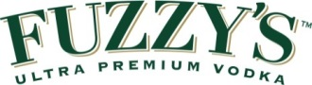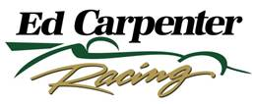

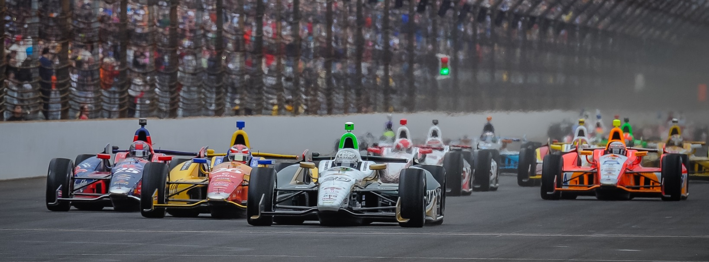

**MEDIA ADVISORY**

**Indy 500 Pole Winner Ed Carpenter Race Week Appearances**

**Monday, May 19th**

7:00-8:00 p.m.  [Crown Liquors](https://www.facebook.com/CrownLiquorsIN) downtown – Ed Carpenter & Fuzzy Zoeller

150 N. Delaware St.

**Wednesday, May 21st**

1:30- 2:30 p.m. Community Day Autograph Session at IMS

4:00-6:00 p.m. 21st Amendment on 86th and Ditch – Ed and Fuzzy

7:00-9:00 p.m. Celebrity Bartending, Ruth Chris’, 96th and Keystone

**Thursday, May 22nd**

3:40-4:40 p.m. Media Interviews for Indy 500 Drivers, IMS Pavilion

5:00 p.m. Fuzzy’s Media Happy Hour, 5th floor of the IMS Pagoda

6:00-8:00 p.m. Kroger in Speedway – Ed, Fuzzy and Linda Vaughn

**Friday, May 23rd (Carb Day)**

11:00–12:00 pm Indy 500 Practice

1:30 p.m. Chevy Q and A (Chevy Display, Fan Village – Ed and JR)

4:30 – 5:30 p.m. Marsh Supermarket Downtown – Ed and Fuzzy

**Saturday, May 24th (Parade Day)**

9:00–10:00 a.m. Indy 500 Autograph Session, IMS Plaza

10:30 a.m. Public Drivers Meeting, Pit Lane

Noon 500 Festival Parade (90 minutes)