For Immediate Release
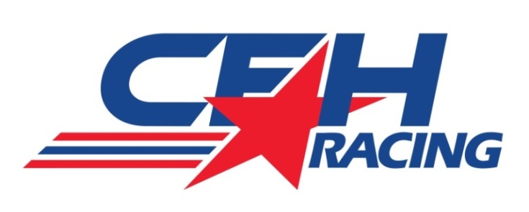
ED CARPENTER RACING MOVES INTO SFH RACING
SPEEDWAY SHOP AS CFH RACING TAKES SHAPE

Planning and Construction Underway for Two-Car Verizon IndyCar Series Team

SPEEDWAY, Ind. (October 13, 2014) – With the 2014 Verizon IndyCar Series completed, the concentration now for the newly-merged CFH Racing operation is the blending of the Ed Carpenter Racing squad with Sarah Fisher Hartman Racing.

That process is underway at the state-of-the-art 40,000 square-foot team headquarters (at 1255 Main St. in Speedway). Both teams have amalgamated their equipment and personnel and the racing shop is currently in a construction mode with additional race car bays and added office space.

“It might be the off-season for the Verizon IndyCar Series, but it is flat out for CFH Racing right now,” said Sarah Fisher, co-owner of CFH Racing and the only female team owner in the Verizon IndyCar Series. “We have moved Ed’s team into our shop and we have a game plan of merging the two one-car teams into a strong two-car organization. Things are a little hectic right now with the construction in the shop but we hope to have everything in place within the next month.”

CFH Racing is also preparing for an upcoming test at Barber Motorsports Park on Oct. 27.

“We took two ECR cars that were fitted with Chevrolet engines to Mid-Ohio a few weeks ago but the test was rained out,” said Tim Broyles, CFH Racing general manager. “We had the two complete teams there as well as Josef (Newgarden) and Mike (Conway) in hopes of working together for the first time. The weather just didn’t cooperate for us. So we’ll go to Barber later this month.”

Fisher explained that the team’s consolidation has been much easier with her team’s past experience working with Carpenter. Fisher’s team captured the 2011 Kentucky Speedway IndyCar Series race with Carpenter in the cockpit. It was the first IndyCar Series victories for both Fisher and Carpenter.

“Ed knew how our team operated from his driving with us previously,” said Fisher. “He has run an excellent program with ECR and we are excited to be bonding our teams for 2015. We have a lot of work to do but we feel confident about this new merger.”

Broyles further explained how everything and everyone are combining efforts is taking shape at CFH Racing.

“After we returned home from the cancelled Mid-Ohio test, we took the ECR cars and trucks straight to the CFH Racing shop,” said Broyles, whose ECR effort captured three 2014 Verizon IndyCar Series races. “Now we have quite a bit of construction going on and we are moving some departments into other rooms too. We will see a lot of progress in the next two weeks with the construction and then we’ll move some of the equipment around before things will settle into our regular off-season worklist.”

-more-
-2-

Broyles said October 27 should be the final 2014 test for CFH Racing as the team prepares for the new body kits.

“We want to get Josef and the SFH crew accustomed to the Chevrolet engine program at this first test,” he said. “When Ed tested the Firestone tires at IMS a few weeks ago, some of the SFHR guys along with Josef observed the two days with the ECR crew and I think that helped. But we want them to be hands-on with Josef in the race car now.”

On Sept. 17, CFH Racing announced it will campaign Chevrolet engines and body kits in 2015.

CFH Racing currently has six chassis set for the 2015 season and Broyles believes they will be needed if the 2015 Verizon IndyCar Series schedule is similar to 2014.

“It was important for our ECR team last year to utilize all three chassis throughout the season,” said Broyles. “With the tight schedule of races and some of them being doubleheaders, the extra chassis came in handy as we prepared the cars each week. It is important to keep everything as fresh as possible with the equipment. We plan is to continue that process in 2015. It also gives us an extra car for the Indy 500 as we look to expand our 500 program next May.”

With all of the changes within the new CFH Racing headquarters, Broyles admits that long hours could be possible, but the team plans to keep normal business hours.

“We want to keep everything pretty normal for the crew guys right now,” he said. “We are trying to have everyone learn about each other early in this growing process. We have experienced personnel that know what it takes to produce a successful operation. We want to have everything to be as consistent as possible. I feel good about the direction everything is going in right now. It’s a highly-competitive series and we want to be ready when testing starts in 2015 as well as with the first race.”

While the blending of two racing teams continues in 2014, CFH Racing believes it is set to battle for Verizon IndyCar Series victories in 2015.

“Our goal is to be at the front of the field on a regular basis in 2015,” said Fisher. “I think everyone here at CFH Racing believes we have the organization to win races and battle for championships.”

# # #

ABOUT CFH Racing: CFH Racing, co-owned by Ed Carpenter, Sarah Fisher and Wink Hartman, will field two cars in the 2015 Verizon IndyCar Series with Chevrolet engines, the same engines that have guided Chevrolet to three consecutive Verizon IndyCar Series manufacturer championships. CFH Racing announced its formation on Aug. 16 with the merger of Ed Carpenter Racing and Sarah Fisher Hartman Racing. The team is based in a state-of-the-art 40,000 square-foot facility at 1255 Main St. in Speedway, Ind., a few blocks from the legendary Indianapolis Motor Speedway. The new headquarters is cutting-edge and features a modern layout that includes work areas for engineering, service, an expanded machine shop, paint and composites. In addition, the facility has a retail store for fans to purchase team-related souvenirs and products as well expanded areas for entertainment and events.

Contacts: Tom Blattler, (317) 525-5692, tomblattler@earthlink.net
Becca Bornhorst, (614) 620-1288, becca@grand-solutions.net

