

**EUROPEAN LE MANS SERIES 2014 – ROUND 1**

**4 HOURS OF SILVERSTONE (April 18 & 19 2014)**

**ALPINE AND NELSON PANCIATICI READY TO TAKE THE LEAD!**

Alpine returns to Silverstone to defend their 2013 title in the European Le Mans Series (ELMS) and score some big points right from the start of the championship. Nelson Panciatici, European champion title holder, has but one wish: to get back on the track of victory and defend the title!

He can count on his Signatech-Alpine team who, managed by Philippe Sinault, have worked hard this winter. During the Castellet tests, they reviewed all the 2014 tyres, focusing on endurance tests rather than performance, especially on the second day. This will give them all the data they need to analyse in order to prepare for Silverstone most effectively.

Nelson Panciatici still managed a fourth best time over the whole two days of tests, which shows the performance level of the Alpine A 450:

Nelson: “In 2014 we must to do as well as last year, that is to say take the title, but even if I hope it will be with a bit less stressful, it was also very close. I know the battle will be fierce, right to the end!

*I’m full of confidence for this first meeting of the season because we have shown on every occasion that we can compete. In the Castellet, we focused on endurance tests which did not stop us from getting to the top of the time sheet! I ran several series with all the Michelin pneumatic options and we extracted some interesting information from those, mostly in their management. I know my team well and I know that we’re heading in the right direction. The competition will be difficult to beat but we’re well prepared. With my new co-drivers, Paul-Loup Chatin and Oliver Webb, we make a solid and fast team with nothing to envy the other favourites.*

*And I know Silverstone well, it’s one of my favourite circuits. The flow Copse, Maggots and Becketts is a pure pleasure to drive and critical for making good time. It also needs a well-balanced car and that’s one of our strong points. We’re ready for this season’s start and I hope we have a good race, better than in 2013 when we finished at the bottom of the podium. We’d like it to be a really sunny day because it was a washout last year. I know Alpine has the capacity to shine and even if it looks like a challenge, we’re going to try and win this first race, I can’t wait to get to Silverstone!”*

Nelson Panciatici is full of confidence because he knows he has all the support he needs from the Signatech-Alpine team and his co-drivers to make the mythical colours of Alpine shine once again, which is not a small part of challenging the competition!

For more information on Nelson PANCIATICI, please visit[**www.nelsonpancia.fr**](http://www.nelsonpancia.fr)

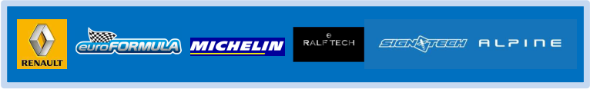[**facebook Join Nelson's Fan Club on Facebook!**](http://www.facebook.com/pages/Nelson-Panciatici/90065452450)