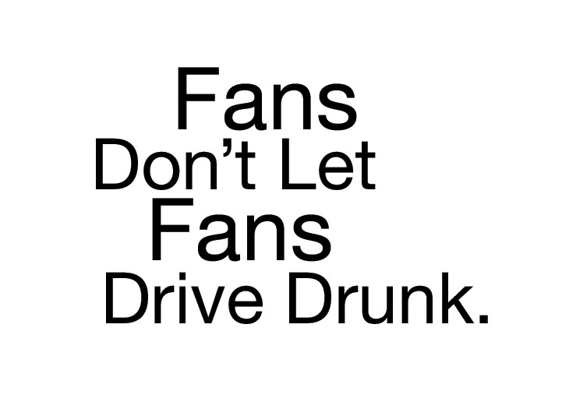

SUPER BOWL PLANNER
SAMPLE NEWS RELEASE
Note: Before filling in the names of the organization and organization spokesperson, you MUST contact them to obtain their permission to use their names in this press release, and you must get their approval for the language of their quotations, and any changes or additions they may require. Only after this is done should you send out the press release.
FOR IMMEDIATE RELEASE: [Date]
CONTACT: [Name, Phone Number, E-mail]

Game Plan for Super Bowl Sunday: Are You Drinking or Driving?
Fans Don’t Let Fans Drive Drunk
[City, ST] – The Super Bowl is America’s most watched national sporting event. On Super Bowl Sunday, February 1, there will be lots of game day socializing that may include drinking. That’s why the National Highway Traffic Safety Administration (NHTSA) and [Local Area] highway safety and law enforcement officials are urging football fans to choose sides now: drinking OR driving. If you plan on drinking on Super Bowl Sunday, designate a sober driver to get you home safely.
NHTSA’s Fans Don’t Let Fans Drive Drunk campaign encourages people to make plans ahead of time that will prevent them from getting behind the wheel of a vehicle after drinking. Driving impaired could result in injury or death for you or others on the road.
According to data from NHTSA, in 2012 there were 10,322 people killed in alcohol-impaired-driving crashes in the United States—31 percent of all crash fatalities in the nation. A driver is considered alcohol-impaired with a blood alcohol concentration (BAC) of .08 or higher, the legal limit in all states. This February 1, don’t become a tragic Super Bowl stat.
“Drunk driving is completely preventable,” said [Local Leader]. “All it takes is a little planning. We want fans to remember that it’s a choice. Drink or drive—but never do both.”

For those who plan to drink, leave your keys at home. Designate a sober driver, whether it’s a friend, relative, taxi, or public transportation. [Insert sober ride specifics here if applicable.] For those who plan to drive, refrain from any alcohol. Instead, enjoy the game with food and non-alcoholic drinks. Being a sober, designated driver is a key role on Super Bowl Sunday. You might just save a life.

For more Super Bowl weekend safety information, visit www.trafficsafetymarketing.gov/SuperBowl
11026a-102214-v2a

