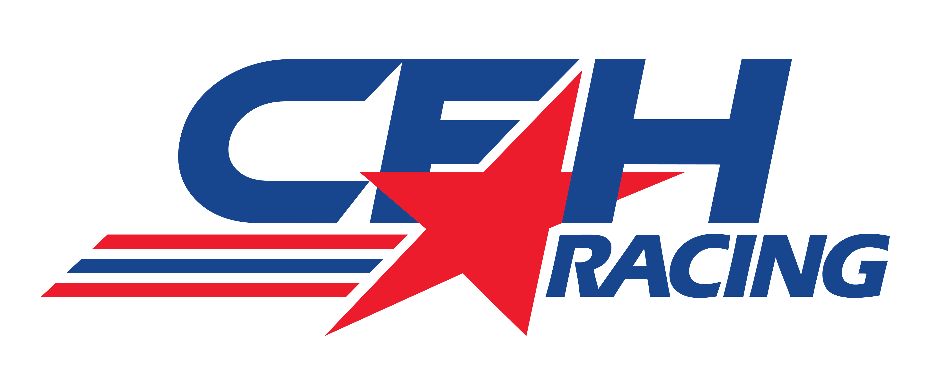

MEDIA ADVISORY

CFH Racing To Make Major Announcement
This Wednesday (Sept. 17) at 11:30 a.m. EDT

CFH Racing team owners Ed Carpenter, Sarah Fisher and Wink Hartman along with team driver Josef Newgarden will be participants this Wednesday (Sept. 17) at 11:30 a.m. EDT for a major announcement regarding the newly-merged Verizon IndyCar Series racing organization.

The media teleconference will include team information for the 2015 Verizon IndyCar Series campaign.

The call-in telephone number is 866-475-2663 PASSCODE: 38122033 or INDYCAR.

On August 16, 2014, CFH Racing announced the merger of Ed Carpenter Racing and Sarah Fisher Hartman Racing for the upcoming racing season. The new team will be based at the current SFH Racing headquarters at 1255 Main St., in Speedway, Ind.

In 2014, Ed Carpenter Racing captured three races (Long Beach and Toronto with Mike Conway driving and Texas with Carpenter at the wheel) and Ed also won his second consecutive Indy 500 pole. Newgarden, the 2011 Indy Lights champion, drove the SFH Racing car to front row starting positions at Texas, Mid-Ohio, Sonoma and Fontana and placed second in the Iowa event. He also finished second at Baltimore in 2013.

WHAT: CFH Racing Major Announcement

GUESTS: Ed Carpenter, Sarah Fisher, Wink Hartman, Josef Newgarden

WHEN: Wednesday, September 17, 2014, 11:30 a.m. EDT

CALL-IN: 866-475-2663 PASSCODE: 38122033 or INDYCAR

CONTACT: Tom Blattler, (317) 525-5692, tomblattler@earthlink.net

