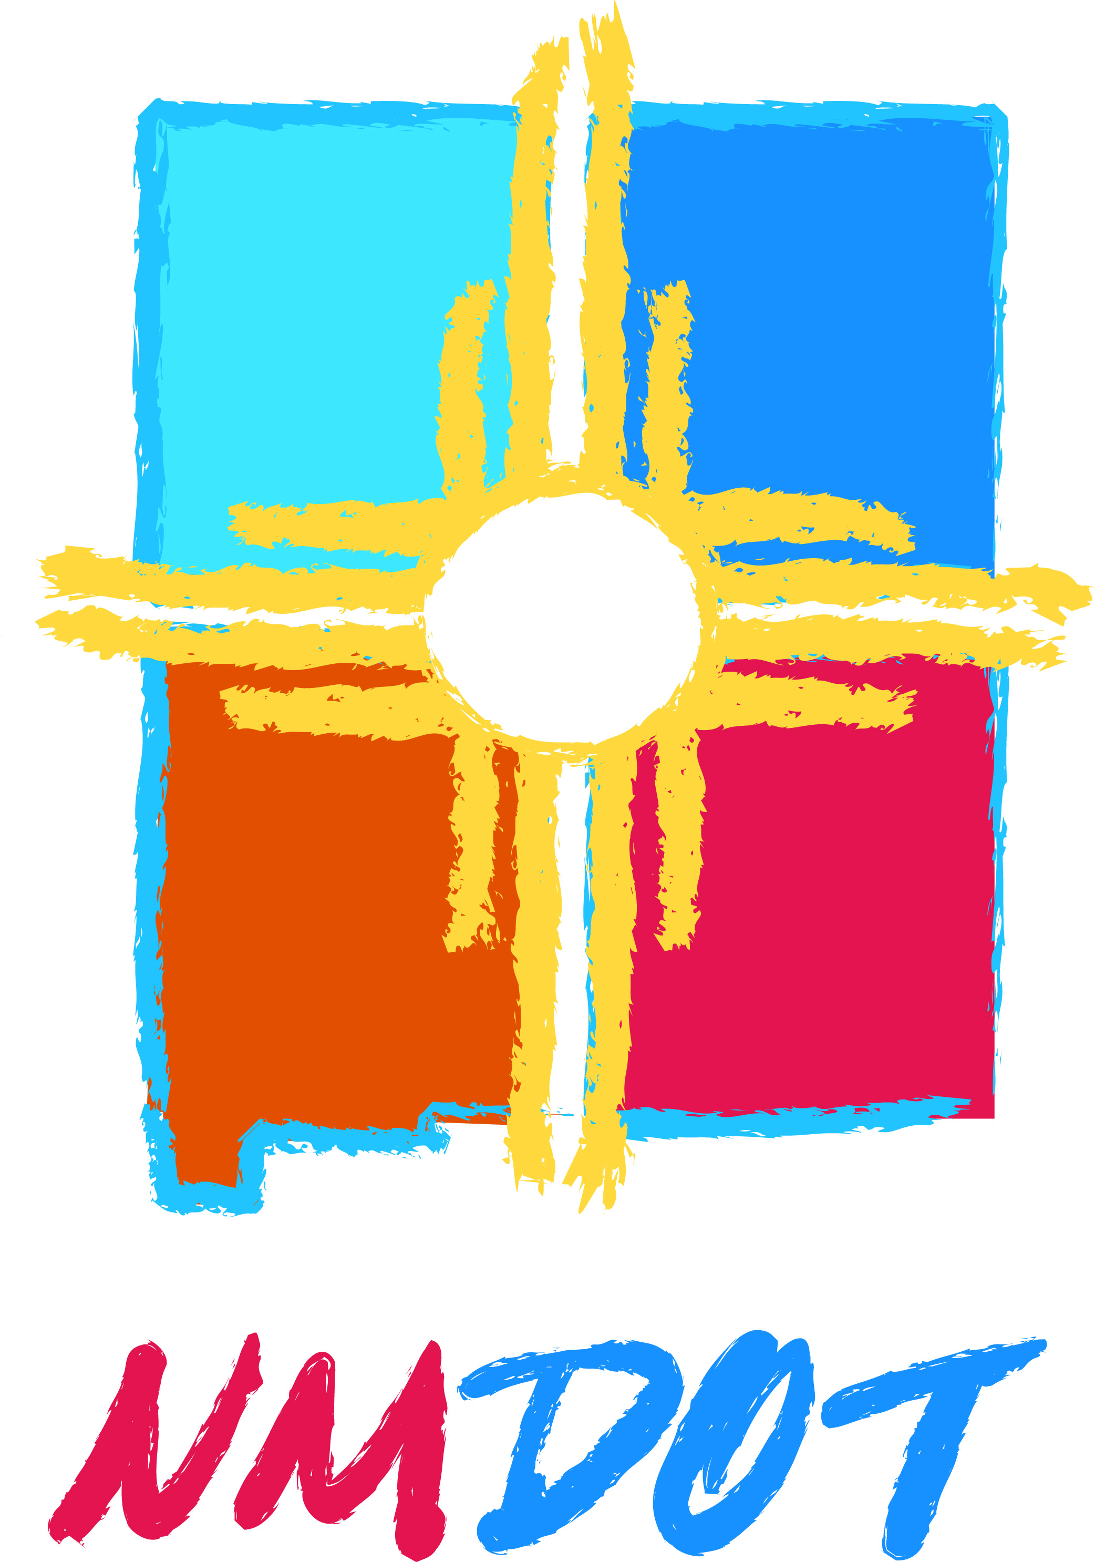

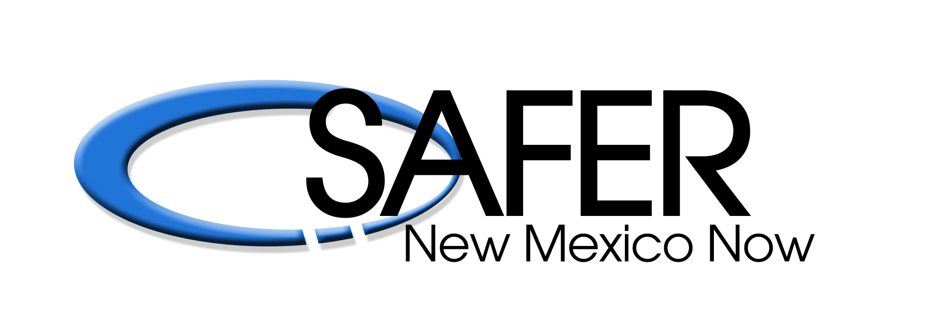

NEW MEXICO DEPARTMENT OF TRANSPORTATION, TRAFFIC SAFETY DIVISION

SAFER NEW MEXICO NOW

NEWS RELEASE
____________________________________________________________________________________________________________

FOR IMMEDIATE RELEASE: Contact: Safer New Mexico Now
August 29, 2014 (505) 856-6143 or (800) 231-6145

Albuquerque, NM – The New Mexico Department of Transportation, Traffic Safety Division and Safer New Mexico Now will hold seven child safety seat clinics statewide on Saturday September 20, 2014 from 11:00 a.m. - 1:00 p.m. The clinics are in support of the National Highway Traffic Safety Division’s National Seat Check Saturday initiative. The participating locations are listed below.

Albuquerque:
Kohl’s – Coronado Mall, 6600 Menaul Blvd., NE
Kohl’s – Paseo Del Norte, 6800 Paseo Del Norte, NE
Kohl’s – Cottonwood Corners, 3715 Ellison Dr., NW

Alamogordo:
Alamogordo Police Department – 700 Virginia

Las Cruces:
Kohl’s – 2500 North Triviz

Las Vegas:
Cornerstone Church – 2207 Seventh St.

Santa Fe:
Kohl’s – 4401 Cerrillos Rd.

These clinics provide parents and caregivers the opportunity to receive hands-on instruction from certified technicians on the correct use of child safety seats. Technicians educate parents on choosing and installing the appropriate child safety seat for their child and vehicle. They can also determine if a seat is recalled, expired, or otherwise unsafe.

Technicians will spend approximately 30 minutes per child safety seat, while providing education to parents on the correct use and installation. Parents and caregivers must bring the child safety seat and, if possible, the child.

The clinics are a public service available to everyone and there is no charge.

The Alamogordo and Santa Fe locations are by appointment only. For more information, please call Safer New Mexico Now at (505) 856-6143 or (800) 231-6145.

