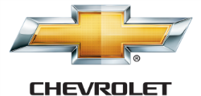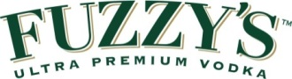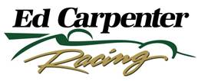

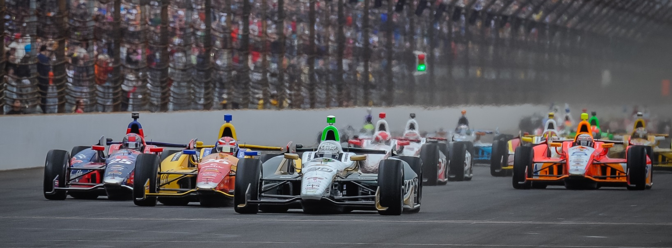

For Immediate Release Contact: Tom Blattler

317-525-5692

**AFTER ANNOUNCING BIG NEWS SATURDAY, CARPENTER**

**WHEELS FUZZY’S CHEVYTO 7TH IN MILWAUKEE QUALIFYING**

**Ed glad to get team news out of the way and go racing now**

**WEST ALLIS, Wis. (August 16, 2014)** – Team owner/driver Ed Carpenter was happy to take off his owner’s hat Saturday and trade it for his racing helmet for qualifying at the famed Milwaukee Mile.

Carpenter, the only owner/driver in the Verizon IndyCar Series, surprised the racing community Saturday afternoon by announcing his successful Ed Carpenter Racing team will merge with Sarah Fisher Hartman Racing in 2015. And the Texas race winner then concentrated on his weekend job of driving the No. 20 Fuzzy’s Ultra Premium Vodka Chevrolet.

Carpenter, second in the afternoon practice session, was pleased to be back in the cockpit after the earlier news and posted the seventh fastest speed in two-lap time trials late Saturday afternoon at the oldest auto racing track in the U.S.

The Butler University marketing grad secured the inside of the fourth row with an average speed of 167,775 miles per hour after qualifying laps of 167.756 and 167.775. Chevy driver Will Power won the pole Saturday at 169.262 m.p.h. in the 22-car field.

“I thought we would be a little quicker in qualifying than seventh since we were second in the afternoon practice,” said Carpenter. “But this ties my best qualifying here (2006) and I am pleased with race car setup. Just wish I could have gotten a little more out of the Fuzzy’s Vodka Chevy today. I was faster on my second lap but I slid a little turns three and four. I have always loved coming to Milwaukee to race and even watch when I was younger. I like the history here and the tough challenge of driving the flat track. I feel good about coming into Sunday’s race.”

-more-

-2-

Carpenter’s team, with wins at Long Beach, Texas and Toronto, is the first single-car effort in the IndyCar Series to win three races since 2004 when Fernandez Racing did the same feat.

Carpenter will drive the Milwaukee and Fontana ovals while two-time 2014 winner Mike Conway will handle the controls of the Fuzzy’s Vodka Chevy next week at Sonoma, Calif., road circuit.

“I’m very excited for the future,” said Carpenter, a three-time IndyCar Series race winner. “But to be honest, I want to go out with a big performance for Ed Carpenter Racing in the last three races. This team has had a great year (3 wins and Indy 500 pole) and I want to win again badly. Then move on to the future with Sarah (Fisher) and Wink (Hartman). We feel we can improve our performance with a two-car team. There is a lot of talent between the two teams.”

Sunday’s ABC Supply Wisconsin 250 is scheduled to take the green flag at 2:50 p.m. CDT and will be televised live on NBC Sports Network. In addition, the 250-lapper will be broadcast on the IndyCar Radio Network with its affiliates, Sirius 213, XM 209 and IndyCar.com.

# # #

