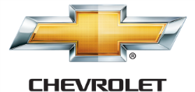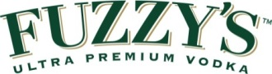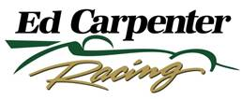

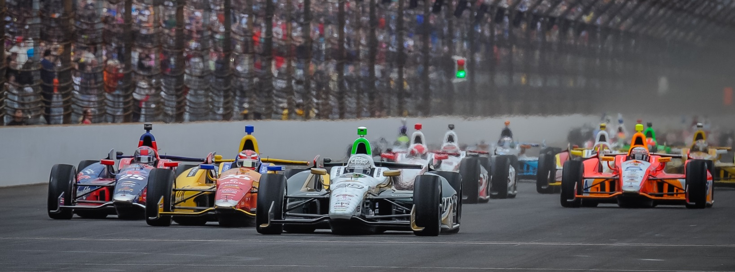

For Immediate Release Contact: Tom Blattler

317-525-5692

**MIKE CONWAY TAKES EVASIVE ACTION ON 1ST LAP TO AVOID**

**MID-OHIO CRASH AND FIGHTS BACK TO 13TH IN FUZZY’S CHEVY**

**Toronto Winner Didn’t Enjoy the Day after Early Move to the Grass**

**LEXINGTON, Ohio (Aug. 3, 2014)** – After the morning warm-up Sunday at the Mid-Ohio Sports Car Course, Mike Conway was feeling good about his No. 20 Fuzzy’s Ultra Premium Vodka Chevrolet entering Sunday’s 90-lap Verizon IndyCar Series main event.

But it only took the first corner of the first lap at the 2.25-mile permanent road circuit to adjust his good mood.

Conway, the two-time 2014 race winner in the Fuzzy’s Vodka Chevy, was forced to take evasive action just after the green flag fell when Tony Kanaan spun and collected Marco Andretti in the mishap. The incident blocked the majority of the track surface and Conway and others were sent to the grass area off the pavement to miss the carnage.

The result of Conway’s off-course excursion created a broken front wing for the Brit’s mount and also taking a different strategy for the race. Conway pitted immediately for fuel and tires and fought his way back at the always-tough passing circuit.

In the end, Conway took his machine to 13th at the checkered flag.

Reigning series champion Scott Dixon was able to run a great fuel-saving race with his Chevrolet-powered car and score his first 2014 win. Following Dixon was Sebastien Bourdais and James Hinchcliffe in the 15th round of the 18-event Verizon campaign.

“I got a good start but I was forced to the outside with the crash there,” said Conway after the race. “I had to avoid it and went on the grass and when I came back on the track I think I tagged the back of Ryan Briscoe. That bent the front wing. So we struggled with that issue most of the race. We kept adding front wing to see if it would help.

-more-

-2-

“It was hard to tell how the strategies were playing out and I was just pushing hard to the end. It was a tough day as it can be at Mid-Ohio. It was hard to move forward throughout the day. The first stint the track just didn’t have much grip at all and that made it hard. We tried the black (Firestone harder) tires and see if things would improve. But it was not much better. Now we just have to gear up for the Sonoma track later this month. It’s a track I really like.”

Conway will be back in the Fuzzy’s Vodka Chevy for the popular Sonoma, California event set for August 22-24 in the Northern California wine country.

But before that event, team owner Ed Carpenter will jump back into the green, gold and white Chevy-powered Dallara for the next stop in the Verizon IndyCar Series when the trail heads to the Milwaukee Mile on August 16-17. Carpenter will also drive his team’s machine at the MAVTV 500 at the Auto Club Speedway in Fontana, California on Aug. 29-30 for the season finale.

# # #

