

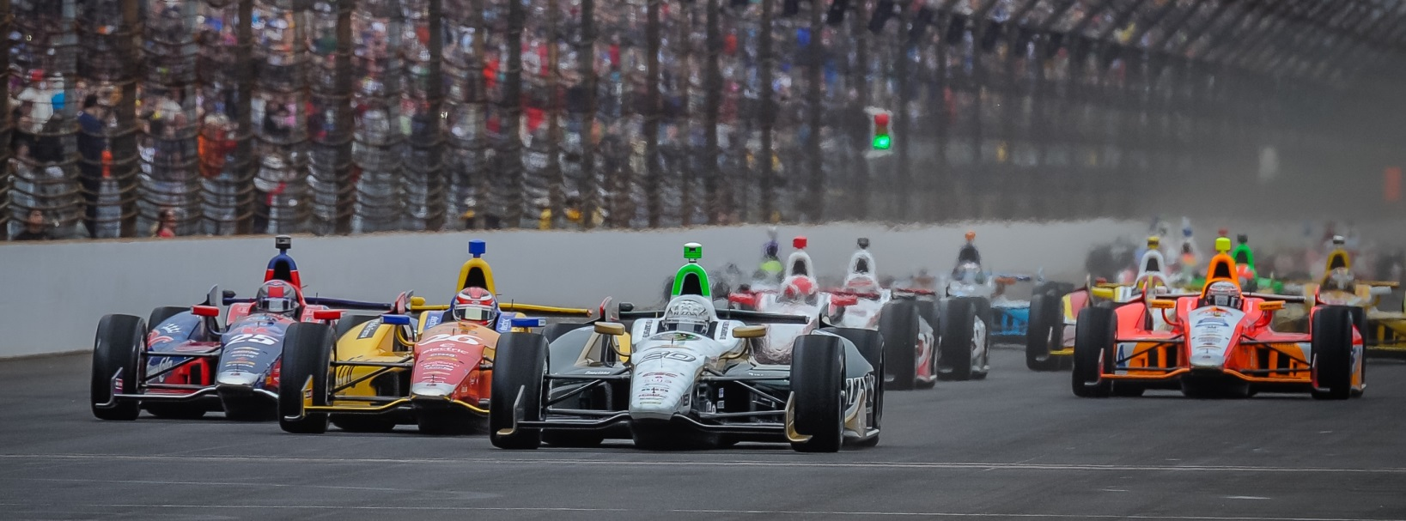

For Immediate Release Contact: Tom Blattler

317-525-5692

**CONWAY, ECR FUZZY’S TEAM IMPROVES THE CAR SATURDAY,**

**BUT RAIN STORMS PLAY HAVOC IN QUALIFICATIONS**

**Mike felt the car’s handling was better before a wet qualifying run**

**LEXINGTON, Ohio (Aug. 2, 2014)** – Mike Conway, coming off his Toronto victory two weeks ago, will start 12th in the No. 20 Fuzzy’s Ultra Premium Vodka Chevrolet for Sunday’s Verizon IndyCar Series feature at the Mid-Ohio Sports Car Course after a wet qualifying round.

Conway, a two-time 2014 victor, was pleased with the improvement in his car’s settings Saturday morning but a heavy downpour soaked the famed 2.25-mile, 11-turn permanent road circuit right before the afternoon qualifying session. Conway advanced from the first round of time trials and fought the tricky track conditions on the grooved Firestone rain tires before settling for 12th in the 22-car field.

Conway was hoping for dry conditions after the Ed Carpenter Racing crew made some adjustments from Friday’s practice runs. But the rain caused all of the teams to switch to the rain tires.

In the first round, Conway clocked an 82.600 mile per hour lap to transfer to round two. In the second contingent, the 30-year-old Brit posted a top speed of 85.729 m.p.h. but failed to advance to the Firestone Fast Six. Sebastien Bourdais won the pole position Saturday in his Chevy-powered machine at 96.586 as the track began to dry out.

“I thought our car was coming into a similar setup like the test last week when we practiced this morning,” said Conway. “And that is good. Then the rain came and we haven’t had a good grip level on the rain tires this year.  I tried to push the car harder and it was sliding around too much.  So we’ll hope to get back to the earlier setup and get a good car setup in the morning warm-up. This place is always difficult to get a proper lap. And it’s physical on the driver too.  It won’t be an easy race.”

Conway will start next to Juan Pablo Montoya in row six in Sunday’s 90-lap main event set to start at 3:45 p.m. EDT. The 15th stop in the 18-race Verizon IndyCar Series schedule will be televised on NBC Sports Network. In addition, the IndyCar Radio Network, hosted by Paul Page, will be broadcast through the nation as well as Sirius 213 and XM 209.

# # #