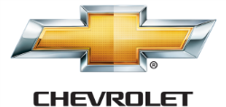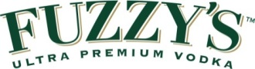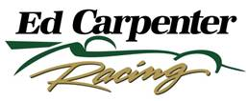

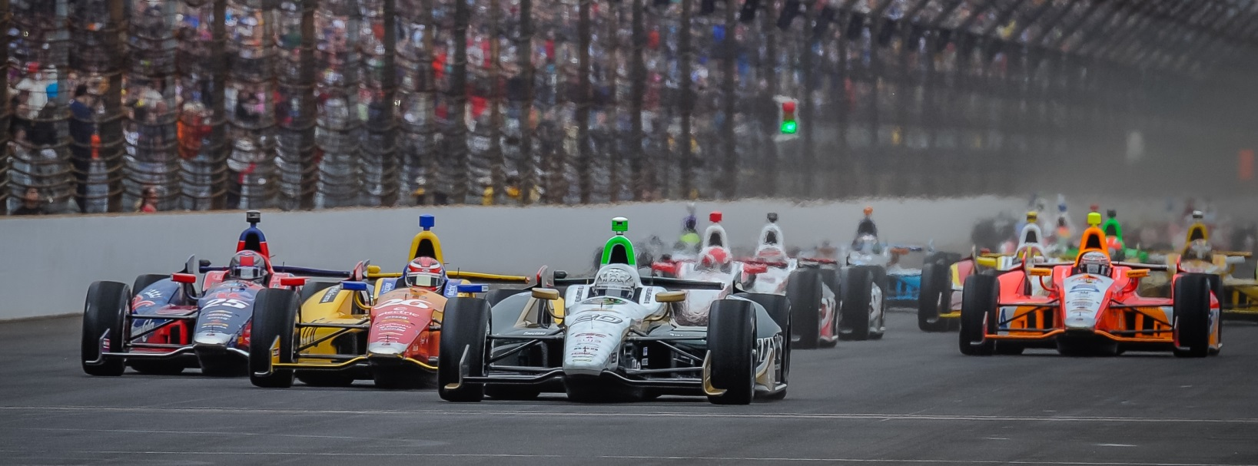

For Immediate Release Contact: Tom Blattler

317-525-5692

**CONWAY, CARPENTER MAKING BIG WAVES IN ONE CAR**

**WITH THREE WINS ALREADY IN THE FUZZY’S VODKA CHEVY**

**Little One-Car Squad Becomes Spoiler to the IndyCar Super Teams**

**INDIANAPOLIS (July 22, 2014)** – Ed Carpenter definitely opened some eyes in the racing world last November when he announced he was only driving the oval tracks in the 2014 Verizon IndyCar Series.

The only team owner/driver checked his ego and put on his owner’s cap entering this year.

The Butler University marketing graduate and multi-time IndyCar Series race winner knew his road racing abilities had improved but not enough to battle the tough competition at the street and road circuits.

So, when Carpenter decided to hire road racing veteran Mike Conway for the 12 road races, some folks took notice.

But no one expected to see the little Ed Carpenter Racing one-car team, with upstart Fuzzy’s Ultra Premium Vodka as the primary sponsor, become a regular in victory lane.

Well, after another brilliant race call last weekend at Toronto, the little team just recorded its third win in 2014 with Conway victories at Long Beach at Toronto and a Carpenter triumph at Texas. Not to mention a second straight pole position at the Indy 500 for Carpenter too.

“When we made this plan to split the driving chores with myself and Mike, we had hoped we could by contending at every race,” said Carpenter, the three-time IndyCar Series race winner. “We thought with a solid road course driver and an oval specialist that the Fuzzy’s Vodka Chevy could be in the hunt for each of the 18 races this year. Now, to win three events makes the season very special.”

-more-

-2-

But Carpenter, Conway and the outstanding ECR crew still have four races remaining as the team sits seventh in entrant points, just one marker behind last year’s series champion Scott Dixon and the Target Chip Ganassi team.

Conway’s sensational call for Firestone slick tires on a drying race track at Toronto proved to be a genius move last Sunday. Much like Carpenter’s call to split the driving duties this year.

“That was totally Mike’s call on the tires,” said Carpenter after the race. “He felt the track was drying and he could go with the Firestone red slicks. We were able to jump into the pits two laps sooner than everyone else and that was the difference.”

Conway’s two wins in the streets this year now gives the 30-year-old British driver four career IndyCar Series victories and he’ll look for more next week at the Mid-Ohio Sports Car Course August 3. Mike will also drive the No. 20 Fuzzy’s Ultra Premium Vodka Chevrolet at Sonoma on August 24.

Meanwhile, the boss jumps back in the cockpit at Milwaukee on August 17 and the season finale August 30 at Fontana, a place he won in 2012 and was second in 2013.

“I have had a lot of fun this year with the ECR/Fuzzy’s Vodka guys,” said Conway. “Ed and his team might be a one-car operation but they put together a strong effort that can rival the big teams like Penske, Ganassi and Andretti. And our record this year has proven it.”

As Conway said, ECR is the little team that could. And the contingent is looking for more.

# # #

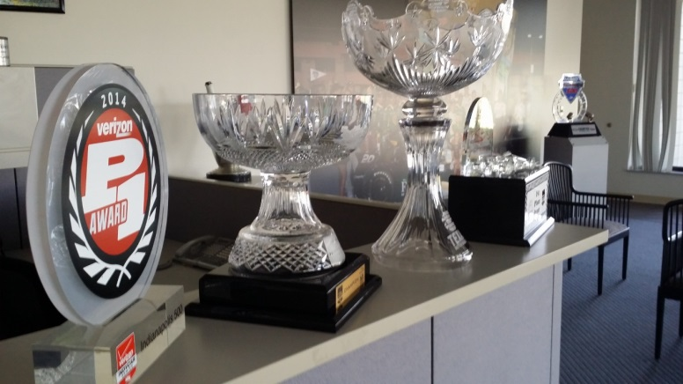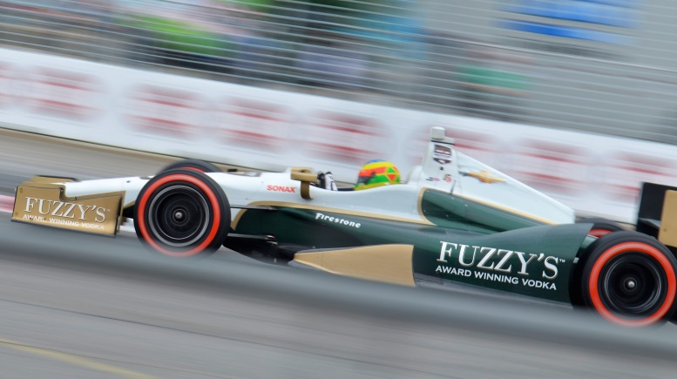

**ECR’s 2014 Hardware and Conway at Toronto**