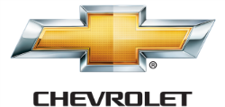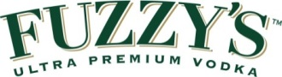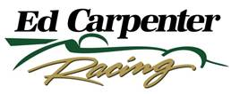

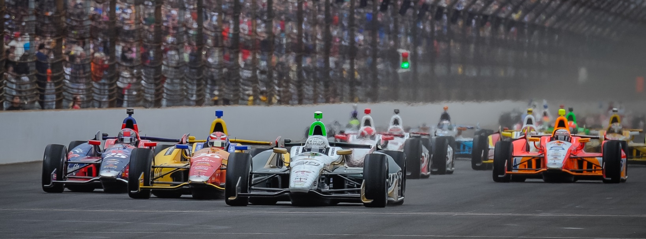

For Immediate Release Contact: Tom Blattler

317-525-5692

**MIKE CONWAY MAKES THE BRILLIANT CALL FOR FIRESTONE SLICKS AND WINS TORONTO RACE 2 IN FUZZY’S VODKA CHEVY**

**Brit Battles Back to Win His 2nd 2014 Street Race Sunday**

**TORONTO (July 20, 2014)** – Mike Conway made the move of the day Sunday in the Honda Indy Toronto when he decided to come in earlier than his fellow drivers for the Firestone slick tires and captured his second 2014 Verizon IndyCar Series event.

Conway, the winner earlier this year at Long Beach, called to his Ed Carpenter Racing squad that he needed to change from the treaded rain tires to the red Firestone slicks as the 1.75-mile, 11-mile temporary circuit at Exhibition Place was drying out.

On lap 43, Conway pitted for the slick tires as his counterparts remained on the grooved rubber. A lap later, the yellow flag come out for the stalled car of Sebastian Saavedra and the majority of the drivers then pitted for slicks in the drying conditions.

That left Conway running fifth with four racers on the rain tires in front of the driver of the No. 20 Fuzzy’s Ultra Premium Vodka Chevrolet. The 30-year-old Brit quickly picked his way through the four leaders and took the lead on lap 50.

Despite a late red flag period for a major crash in turn three, Conway held the point and scored his third career IndyCar Series victory and the third win of the year for Ed Carpenter Racing. Team owner Ed Carpenter won at Texas Motor Speedway last month on the 1.5-mile oval track.

Conway’s win also win the 250th triumph in IndyCar racing for the legendary tire manufacturer.

Conway took the win in a rain-shortened timed event that recorded 56 laps in a little over 80 minutes. Rain hit the Toronto event on lap 12 with a quick-moving storm system dousing the circuit and all drivers pitting for Firestone rain rubber.

-more-

-2-

Then Conway was penalized for making contact with a piece of pit equipment from Dale Coyne Racing that dropped him to the 19th position. He fought his way back to 12th by lap 36. And on lap 43, Conway made the brilliant decision to jump into the pits for fuel and the new slicks.

By lap 50, Conway was in the lead and held off Tony Kanaan and Will Power for another all-Chevy podium sweep.

Earlier in the day, Sebastien Bourdais led another all-Chevy podium over Helio Castroneves and Kanaan.

Things do not slow down for Conway and the ECR/Fuzzy’s Chevy team as the squad moves to the Mid-Ohio Sports Car Course this Thursday for a testing day in preparation for the August 3 race at the 2.25-mile permanent road course.

“It was really difficult conditions and we were kind of struggling out there for a bit,” said Conway about the rain conditions. “Then I knew as soon as I could see the dry line it was time to come in, and it was a great call. And the guys were up for it. I wasn’t sure what they were going to say so from there we just kind of took off and just controlled the race. I was a bit nervous with the red flag there but I knew with Justin (Wilson) behind me (on rain tires), we would be able to cover it. It was good fun out there.”

Conway felt confident about his decision to jump to the slick tires earlier than the rest of the field.

“The tire temperatures came in really fast and that’s what you need in those types of conditions,” he admitted. “So I could just control it and not have to push too hard and enjoy those last few laps.”

Carpenter again relished as the team owner with another Conway road victory.

“You always hope to have this type of year with three wins,” said Carpenter regarding his decision to split the driving chores in 2014 with Conway. “A big part of the reason why we brought Mike in was just to try to be stronger all the time. We believed as a team and we had won before as a team. I personally felt like we had better cars at road and street courses than what I was able to show. The cars were a little better than I was. We’re trying to grow the business, grow the team and get results for all our partners.”

Carpenter believed he had a winning operation when he started his own team in 2012.

“It’s been nice to be able to do win and run up front more consistently so far this year,” Ed said. “Mike is one hell of a racer. When you get him in position and we do a good enough job, or today he made the right call, he elevates his game and rises to the occasion. You saw today he drove away from guys who have been fast all weekend. Same thing in the win at Long Beach, he may not have the fastest car in the whole race but, when he gets in those positions, he doesn’t let go of it. And we’re happy he’s on our team.”

# # #