

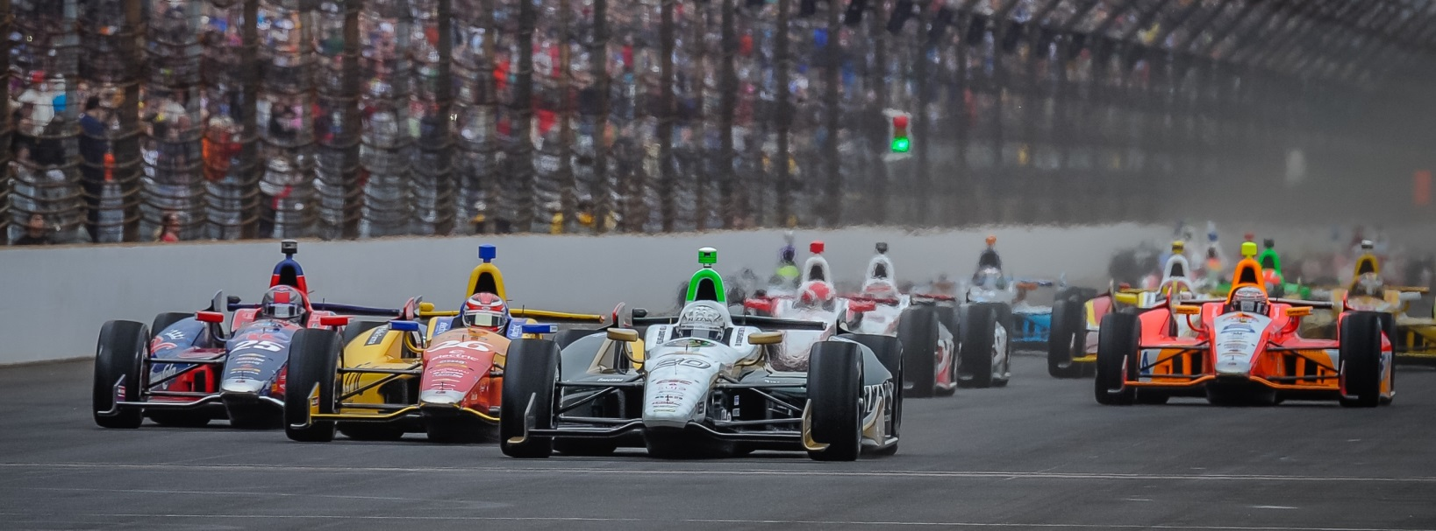

For Immediate Release Contact: Tom Blattler

317-525-5692

**CONWAY TAKES 15TH IN 1ST TORONTO RACE SUNDAY MORNING; SET FOR 2ND 65-LAP TWIN FEATURE AT 4:15 PM EDT**

**Fuzzy’s Chevy Driver Spins to Avoid Contact on First Lap**

**TORONTO (July 20, 2014)** – Luck wasn’t on Mike Conway’s side Sunday morning in the first of two 65-t widelap Toronto feature races at Exhibition Place. The Brit took 15th place in the first race.

The 2014 Long Beach race winner started 13th in the opening contest but had to spin his No. 20 Fuzzy’s Ultra Premium Vodka Chevrolet on the first lap to avoid contact with Simon Pagenaud who had spun his mount in turn four.

As a result, Conway was forced to stall his machine and waited for the Verizion IndyCar Series safety crew to restart the Ed Carpenter Racing driver’s car’s engine. By the time the engine was re-fired, Conway was relegated to the rear of the field. Several other drivers were also sent to the back of the field from the first lap incident.

On the restart, Conway worked his way to 12th before he came into the pits for fresh Firestone tires and fuel. He continued to fight his way up the grid at the tight 1.75-mile, 11-turn street circuit before another pit stop on lap 34. Conway then drove in a fuel conservation mode in an effort to finish near the top-ten and battled with a variety of drivers before settling for 15th.

Frenchman Sebastien Bourdais led an all-Chevy sweep of the podium in the first Toronto race followed by Helio Castroneves and Tony Kanaan. The second Toronto race is set for 4:15 p.m. EDT.

“We were just saving a lot of fuel from the midway of the race to the end,” said Conway. “And you are looking in your mirrors a lot, making sure you don’t get overtaken. I did make it to the end and did overtake some people. Then on my last move on the last lap, I tried to get by (Jack) Hawksworth (for 13th) into turn three but got wide. Then (Carlos) Huertas stuck his nose inside at turn five and I couldn’t hold him off. I think our pace is a little better in the race and especially with reds (Firestone tires). Rubber is going down now on the race surface for the second race so maybe the car will come to us better.  At the start, I meant to stop and not hit Simon (Pagenaud) but the car spun around.  I didn’t hit anything.  But I stalled the engine and I had to wait to have the safety team to restart me.  That put us towards the back then.”