

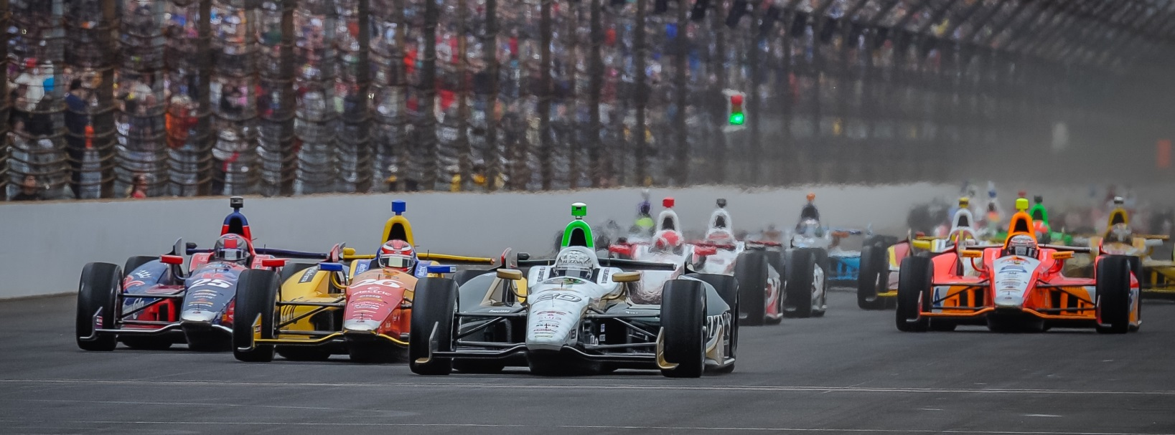

For Immediate Release Contact: Tom Blattler

317-525-5692

**FRUSTATION FRIDAY FOR CONWAY AND THE ECR FUZZY’S TEAM IN OPENING PRACTICE AT TORONTO INDY DOUBLEHEADER**

**Bumpy Track Proves Tough for Long Beach Winner in Practice**

**HOUSTON, Texas (July 18, 2014)** – Friday’s practice rounds at the tight 1.75-mile, 11-turn temporary circuit in Exhibition Place looked promising early for driver Mike Conway and his Ed Carpenter Racing team in the Toronto doubleheader..

Unfortunately, the frustration factor came later in the day for the single-car operation.

After taking the No. 20 Fuzzy’s Ultra Premium Vodka Chevrolet in the top-ten for the most of the morning practice runs, the Long Beach Grand Prix had to settle for the 22nd fastest speed at the end of Friday’s two practice rounds.

Conway posted 42 laps throughout the two 45-minute sessions with a best speed of 103.336 miles per hour. The fastest driver for the today’s Verizon IndyCar Series practice was Simon Pagenaud with a top speed of 105.285 m.p.h. followed by Helio Castroneves and Scott Dixon.

In the morning round, Conway’s speed was 12th fastest but the 30-year-old Brit could not improve his speed in the afternoon practice.

Qualifying for Saturday’s first Toronto race will begin at 10:00 EDT a.m. with the 85-lap contest scheduled to begin at 3:48 p.m. EDT with a standing start. Sunday’s program also is set for 3:48 p.m. EDT with a rolling start. Both Toronto races will be televised live on NBC-TV starting at 3:00 p.m. EDT and the IndyCar Radio Network will broadcast on Sirius 213 and XM 209.

“We are not very competitive right now,” said Conway. “We haven’t got the car dialed in. It’s the same as the Houston weekend. We haven’t been able to tackle the bumps as we want. We’ll have to try out a few things in qualifying on Saturday morning. We know where need to improve with car but we haven’t been able to hit it just yet. So it is frustrating. We’ll work hard tonight to get a better setup for Saturday.”