

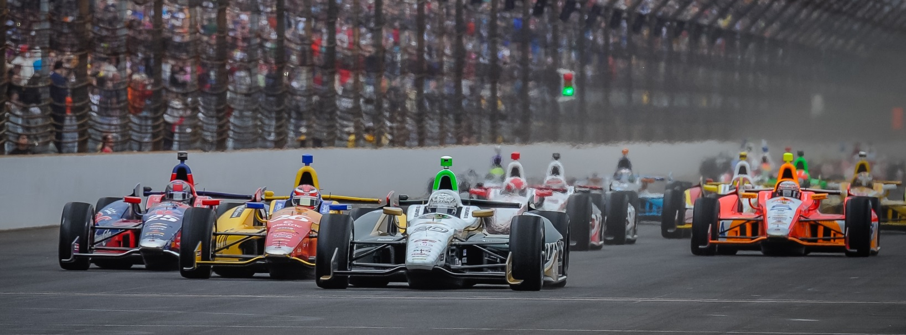

For Immediate Release Contact: Tom Blattler

317-525-5692

**MIKE CONWAY PLAYS INTERNATIONAL TRAVELER RECENTLY,**

**NOW BACK FROM EUROPEAN TESTING FOR TORONTO RACES**

**Long Beach Race Winner Set for Street Battle in Fuzzy’s Vodka Chevy**

**TORONTO (July 15, 2014)** – Mike Conway is collecting his “frequent flyer” miles at rapid rate these days.

The Toyota Grand Prix of Long Beach champion heads back to Toronto this week for the annual Verizon IndyCar series doubleheader through the streets of Exhibition Place near Lake Ontario.

But Conway’s air miles have been growing with his recent IndyCar Series races in the No. 20 Ed Carpenter Racing/Fuzzy’s Ultra Premium Vodka Chevrolet and his testing days in Europe.

Not only is Conway a regular at the street and road circuits for Carpenter’s IndyCar Series squad but he is a test driver for the factory Toyota Hybrid sports car program and, recently, the primary pilot for the Dragon Racing Formula E open-wheel team.

“I’m definitely getting the frequent flyer miles going with the trips across the Atlantic lately,” said Conway, the three-time IndyCar Series race winner. “I have a home in the Phoenix area but I really haven’t seen it too much this year. With travel for the testing of the sports car and Formula E, I’m very pleased to be back in North America for a few weeks.”

Conway comes to Toronto after a recent testing session at Donington Park in England for the all-new Formula E Series which begins this fall.

“To be honest, it’s always good to stay in a race car and get that all-important seat time,” admits Conway, who raced in the IndyCar Series last year as well as the World Endurance Series. “I’m anxious to get back to streets of Toronto in an IndyCar. It’s a great event there and the racing is always good and exciting. The fans in Toronto really appreciate the racing in the IndyCar Series.”

-more-

-2-

Conway joined Ed Carpenter Racing this winter when the team owner decided to concentrate on oval racing only in 2014. And that decision has already paid off.

Conway, in his second race with the team, won a great comeback race in Long Beach in April and Carpenter has won the pole at the Indianapolis 500 and the Firestone 600 race at Texas Motor Speedway this year.

“Our goal with the new combination was to be competitive at all of the races this year with the Fuzzy’s Vodka Chevrolet,” said Carpenter, the only team owner/driver in the series. “We are working to make that happen. So far winning two races has been good, but we want more now.”

Conway’s prowess on the street circuits figures to give the ECR team a boost this weekend in Toronto.

“We had a couple of mishaps at the last doubleheader in Houston,” said Conway. “But I think we can put together a solid setup for the Fuzzy’s Chevy that will make us very competitive. The Toronto track is tricky and the surface is always pretty bumpy. So it will be a test for all of the teams to get their setups right there. But I’m looking forward to the doubleheader again.”

Conway, always in excellent shape, knows the physicality of the doubleheader on the drivers.

“The doubleheader weekends can be rough on the drivers from both a physical and mental standpoint,” he explains. “The drivers and the teams are used to one race per weekend. But now, everyone has to be prepared to handle 85 laps of racing each day. It is tough mentally for the crews on their pit stops as well as the drivers on the track. People tend to make mistakes on the second day due to fatigue.”

The Toronto action begins at the 1.75-mile, 11-turn temporary circuit this Friday with two practice rounds starting at 10 a.m. CDT. The two 85-lap features on Saturday and Sunday will get underway at 3:40 p.m. EDT and both races will be televised on the NBC Sports Network beginning at 3 p.m. CDT. In addition, the Toronto contests will be broadcast over the IndyCar Radio Network and Sirius 213 and XM 209 in satellite radio.

# # #

