

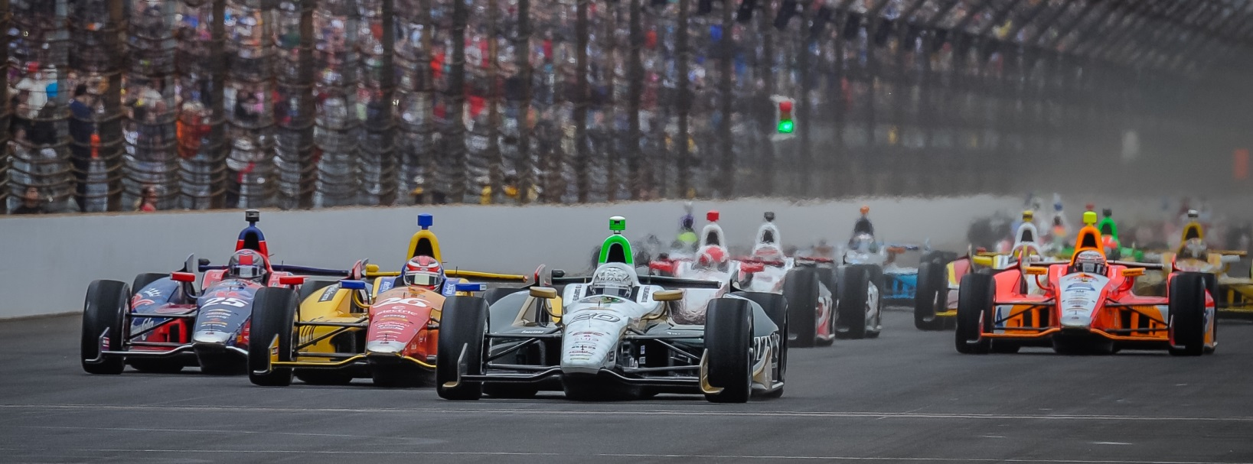

For Immediate Release Contact: Tom Blattler

317-525-5692

**CARPENTER TAKES TOP TEN SPOT IN IOWA QUALIFYING;**

**INDY 500 POLE WINNER READY FOR 300 MILER SATURDAY**

**Fuzzy’s Vodka Chevy Racer Seeks 2nd 2014 Victory at Short Track**

**NEWTON, Iowa (July 11, 2014)** – Ed Carpenter, the Verizon IndyCar Series only team owner/driver, will start 10th in Saturday’s Iowa Corn 300, the 12th stop in the 18-race campaign, in his No. 20 Fuzzy’s Ultra Premium Vodka Chevrolet at Iowa Speedway.

Carpenter, the Firestone 600 winner last month at Texas Motor Speedway, recorded a two-lap average of 184.589 miles per hour in Friday’s qualifying runs on the 7/8-mile Bullring oval east of Des Moines. Ed will start on the outside of row five Saturday when the green flag drops at 7:50 p.m. CDT. The race will be televised on NBC Sports Network and broadcast on the IndyCar Radio Network (Sirius 213, XM 209).

The two-time Indy 500 pole winner posted lap speeds of 185.170 m.p.h. and 184.012 m.p.h. after a tough day of waiting out the rain storms and the drying of the racing surface.

Carpenter looked to have a possible top-five qualifying effort Friday evening with a solid 185-plus first lap but the second circuit saw the Fuzzy’s Chevy get a little too loose (oversteer) in the corners. Ed had to correct the car and the speed dropped one mile per hour.

Scott Dixon drove his Chevy-powered car to the pole Friday with a two-lap average speed of 186.256 m.p.h. some six m.p.h faster than the old Iowa Speedway two-lap track record set by Takuma Sato in 2011. Sato’s old mark 180.375. Helio Castroneves held the single-lap record fo 185.687. Tony Kanaan will start second Saturday night followed by Castroneves, Ryan Briscoe and Carlos Munoz.

“It’s not a bad run for here but the car did get a little loose on the second lap or we would have had better starting spot,” said Carpenter, who finished fourth in last year’s Iowa Speedway race. “You always want a better speed when you aren’t on the pole. But it has been a tricky day with the weather conditions. Waiting out the rain and the drying of the track is always tough. I think we have a good car for the race. We’ll have to see how the conditions go after the rubber from the truck race and possible rain. We were fast last year here and I feel like our race setup will be good. The 50 extra laps could prove to be a factor towards the finish. The track could really change throughout the race and you have to be able to adjust to that element.”