

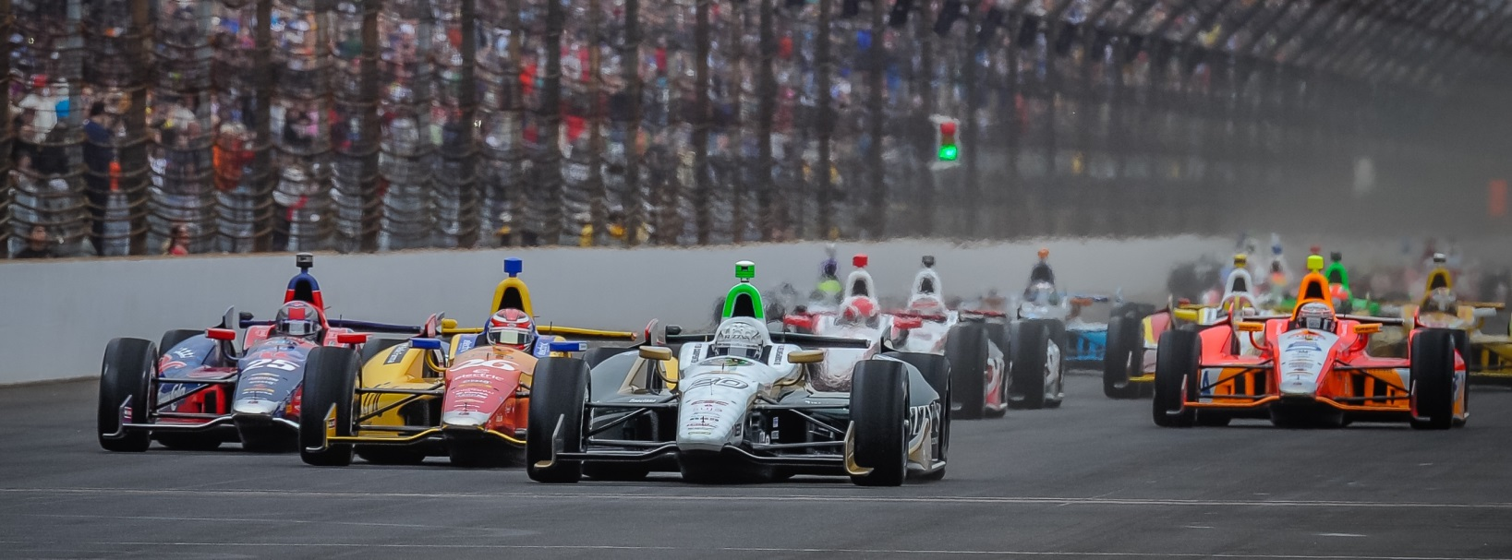

For Immediate Release Contact: Tom Blattler

317-525-5692

**SO MUCH FOR OFF RACE WEEKS IN VERIZON INDYCAR SERIES,**

**ECR AND OTHER TEAMS BUSY ON TEST PROGRAMS**

**Two Weeks of Testing has ECR Busy with Ed Carpenter at 3 Different Tracks**

**INDIANAPOLIS (June 20, 2014)** – A welcome sight today at the Ed Carpenter Racing headquarters was the ECR/Fuzzy’s Ultra Premium Vodka Chevrolet tractor and trailer.

That big rig hasn’t seen its home on the west side of Indianapolis for some time.

Let’s add up the days.

Starting from May 7 at the Indianapolis Motor Speedway to Friday (June 20), the team’s transporter has been in the Indianapolis race shop a total of five days.

With races at Indy (2), Detroit (2) and Texas, the schedule looked favorable with a two-week break in the middle of June. But that is where the schedule gets misleading.

Since Ed Carpenter’s victory in the Firestone 600 at Texas Motor Speedway, the ECR/Fuzzy’s squad and other Verizon IndyCar Series teams have continued to be on the road and testing.

“Unfortunately, we are probably our own worst enemy when having a break in the schedule,” said Tim Broyles, ECR general manager. “The league (IndyCar Series) has left us a couple of weeks open but the testing schedule fills in those dates. Most of the teams were doing two test and some were at three tests like us.”

Following the Texas win, ECR traveled straight to Iowa Speedway and the Milwaukee Mile for one-day testing sessions and then onto Pocono Raceway for Thursday’s rain-shortened test with Carpenter in the cockpit in all three runs. Mike Conway, the Long Beach winner, returns to the No. 20 Fuzzy’s Vodka Chevy next week in Houston.

-more-

-2-

“However, we were able to work in a three-day weekend last week which helps recharge the batteries and get the guys with their families,” said Broyles. “It’s just not much of a break for the teams right now. Plus we are repairing the car that was crashed at Indy.”

And the next four weeks in the IndyCar Series calendar will include six races with two at Houston (June 28-29), Pocono 500 (July 6), Iowa Speedway (July 12) and two more races at the Toronto weekend (July 19-20).

“We kept some of the guys in the shop this week during the Pocono test to prep the Houston road race car and the Pocono race car,” Broyles explained. “And we used the test car for the Pocono run this week.”

In the meantime, the ECR operation is attempting to freshen up its paint work and sub-assembly pieces as the 2014 Verizon IndyCar Schedule becomes extremely busy with ten races in ten weeks.

“Plus we will be testing during the off-weekend at Mid-Ohio and get ready for that event on August 3,” said Broyles. “It’s not just our team. It’s hard on all of the IndyCar teams and hard on the truck drivers, the mechanics and everyone on each of the other teams. The trucks have to be on the road Tuesday to Houston for the Wednesday load-in.”

So, if anyone thought the IndyCar Series teams had a couple of weeks to relax before the next four-week stint, you can forget those thoughts.

It’s just part of the racing season and the ECR boys are now anxious to get back on the tour and visit victory lane once again.

The series restarted next weekend in Houston with the Shell/Pennzoil Grand Prix of Houston doubleheader set for June 28-29. Both races will be televised on the NBC Sports Network beginning at 3 p.m. EDT.

# # #

