

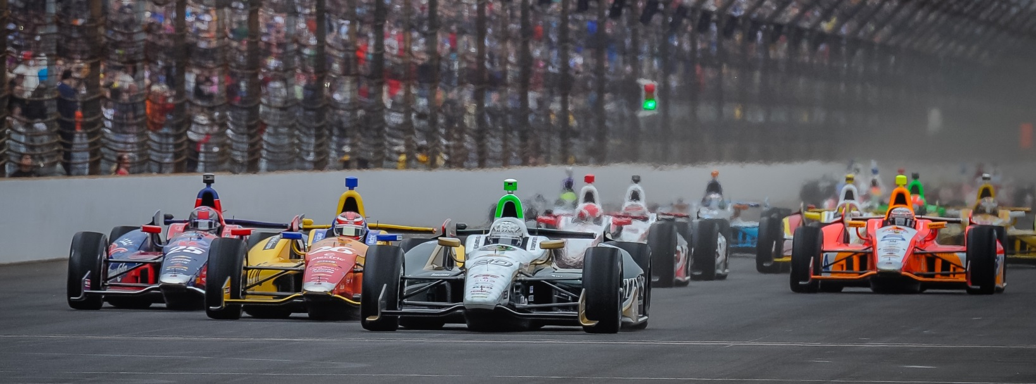

For Immediate Release Contact: Tom Blattler

317-525-5692

**SEVEN MONTHS SINCE ED CARPENTER WAS IN A RACE CAR;**

**ONLY SERIES’ OWNER/DRIVER ANXIOUS FOR INDY 500 RETURN**

**Ed’s new role produces dividends with Conway’s Long Beach win**

**SPEEDWAY, Ind.  (May 11, 2013)** – Ed Carpenter’s role changed this year as team owner and driver of the No. 20 Fuzzy’s Ultra Premium Vodka Chevrolet.

The Butler University marketing graduate made a major career decision to drive in only the oval races of the 2014 Verizon IndyCar Series, as the defending Indy 500 pole sitter hired veteran road racer Mike Conway to pilot his ECR/Fuzzy’s Chevy in 12 street/road races.

The only owner/driver in the series looked like a prophet in the second race of the season when Conway scored the victory in the prestigious Toyota Grand Prix of Long Beach last month.

Now, it’s Carpenter turn to take over the controls of the No. 20 as practice rounds begin today for the 98th running of the Indianapolis 500-Mile Race. The 2014 race is Sunday, May 25.

Carpenter has not been in a race car in seven months, having placed second to Will Power in the 2013 season-finale last October in Fontana, Calif. Other than a few testing sessions this year, Carpenter has concentrated on the organization of his Ed Carpenter Racing operation.

“To be honest, I am very excited to get back in the cockpit today,” said Carpenter, who the 500-mile Fontana event in 2012. “I made the decision last year to get out of the seat for the road and street races. Mike has already won a race for us, so it was the right call. But I became a race car driver because of the Indy 500. I have a great passion for the race. It is my total concentration now for the next two weeks.”

Carpenter has been impressive in his last four 500-mile races in the Verizon IndyCar Series, dating back to 2012 when he became a team owner and driver.

-more-

-2-

In the 2012 Indy 500, the father of three young children (Makenna, Ryder and Cruz) came from 28th starting position to run third with 20 laps remaining before a front wing part broke and sent him into a spin. He came back later that year at the MAV500 and passed Dario Franchitti on the last lap to take the victory at Fontana.

Last year, Carpenter shocked the IndyCar community by defeating the super teams of Andretti and Ganassi to capture the coveted 2013 Indy 500 pole position. He led the most laps (37) but finished a disappointing tenth. Then, at Fontana, Ed placed a close runner-up to Power in the last 500-miler at Fontana.

“It’s been awhile since that Fontana race but I have been in the car for several tests this year, so I feel good about returning to Indy,” explained Carpenter. “My enthusiasm for running the ovals and competing at Indy is very high. We have worked hard to get ready for the month of May. I believe we can win this race this year.”

Carpenter, the team owner, made another decision for May. The last two years Carpenter’s effort has been a single-car operation. But the 33-year-old racer has been attempting to expand his squad for several years and now has made it happen for the 98th Indy 500. Carpenter secured primary sponsorship from Preferred Freezer Services for the No. 21 Chevrolet and hired 2011 Indy 500 runner-up J.R. Hildebrand to drive the car.

“I have been talking to J.R. since last June about the possibility of running a second car with us,” said Carpenter. “I believe J.R. is a very talented driver and having him as a teammate this month will really help our effort in May. I would love to have J.R. run more races with us if the funding is found in the future.”

But Carpenter has set his team owner role aside for the next two weeks. Only driving the ECR/Fuzzy’s Vodka Chevy is on Ed’s mind. And he is ready for the challenge.

“This race will be my 11th Indy 500 so I think I know what it takes to race up front and by a contender for the win,” he said. “I felt we had a great chance last year and the race kind of got away from us in the last 100 laps. We have studied our data from last year and we are set to run strong again. But this time we want to lead that last lap.”

There is no doubt that “Driver” Ed has his sights set on the winner’s circle on May 25.

