

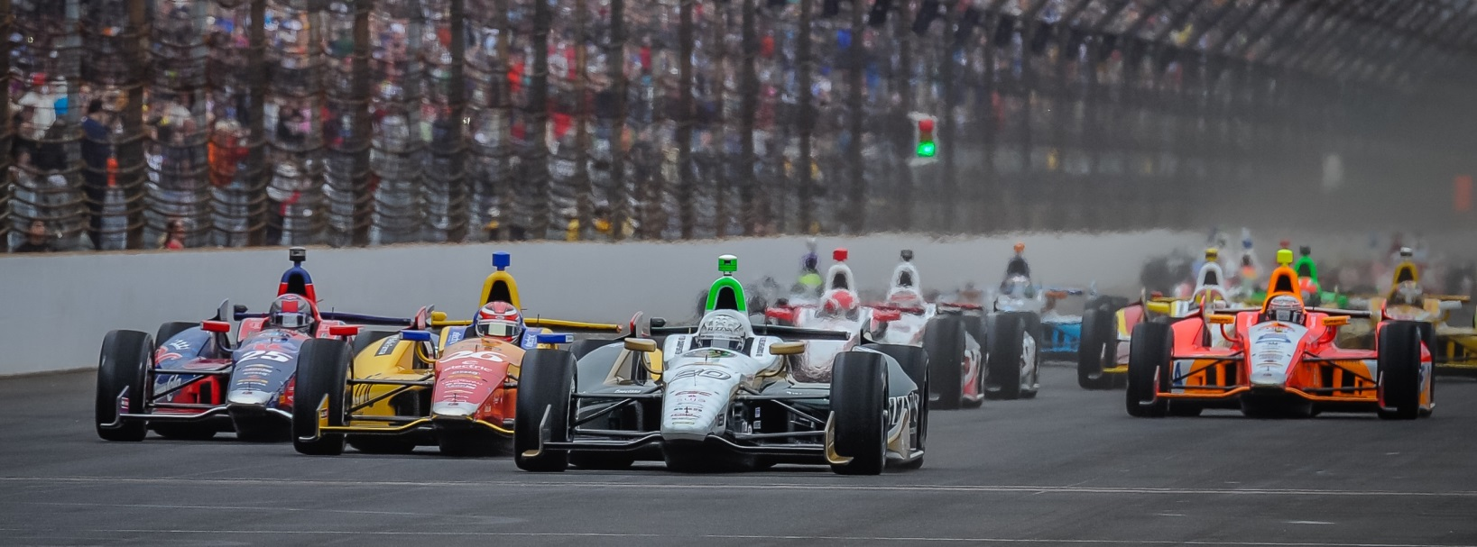

For Immediate Release Contact: Tom Blattler

317-525-5692

**BOTCHED STANDING START HURTS CONWAY’S CHANCES EARLY IN STRANGE INAUGURAL GRAND PRIX OF INDIANAPOLIS**

**ECR/Fuzzy’s crew makes repairs to re-enter race and gain valuable points**

**SPEEDWAY, Ind.** (May 10, 2014) – Saturday’s inaugural Grand Prix of Indianapolis got off to a wild start, as a pair of stalled Verizon IndyCar Series machines wreaked havoc, catching Mike Conway in the No. 20 Fuzzy’s Ultra Premium Vodka Chevrolet as he tried to avoid the chaos.

When the green flag fell on the 25-car field, Conway launched successfully from the 24th grid position on the standing start. However, pole sitter Sebastian Saavedra stalled his No. 17 KVAFS car at the start line and Conway had to make evasive action immediately. Carlos Munoz’s car made contact with Saavedra, forcing Conway into the inside wall, and thus causing significant right side suspension damage to the Fuzzy’s Vodka Chevy.

Conway was able to return to the ECR/Fuzzy’s Vodka pit upon completing the first lap of the 2.4-mile road course under caution. Conway and crew immediately headed back to the garage for extensive repairs on the No. 20 Chevrolet. The team did a well-orchestrated overhaul to get Conway back into action Saturday in the first IndyCar Series road race at the famed track.

After quick repair, Conway rejoined the race on lap 18, in the 23rd position.

Conway continued to make the best of the situation, rewarding the efforts of his crew and the misfortunes of his fellow competitors. Through attrition, Conway was able to move up five positions before intentionally retiring from the race on lap 76.

“We had a good start and I started picking my way through some guys,” said Conway, the recent Long Beach winner. “I went to the right and I heard on the radio that (Sebastian) Saavedra had stalled. I stayed inside and I could see that the car was stopped. I went for the spot that was open along the wall.

-more-

-2-

“(Carlos) Munoz was in front of me and he misjudged the space and clipped Saavedra. That moved Saavedra’s car out just enough that there was no enough for me and it caught me.  That put me into the inside wall and we broke the right side suspension, front and rear. The ECR/Fuzzy’s boys did a great job fixing it. And all I could do was go back out and salvage the points. We tried to learn something with couple of setup changes.  Still need to pick up some speed but it was good to get some points and I think we are in sixth now.”

Fuel mileage played a factor in the 82-lap race as Simon Pagenaud took the victory, followed by Ryan Hunter-Reay and Helio Castroneves.

Conway and the crew’s efforts to get the ECR/Fuzzy’s machine back on track was not done in vain, as the repairs have kept the Ed Carpenter Racing entry sixth in the Verizon IndyCar Series standings with 93 points. Will Power still hangs on to the Series lead with just one point (149) over Hunter-Reay.

Track activity resumes Sunday at the famed Brickyard, as the 2.5-mile oval will open for practice (12-6 p.m.) in preparation for the 98th running of the Indianapolis 500 set for May 25.

Team owner/driver, Ed Carpenter will return to the cockpit of the Fuzzy’s Vodka Chevy as he looks to defend his 2013 Indianapolis 500 pole position. Joining him in the team’s second entry will be 2011 500 runner-up JR Hildebrand in the No. 21 Preferred Freezer Services Chevrolet.

# # #

