

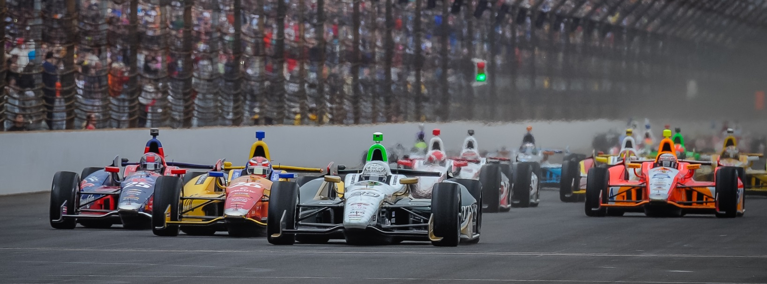

For Immediate Release Contact: Tom Blattler

317-525-5692

**ED CARPENTER RACING ANNOUNCES JR HILDEBRAND**

**AS TEAM’S 2ND DRIVER FOR 98TH INDIANAPOLIS 500**

**Popular American to pilot ECR’s No. 21 Entry in Classic Race**

**INDIANAPOLIS, Ind.  (March 20, 2014)** – Ed Carpenter Racing today announced that American racer J.R. Hildebrand will be the driver of the team’s second entry in the 98th running of the Indianapolis 500 Mile Race set for May 25 at the famed Indianapolis Motor Speedway.

Hildebrand, runner-up in the 2011 Indy 500 as a rookie, will drive the No. 21 Ed Carpenter Racing Chevrolet-powered Dallara car in the “Greatest Spectacle in Racing.” Corporate partnership support for Hildebrand’s entry will be announced in the near future.

ECR team owner and driver Ed Carpenter will make his 2014 Verizon IndyCar Series debut for his team in the Indy 500. The 2013 Indy 500 pole winner will pilot the popular No. 20 Fuzzy’s Ultra Premium Vodka Chevrolet in the 200-lap racing classic.

The Carpenter-Hildebrand combination currently will be the only All-American team entered in this year’s Indy 500.

The two-car ECR effort in the Indy 500 will be led by general manager Tim Broyles, team crew chief Bret Schmitt and lead engineer Matt Barnes. In addition to the two ECR Indy 500 cars, Ed Carpenter Racing has entered defending Detroit race winner Mike Conway in the inaugural Grand Prix of Indianapolis set for May 10 at the revised 2.434-mile, 14-turn IMS road circuit.

“We, at Ed Carpenter Racing, are very pleased to bring J.R. Hildebrand into our Indy 500 effort this year,” said Carpenter, a 10-time Indy 500 starter. “J.R. has been the Indy 500 Rookie of the Year and an Indy Lights champion, so his credentials are very impressive. It is great to have another American driver in the 500 this year and competing with ECR. We believe a second car at Indy will assist us in preparing for a strong performance in this year’s Indy 500.”

Hildebrand, 26, won the Indy 500 Rookie of the Year honors in 2011 when he placed second to Dan Wheldon and the California native captured the 2009 Indy Lights championship. Prior to the Indy Lights title, Hildebrand won the 2006 U.S. F2000 crown and the 2004 SCCA Formula Russell points.

Hildebrand, originally from Sausalito, Calif., and now living in Boulder, Colo., is a three-time starter at the Indianapolis 500.

“I’m extremely excited to join Ed Carpenter Racing for this year’s Indianapolis 500,” said Hildebrand. “Ed’s team has been very strong on the ovals the past two years including winning at Fontana and taking the pole position at last year’s 500. Working with Ed and his staff at Indy gives me a lot of confidence going into the world’s biggest race. I can’t wait to jump into the No. 21 Chevy and get back to the Speedway.”

Practice for the 98th Indy 500 will begin Sunday, May 11, with qualification runs scheduled for May 17-18. The Indy 500 is set to start at noon on May 25.

# # #

**About Ed Carpenter Racing**

Owned by IndyCar Series driver Ed Carpenter, Ed Carpenter Racing was formed in 2011 in association with  primary sponsor, Fuzzy’s Ultra Premium Vodka, and legendary golfer Fuzzy Zoeller. Ed Carpenter Racing has comprised a stellar lineup of associates led by Tim Broyles as general manager, Bret Schmitt as crew chief and Matt Barnes as lead engineer. Their experience in open-wheel racing gives Ed Carpenter Racing strong leadership along with a solid contingent of crew members. Carpenter and the ECR/Fuzzy’s team won the 2012 season finale at Fontana, Calif., the MAVTV500, as well as the pole position at the 2013 Indianapolis 500. The No. 20 Fuzzy’s Ultra Premium Vodka entry is powered by the twin-turbo V-6 Chevrolet IndyCar engine in 2014. Road racing specialist Mike Conway will drive the No. 20 at the road/street races in 2014 while Carpenter will handle the car in the six oval events including the Indy 500.  J.R. Hildebrand will drive the No. 21 ECR Chevrolet in the 9th Indy 500. Ed Carpenter’s racing history, dating back to age eight, includes victories in the IZOD IndyCar Series, Firestone Indy Lights and USAC National Sprint Car and Midget competition. For more information, please visit [www.EdCarpenterRacing.com](https://mail.walkerracing.com/owa/redir.aspx?C=61rSHwiqUEuIdfcyu0pwI36UO9BWL9BIJJJgu31vUf3SmhMccV3qlzpBoAP-HQdzxg6lWH4mulY.&URL=http%3a%2f%2fwww.EdCarpenterRacing.com).