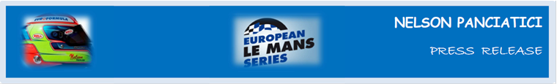
TEST DAY – LE MANS 24 HOURS 2014 (May 31 & June 1)
A PROMISING PERFORMANCE FROM ALPINE AND NELSON PANCIATICI!
As his co-drivers are newcomers to Le Mans, they had to do their mandatory qualifying laps and learn the subtleties of the Circuit de le Sarthe. So it was only at the end of the day that Nelson Panciatici got behind the wheel of the Alpine A450b. Despite a puncture from debris and several red flags, Nelson set the third-best time in the LM P2 class.
In spite of a few small problems, the Signatech-Alpine team, managed by Philippe Sinault, was able to complete the test programme planned and show that the Alpine A450b can keep pace with the front-runners. Next week will be even busier in the run-up to the race and while Nelson Panciatici is happy with the results of the test day, he is also cautious:
“Our test day went well, we did some good work for the race and stayed in the top rankings. We were able to test the whole range of Dunlop tyres and I got my marks again here at Le Mans. I lost a bit of time when I punctured after running over a piece of debris but I think it went quite well on the whole. Our objective was not to aim for performance but we clocked the third-best time which shows promise for the coming race! Paul Loup Chatin and Oliver Webb, my co-drivers, rose to the occasion and overall our results look good. We need to keep our cool for this really difficult race. Today was a nice confidence booster ahead of race week, I really can’t wait to be there!”
Philippe Sinault is also happy: “More than anything else, I am pleased to say we were able to work through our entire programme which was very busy. Paul-Loup and Oliver completed their 10 mandatory rookie laps and we are able to evaluate the different Dunlop tyres we are using. Despite suffering a puncture, we were on the pace and up with the fastest cars this morning. Then, this afternoon, we posted the third-best time. The coming week promises to be very busy as we finish our preparations for the race.”
The Signatech-Alpine team will now study the information they gathered during the tests and continue to prepare for the coming 24 Hours of Le Mans which takes place on June 14 and 15. A podium would be a nice reward!

For more information on Nelson PANCIATICI, please visit www.nelsonpancia.fr
Join Nelson's Fan Club on Facebook!

