

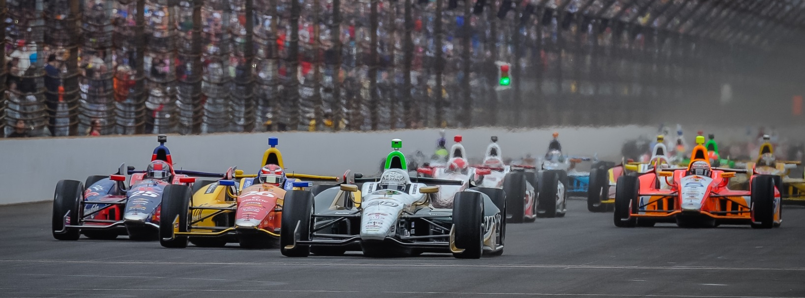

For Immediate Release Contact: Tom Blattler

317-525-5692

**CARPENTER POSTS 5TH FASTEST SPEED FRIDAY IN TEXAS QUALIFYING FOR SATURDAY NIGHT’S FIRESTONE 600K**

**Indy 500 Pole Winner ties his best Texas Motor Speedway Qualifying**

**FORT WORTH, Texas (June 6, 2014)** – The tough high-banked 1.5-mile oval at Texas Motor Speedway has proven to be a handful for the Verizon IndyCar Series drivers in recent years and Friday’s qualifying round for the Firestone 600K was no different.

Two-time defending Indy 500 pole winner Ed Carpenter tied for his best qualifying at TMS Friday but he still disappointed with his two-lap run in the No. 20 Fuzzy’s Ultra Premium Vodka Chevrolet. Carpenter qualified fifth Friday afternoon in the 90 plus-degree heat.

Carpenter was pleased with his car in the morning practice session as the team worked primarily on the race settings for Saturday night’s 600K main event set for 7:30 p.m. CDT. The race will be televised on the NBC Sports Network.

Unfortunately, in the morning, Carpenter was able to make just one qualifying simulation lap due to traffic on the fast track north of Fort Worth.

The heat and humidity had definitely jumped when the cars hit the oval for the afternoon qualifying event.

Carpenter posted a strong 218.326 mile per hour lap for an opener but the second clocking fell off to a 217.031 for a two-lap average of 217.677 m.p.h. Will Power captured the Verizon P1 pole position with a 218.896 followed by Josef Newgarden, Tony Kanaan, Juan Pablo Montoya and Carpenter.

Ed’s previous best qualifying run at Texas was fifth in the 2011 doubleheader.

“I am disappointed with the car in qualifying,” said Carpenter, who placed fourth last year at Texas. “It felt good in practice this morning. And the first lap is good (218.326), but the car really fell off the second lap (217.031). There was just no grip. I’m not sure this aero (dynamic) package is right for us. Texas Motor Speedway is the toughest oval track we run now. It’s tougher than Indy, Fontana and others. We haven’t had pack racing since 2005 or ‘06 here. It’s been single file here since 2007 but everyone still thinks we race in packs here.  That’s just not the case. We’ll have to see how the race plays out now.”