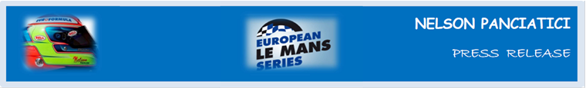

**TEST DAY – LE MANS 24 HOURS 2013 (June 8 & 9)**

**NELSON PANCIATICI BACK AT LE MANS IN THE ALPINE A450 N°36**

They finished second in the 3 Hours of Imola of the European Le Mans Series, and Nelson Panciatici and his Signatech-Alpine team now stand second overall in the provisional ranking. He will now take part in the Test Day for Le Mans 24 Hours this weekend, and the whole team managed by Philippe Sinault has prepared well, notably with their night trials on the Magny-Cours circuit.

For Nelson Panciatici, driving on the track of the 24 Hours of Le Mans will no longer be new. In his first performance last year he finished fourth and was awarded the Prix Jean Rondeau for Best Rookie. He is looking forward to the day:

“The 24 Hours of Le Mans is a unique track with particularities that don’t exist anywhere else, which makes this Test Day all the more important. We need to find our marks again and brush up as quickly as possible to then focus on the tuning of the car with the new aerodynamic kit. We’ve got a very busy programme, notably with the endurance tests on the Michelin tyres and, of course, fuel consumption. The day will allow us to gather important information for the race and even though there won’t be much rubber on the track yet, it will a perfect warm-up. I feel comfortable with the Signatech-Alpine team and I get on really well with my co-drivers, Pierre Ragues and Tristan Gommendy, I will also benefit from their experience at Le Mans. We have a good, fast and reliable car, I was on the Ellip6 simulator, watched videos and worked on the data we’ve collected that Olivier Bacchis, my engineer, gave me. I also followed a specific fitness regime to get ready for this! It’s a magical challenge and I can’t wait to get started!”

The Signatech-Alpine team is totally focused on the Test Day and Nelson Panciatici, with the solid backing of his co-drivers, intends to garner as much information as possible for the coming Le Mans 24 Hours, which takes place on June 22 and 23. For all drivers a victory represents an important notch in ones’ career, but they must concentrate on the trials before they get to that!

For more information on Nelson PANCIATICI, please visit[**www.nelsonpancia.fr**](http://www.nelsonpancia.fr)

[**facebook Join Nelson's Fan Club on Facebook!**](http://www.facebook.com/pages/Nelson-Panciatici/90065452450)