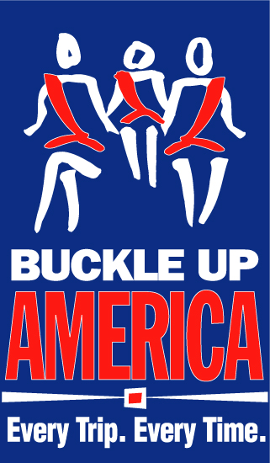
Buckle Up America. Every Trip. Every Time.
2013 Thanksgiving Planner
Sample News Release

FOR IMMEDIATE RELEASE: Date
CONTACT: Name, Phone Number, E-mail address

Note: Before filling in the names of the organization and organization spokesperson, you MUST contact them to obtain their permission to use their names in this press release, and you must get their approval for the language used in their quotes, and any changes or additions they may require. Only after this is done may you send out the press release.

[Organization] Reminds Thanksgiving Travelers
To Buckle Up-- Every Trip, Every Time.

[City, State] – With Thanksgiving right around the corner, people will soon flock to the roads to visit and celebrate with family and friends. [Organization] reminds all travelers, whether they are heading across the country or just across town, to ensure a safe arrival and a happy holiday by buckling up - Every, Trip Every Time.

“The risk of being involved in a serious or deadly car crash increases when the number of cars on the road increases, and the long Thanksgiving weekend is one of the busiest travel times of the year,” said [Local Official]. “So we want to remind everyone that your seat belts can save your life – and those you are traveling with.”

According to the U.S. Department of Transportation’s National Highway Traffic Safety Administration (NHTSA), seat belts saved almost 12,000 lives nationwide in 2011. Research shows that with proper seat belt use, the risk of fatal injury to front seat passengers is reduced by 45 percent, and the risk of moderate to serious injury is reduced by 50 percent.

Such a simple step can save a life, but too many lives are being lost because some have still not gotten the message. During the 2011 Thanksgiving period, 249 passenger vehicle occupants were killed in motor vehicle traffic crashes nationwide. Fifty percent of those killed were not wearing seat belts.

In 2011, 52 percent of the 21,253 passenger vehicle occupants killed in motor vehicle crashes were NOT wearing seat belts at the time of the crash.

Nationally in 2011, 62 percent of the 10,135 passenger vehicle occupants who were killed in nighttime crashes were not wearing their seat belts, compared to 43 percent during the daytime hours.

“All too often, we see crash victims who were caught up in the excitement of the Thanksgiving holiday and didn’t arrive safely at their destination,” said [Local Official]. “We want to remind everyone who will be on the roads to please buckle up - Every Trip, Every Time - so you can give thanks this holiday season and enjoy the time with your loved ones.”

For more information about traveling safely during Thanksgiving, please visit www.trafficsafetymarketing.gov.

###

