xxxxx 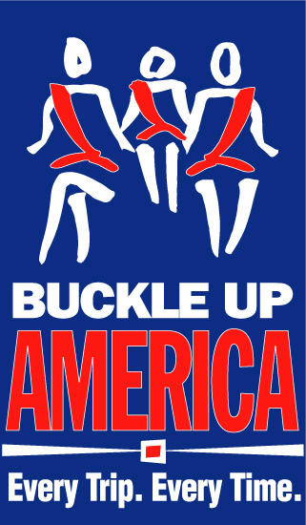
Buckle Up America. Every Trip. Every Time.
2013 Thanksgiving Planner
Sample OpEd

This Thanksgiving, Be Thankful for Your Seat Belt
Buckle Up America -- Every Trip, Every Time.
By (Local Leader)

Thanksgiving is one of the great American holidays that involves a lot of travel. Family and friends from across the country or just across town take to the roads to visit together and celebrate, making it one of the busiest travel times of the year.

But the excitement and hustle and bustle of the holiday can be major distractions for those on the road, and all too often those distractions have deadly consequences.

That’s why it’s important to do the single most effective thing to save your life in the event of a traffic crash: wear a seat belt.

This Thanksgiving, [Local Organization], highway safety advocates, and law enforcement officers across the country are spreading the message and reminding travelers to always wear their seat belts with the Buckle Up America - Every Trip, Every Time campaign.

According to the U.S. Department of Transportation’s National Highway Traffic Safety Administration (NHTSA), seat belts saved almost 12,000 lives nationwide in 2011. In fact, research shows that with proper seat belt use, the risk of fatal injury to front seat passengers is reduced by 45 percent, and the risk of moderate to serious injury is reduced by 50 percent.

Since such a simple step can be the difference between life and death, one would think everyone would always wear their seat belts while in a car. Yet that is not the case. Too many people still don’t use these lifesavers, and unfortunately, deaths which could have been prevented keep occurring every day.

In 2011, 52 percent of the people killed in all traffic crashes were NOT wearing seat belts at the time of the crash. During the 2011 Thanksgiving holiday weekend alone, 50 percent of those killed were unbelted at the time of the crash.

Nighttime is an especially dangerous time for deadly traffic crashes. Nationally in 2011, 62 percent of the 10,135 passenger vehicle occupants who were killed in nighttime crashes were not wearing their seat belts, compared to 43 percent during the daytime hours. During the 2011 Thanksgiving holiday, 57 percent of the passenger vehicle occupants killed in nighttime crashes were unbelted, while only 40 percent of daytime fatalities were unbelted.

These deaths are unnecessary and preventable. Be careful on the roads and don’t let this Thanksgiving end in tragedy. Insist on proper seat belt use by everyone you travel with.

Remember: Buckle Up America - Every Trip, Every Time. You’ll be thankful you did.

###

