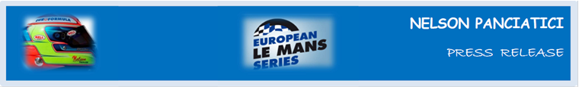

**LE MANS 24 HOURS 2013 (June 22 & 23)**

**ALPINE A450 AND NELSON PANCIATICI IN THE STARTING BLOCKS!**

The Signatech-Nissan team successfully ran through all their tests on Test Day and demonstrated just how competitive the Alpine A450 is without driving for the sake of pure performance. With these positive results, Nelson Panciatici feels ready to take on Le Mans 24 Hours!

Nelson Panciatici, who reached the foot of the podium last year even though a flat tyre three hours from the finish knocked him out of second place in the LMP2 class, knows he has a trump card to play even though competition looks fierce:

*“The battle in LMP2 is going to be intense*,” Nelson Panciatici tells us. *“I am confident, we have been competitive and reliable since the start of the year and our Michelin tyres work perfectly on the Alpine A450. But Le Mans 24 Hours is a different kind of race and we have to stay grounded, a podium win would be a nice reward for everyone and we will seize any opportunity to win! I worked hard on my fitness regime because it will be difficult to stay on top form for 24 hours.*

*“Test Day reminded me how intense the traffic can be and how hard it is to get a clear lap, I didn’t complete a single lap without some hold-up, it is part Le Mans’ magic and we have to adapt to it.*

*“Our tests were good which leads us to believe we will perform well and our strategic choices could make all the difference. I am calm because with my co-drivers, Pierre Ragues and Tristan Gommendy, we have all we need to aim for a “performance” in the LMP2 class, even though I know it won’t be easy and competition will be tough. I don’t have a lot of experience in Le Mans 24 Hours, this is only the second time I take part, but I have great support from the whole Signatech-Alpine team, and even though I know we have to be vigilant, I still feel we can do it!”*

The LMP2 battle is going to be a serious challenge as more than 20 cars have signed up in this class and the show will be as intense as that in LMP1! The Signatech-Alpine team want to fight for lead positions and Nelson Panciatici will do his best to get there!

For more information on Nelson PANCIATICI, please visit[**www.nelsonpancia.fr**](http://www.nelsonpancia.fr)

[**facebook Join Nelson's Fan Club on Facebook!**](http://www.facebook.com/pages/Nelson-Panciatici/90065452450)