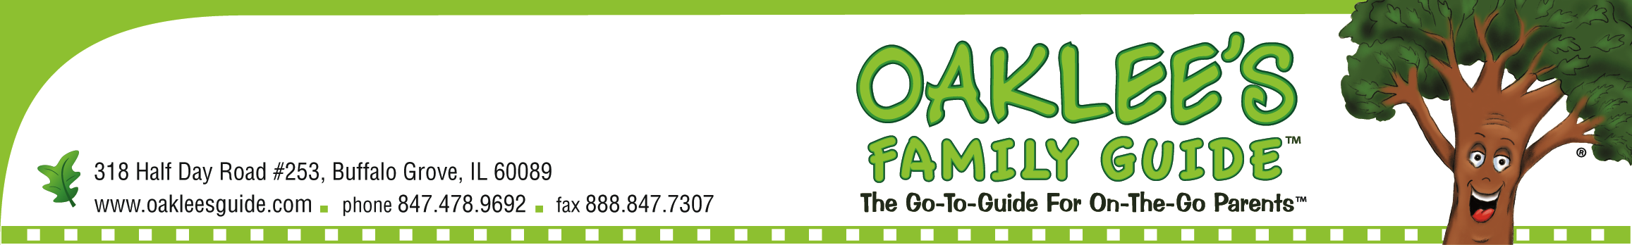

FOR IMMEDIATE RELEASE
Contact: Marie Ramos
Tel: 847-478-9692
Email: marie@oakleesguide.com

Oaklee’s Family Day at the 2013 Chicago Auto Show

Buffalo Grove, IL – February 1, 2013--- Families planning to attend the Chicago Auto Show this year have a good reason to come to the show on Presidents Day, Monday, February 18th. For the first time, the show is planning a Family Day with a schedule full of activities all-day long from Oaklee’s Family Guide, the official family guide of the 2013 Chicago Auto Show. The Family Day has a full line-up of interactive events and activities. Below is the current schedule.

Monday, February 18
10am: Get your wristband so to meet Disney star Leo Howard from the hit show ‘Kickin’ It’
11am: Language Stars Main Stage Performance
12:00pm Radio Disney Road Crew
1:00pm Meet Leo Howard
3:15pm Rock out to local kids that rock with Precision Band
4:00pm Meet the new reigning Ms. Teen IL USA Grayson Hodgkiss
5:00pm Bring your flock to the Lucky Duck Story Time
6:00pm Kick up your heels to rockabilly sensations The Old Town Underdogs
There will be festivities along the way including:
- Mini-classes from Language Stars
- Interactive theater experiences with Compass Creative Dramatics
- Learn how to toss the ball with the Wood Family Foundation
- Win prizes all day long!
- Catch a break at our mini-movie experience
- Get the latest edition of Oaklee’s Family Guide
- Take your picture with Navy Pier
- Get in a little putting with The Putting Edge

“Oaklee’s Family Guide is thrilled to be a part of the Chicago Auto Show! We have put together a fantastic line of fun for the day and we can’t wait to share the fun with our families and fans!” says
Nancy Stevens, the founder and owner of Oaklee’s Family Guide.

Oaklee's Family Guide™ is The Go-To-Guide for On-The-Go Parents™ in the Chicagoland area. We do the legwork to find the what, when and where of family events, places and services, including great money-saving coupons. We put it all together in an easy-to-use publication and website so busy parents can spend more time having fun with their families. Find a copy at your local library or park district, or visit us online at www.oakleesguide.com.

# # #
If you'd like more information about this topic, or to schedule an interview with Nancy Stevens, please call Marie Ramos at 847-478-9692 or e-mail Marie at marie@oakleesguide.com.

