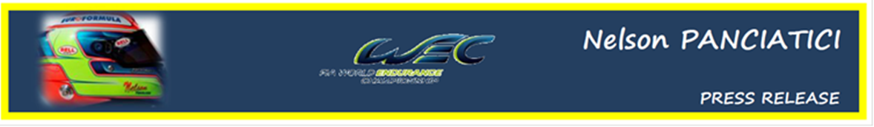
FIA WORLD ENDURANCE CHAMPIONSHIP – ROUND 5:
6 HOURS OF SAO PAULO (14 and 15 September 2012)

A FIRST FOR NELSON PANCIATICI
Nelson Panciatici will take part in the 6 Hours of Sao Paulo challenge for the first time, on the Jose Carlos Pace circuit in Interlagos, Brazil, with his G-DRIVE RACING BY SIGNATECH NISSAN team.
Boosted by the great podium he achieved at Silverstone with the help of his co-drivers, Pierre Ragues and Roman Rusinov, Nelson Panciatici enters the fifth challenge of the FIA WORLD ENDURANCE CHAMPIONSHIP with confidence and equanimity:
Nelson Panciatici: "I had great fun at Silverstone, our podium rewards the huge effort of the whole team. I will be new to the Interlagos circuit which is known to be difficult, but our practice plan should get us ready for the day. We also had a good session on the simulator which gave us the opportunity to get our bearings. I'm feeling confident! With Damien, my engineer, we have also gone over quite a few technical solutions to optimise the tuning of our ORECA 03 NISSAN. We know that the competition will be tough but we are ready to fight for victory, or at least a podium, we will do what it takes anyway!"
Philippe Sinault, the manager of the G-DRIVE RACING BY SIGNATECH NISSAN team, is certain his team and drivers are in a positive phase which should allow them to repeat their great performance at Silverstone:
Philippe Sinault: "The podium at Silverstone was a proper reward for the team as it was for the drivers. We needed that oxygen boost to finish the season and aim for the final podium. We are recharged to the max and ready for the last part of the championship. Interlagos is a difficult track that our drivers do not know and it's extremely physical. We will need to work hard in the practice and spend time on our strategy but I'm feeling confident."
As usual, the LMP2 is likely to be the most lively category with fractional time differences at the finish. The G-DRIVE RACING BY SIGNATECH NISSAN team and their drivers would not want to miss it!

For more information on Nelson PANCIATICI, please visit www.nelsonpancia.fr
Join Nelson's Fan Club on Facebook!

