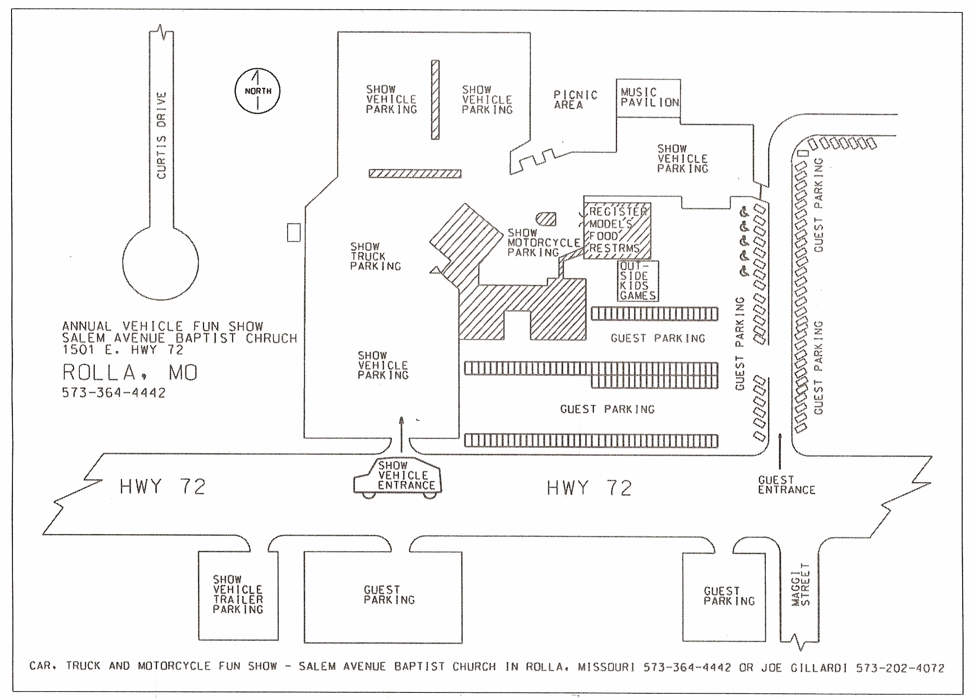
CAR, TRUCK & MOTORCYCLE FUN SHOW SALEM AVENUE BAPTIST CHURCH
IN ROLLA, MO 573-364-4442 OR JOE GILLARDI 573-202-4072
KIDS GAMES

