November 10, 2015

Press Release

NMDOT Advises of Potential
Traffic Delays
Movement of Second Heavy Load Transfer Scheduled To Begin November 12

Santa Fe - The New Mexico Department of Transportation announced today that travelers should expect delays in northwest New Mexico toward the end of the week of November ninth due to trucks hauling extremely heavy loads to Utah. The loads – which are the heaviest to ever be transported on New Mexico roadways – are transformers that will arrive in Thoreau, New Mexico by train and will then be loaded onto the trucks.

The first heavy equipment transformer weighing more than 1.7 million pounds completed its route through New Mexico on October 30. The movement of the second transformer is scheduled to travel this week, weighing more than 1.6 million pounds. This load will be 411 feet long, 22 feet wide and 19 feet tall, with one truck pulling and five trucks pushing each load, just as the previous load.

Motorists are urged to plan ahead of time to avoid delays. The route for the second load is as follows:

- Thursday, 11/12/15 (9 a.m.) - Depart Thoreau, NM and travel north on NM 371 to Navajo Route 9, near Crownpoint at approximately 10 mph. Expected travel time is 4-5 hours.

- Friday, 11/13/15 (9 a.m.) - Depart and travel west on Navajo Route 9 to US 491 just north of Twin Lakes.

- Saturday, 11/14/15 (9 a.m.) - Depart and travel north on US 491 to US 64, south of Shiprock. Expected travel time is seven hours.

- Sunday, 11/15/15 (9 a.m.) - Depart and travel west on US 64 to the Arizona/NM Border. Expected travel time is 3-4 hours.

NMDOT has been assured that the transportation won’t affect emergency vehicles. The New Mexico State Police Commercial Vehicle Enforcement Bureau will escort the caravan along all NM and US routes.

Once the transport is complete, the NMDOT will perform maintenance patrols along the NM and US routes to inspect for any impacts and/or damage to the roadway. If any are discovered, repairs will be made accordingly.
###

Melissa Dosher, NMDOT Public Information Officer, 827-5526 (office), 469-5698 (cell) melissa.dosher@state.nm.us ; Rosanne Rodriguez, NMDOT District Five Public Information Officer, (505) 205-4992 Rosanne.Rodriguez@state.nm.us; Delane D. Baros, NMDOT District Six Public Information Officer (505) 240-1392. Delane.Baros@state.nm.us

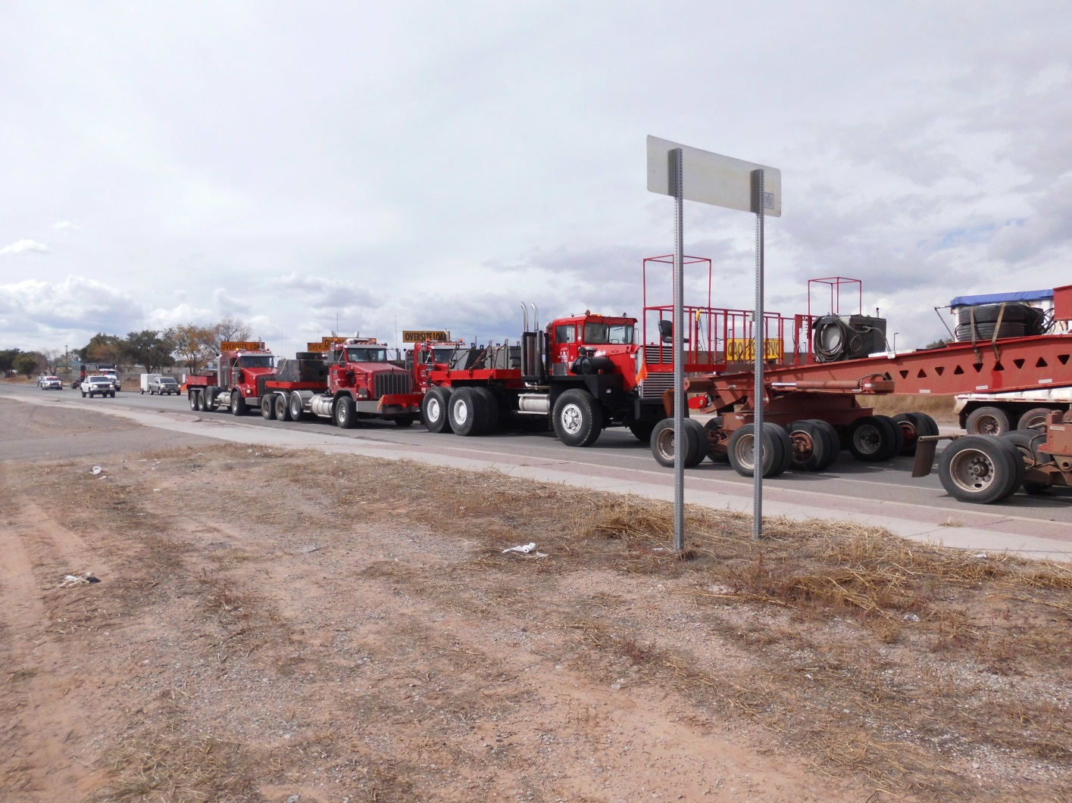

Transformer being hauled through New Mexico week of October 26, 2015

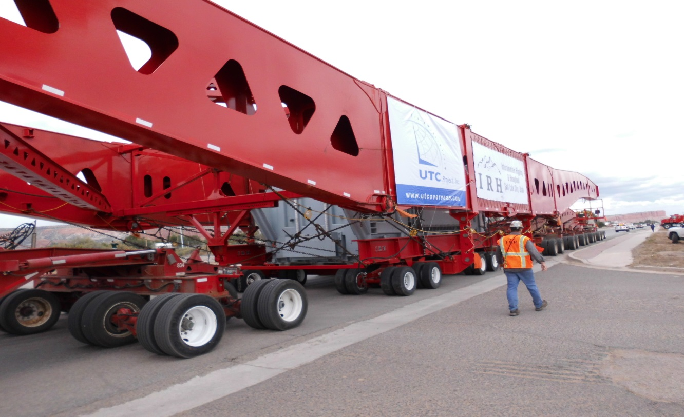

Notice the size of people in relation to transport trailer. This gives a perspective of how large the first load was.

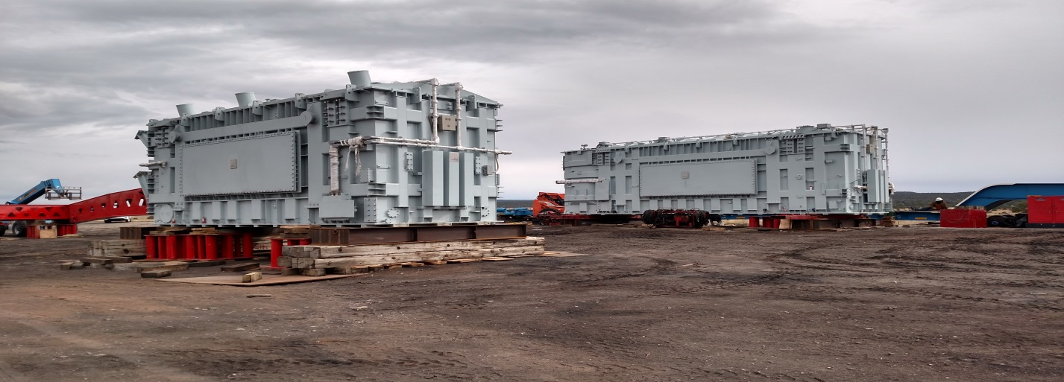

Transformers like the ones that will be transported across northwest New Mexico.

