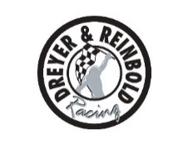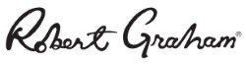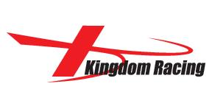
For Immediate Release Contact: Tom Blattler
317-525-5692

TOWNSEND BELL, DREYER & REINBOLD – KINGDOM RACING COMPLETE
CARB DAY AND PIT STOP CHALLENGE FRIDAY AT IMS

The Robert Graham Special Post 224 MPH Lap in Practice

SPEEDWAY, Ind. (May 22, 2015) – It was a busy day for driver Townsend Bell and the Dreyer & Reinbold – Kingdom Racing team during “Carb Day” activities at the Indianapolis Motor Speedway Friday in preparations for the 99th Indianapolis 500.

Bell, who will start 23rd in Sunday’s “Greatest Spectacle of Racing,” recorded 34 laps in Friday’s one-hour practice session, the final runs before Sunday’s 200-lap classic at the legendary 2.5-mile oval. The 40-year-old veteran driver from Pacific Palisades, Calif., clocked a best of 224.508 miles per hour in the No. 24 Robert Graham Special Chevrolet.

In fact, Bell’s speed was the best of the day for a “none tow” lap without an assist of a draft from another car.

Following the morning practice, Bell and his Dreyer & Reinbold – Kingdom Racing crew competed in the highly-entertaining Tag Heuer Pit Stop Challenge with the “over the wall” members of Jeff Simon (right front tire), Brian Goslee (left front tire), Chase Selman (right rear tire), Cody Selman (left rear tire), David Taylor (fueler) and Ron Smith (air jack) putting a strong effort.

The competition for the pit crews marked the initial appearance for Bell as a driver in the head-to-head pit stop event. And Townsend was impressive in the first round of action.

In fact, the Dreyer & Reinbold – Kingdom Racing team recorded the quickest time of the entire event with a 12.144-second stop in defeating James Jakes. The team then took on defending Verizon IndyCar Series champion Will Power and his crew in round two.

Bell and his team look quick early against Power’s squad but the Australian driver’s crew just nipped Bell’s contingent, 12.75 seconds to 13.33.

To round out the day for Bell, he served as a host in the NBC Sports Network telecast of the “Carb Day” events.

“It was a busy day for me but it was exciting too,” said Bell, who’ll race in the 24 Hours of LeMans next month. “Our race car felt pretty good in race trim today. We’ll make a couple of adjustments to improve the car for Sunday’s race. We have been very quick on our pit stops all month and I feel confident about our chances in the race. In the pit stop challenge, I thought we had an excellent chance to advance to the final today. But we didn’t get the solid stop we wanted against Will’s team. We’ll improve on that aspect too and have strong stops in the race. Overall, we have had a good month here at Indy and we have to be patient and pick our spots in traffic to have a good performance.”

Saturday at the Indianapolis Motor Speedway will include a driver autograph session at 9 a.m. with the Public Drivers’ Meeting at 10:30 a.m. The entire 33-driver field will participate in the noon IPL 500 Festival parade in downtown Indianapolis. The start of the 99th Indy 500 is scheduled for 12:15 p.m. EDT this Sunday, May 24.

