

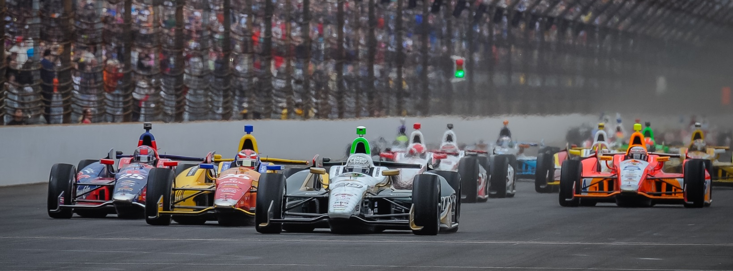

For Immediate Release Contact: Tom Blattler

317-525-5692

**CONWAY QUALIFIES 17TH SATURDAY AT SONOMA RACEWAY,**

**TOUGH ROAD CIRCUIT ALWAYS POSES PROBLEMS FOR TEAMS**

**Two-time 2014 Winner Seeks Comeback Run Sunday**

**SONOMA, Calif. (August 23, 2014)** – Mike Conway knew Sonoma Raceway’s 2.385-mile, 12-turn would pose problems for the drivers in qualifying Saturday.

The very challenging permanent road course changes steadily throughout the day and the weather conditions make the racing surface tricky. That scenario proved to be the case Saturday for Conway and his Ed Carpenter Racing/Fuzzy’s Ultra Premium Vodka Chevy crew.

Conway looked quick in the initial laps of time trials in the No. 20 Fuzzy’s Vodka Chevy. He jumped to the top spot in his first lap in the round one and then held a transfer position with just one minute remaining in the 10-minute session.

Unfortunately, Conway’s car didn’t hold the grip with the red Firestone tires in his last lap and he failed to make the transfer to round two at Sonoma Raceway. Mike will start 17th in the Sunday’s 85-lap main event.

Will Power, the current Verizon IndyCar Series point leader, won the pole Saturday. Young Josef Newgarden will share the front row with Power in Sunday’s feature which starts at 1:40 p.m. PDT.

The 17th round in the 18-race IndyCar Series tour will be televised live Sunday on the NBC Sports Network starting at 1 p.m. PDT (4 p.m. EDT). The race also will be broadcast on the IndyCar Radio Network through its affiliates as well as Sirius 213, XM 209 and indycar.com.

“The Fuzzy’s car felt much better on the alternate (red) tires in qualifying,” said Conway, the 2014 Long Beach and Toronto winner. “But we struggled to get through to the next round. We missed out a little on the last lap as the checkered flag came out in front of us. I thought I might have been able to go quicker.  But it’s hard to say because the tires do drop off after the first few laps. The track was the same as practice this afternoon.  We just didn’t get enough out of the car to move to round two.”

# # #