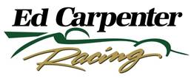

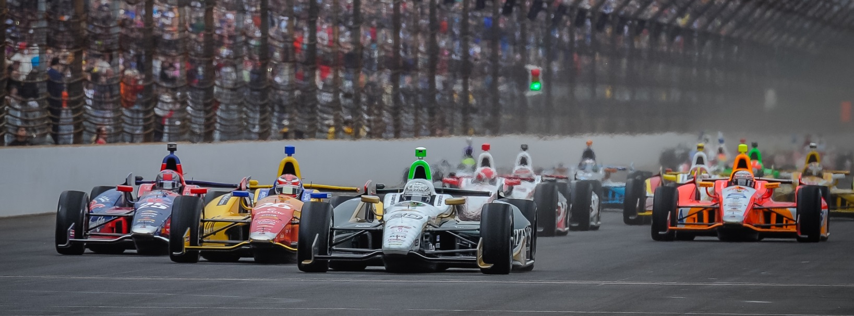

For Immediate Release Contact: Tom Blattler

317-525-5692

**MID-OHIO TRACK CHANGES FOR CONWAY, ECR FUZZY’S TEAM**

**FRIDAY IN OPENING PRACTICE ROUND AFTER TESTING RUN**

**Toronto Winner a little frustrated with handling after strong test**

**LEXINGTON, Ohio (Aug. 1, 2014)** – Toronto race 2 winner Mike Conway stood in the pit area Friday at the Mid-Ohio Sports Car Course and just shook his head. The driver of the No. 20 Fuzzy’s Ultra Premium Vodka Chevrolet couldn’t believe the changes in the 2.25-mile road course surface.

“We thought we would be set to run strong on Friday here,” said Conway, the 2014 two-time race winner. “We had a good test here last week and it is just strange that the track surface could change that much. Maybe it’s the rubber of the other series that affect the track for us.”

Conway was pleased with his machine after last Thursday practice runs which saw 21 drivers participate in the eight-hour testing session. But what a difference a week can make.

“To be honest, I find it very strange how much the track surface has changed,” admitted Conway. “We went right out on the track this morning and there just wasn’t any grip. We were sliding around and the car just wouldn’t turn. Later in the afternoon session, we found a better direction with the car. But back in the field right now isn’t where we want to be on the grid.”

Conway’s best time was set in the 45-minute afternoon practice round with a speed of 120.146 miles per hour. He recorded a 119.928 m.p.h. in the morning runs.

“It’s always a little strange here at Mid-Ohio,” he said. “I’m not sure if it is the rubber from the different support series that causes it. And it’s not that hot too.”

Ryan Hunter-Reay was the fastest of the day with a 122.180 m.p.h. lap.

Practice continues Saturday at Mid-Ohio beginning at 10 a.m. EDT with qualifying set for 2 p.m.

Sunday’s 90-lap Verizon IndyCar Series main event is scheduled to get underway at 3:45 p.m. EDT. The race will be telecast on NBC Sports Network starting at 3 p.m. while the IndyCar Radio Network will broadcast the 15th race of the 2014 campaign on its network as well as Sirius 213 and XM 209.