 

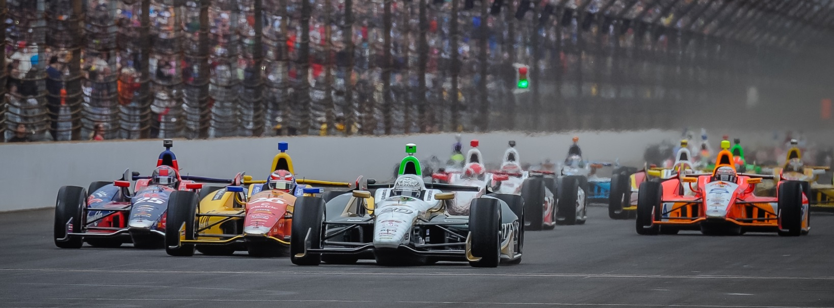

For Immediate Release Contact: Tom Blattler

317-525-5692

**JR HILDEBRAND PLACES IN THE TOP TEN SUNDAY IN INDY 500,**

**AS PREFERRED FREEZER CHEVY DRIVER RUNS WITH LEADERS**

**California Native Shows Tremendous Speed before a Tire Issue**

**INDIANAPOLIS (May 25, 2014)** – J.R. Hildebrand’s charge to the front of the field Sunday in the 98th running of the Indianapolis 500-Mile Race had the fans on their feet.

The popular 2011 Indy 500 Rookie of the Year started ninth in the No. 21 Preferred Freezer Services Chevrolet and moved up quickly to third place by lap 43 in the 200-lap “Greatest Spectacle in Racing.” Despite saving fuel in the second stint Sunday, Hildebrand continued to run solidly in the top five to the halfway point in the race.

Unfortunately, a tire issue forced Hildebrand to pit earlier than the rest of the contenders Sunday and that stop pushed J.R. all the way back to 11th and later to 22nd in the 33-car field. But the former Indy Lights champion made a spectacular run through the field to race as high sixth by lap 141.

At the checkered flag, Hildebrand finished tenth in his initial outing with the Ed Carpenter Racing team but he felt his Chevy-powered car was much faster during the race.

“Any day that you are not sitting in victory lane and drinking the milk, it’s a disappointment,” said Hildebrand after the race. “For us, the Preferred Freezer Service Chevy team, it’s frustrating because we had a really good car. We had an issue with a tire that got us out of the pit sequence. The car got bad with the tire issue. I had to pit or I was going to crash. But the car was fast. We passed a ton of guys today including in the end. It was nice earlier when we jumped from ninth to third and I was running with Ed.”

Hildebrand is hoping to run more events in the future with ECR after his strong run today.

-more-

-2-

Hildebrand’s teammate, ECR team owner Ed Carpenter, led 26 laps Sunday from his pole position before being taken out on lap 175 due to a turn one incident with James Hinchcliffe. Ryan Hunter-Reay scored his first Indy 500 victory.

“I’m happy for Ryan (Hunter-Reay) and it’s a bummer for Ed,” said Hildebrand. “We had really good cars today. It was fun to drive the ECR car.  In those first few stints, the car was just a pleasure to drive. I’m happy the car is in one piece and I think we showed we had some speed today. We had the pace of the leaders and I ran with all of those lead guys at one time today.  As the track got hotter, the other guys were sliding around so much. So I felt without that early pit stop, we would have been right there too. We got caught out a little by the late yellow flag. I had to come back and pass a lot of cars.

“To run up front, you need a great equipment and level head on your shoulders. Frankly, I’m disappointed with tenth. We had a stronger car. It was fun to race with the ECR guys. I would love to get into a full-time deal with this team. This team is very good.”

The ECR team will be back in action next week in the streets of Belle Isle when the Verizon IndyCar Series returns to the Motor City for the “Duals in Detroit.” ECR driver Mike Conway is the defending winner and will drive the No. 20 Fuzzy’s Ultra Premium Vodka Chevrolet.

# # #

