  

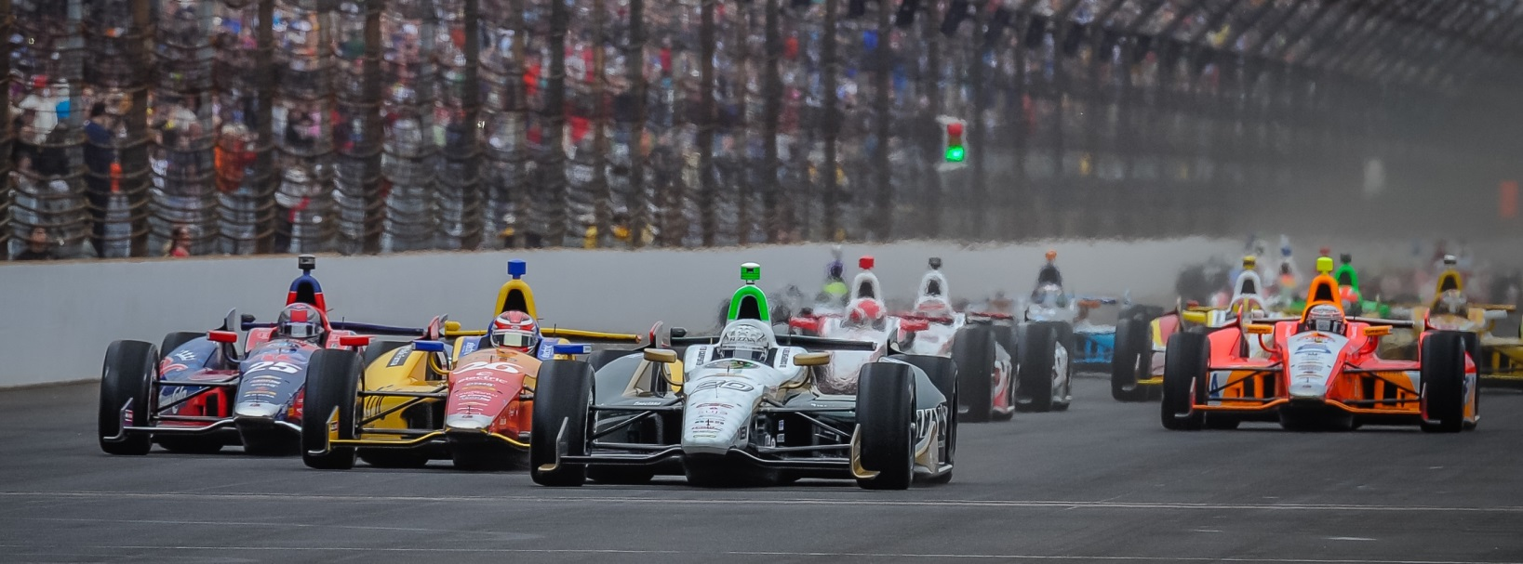

For Immediate Release Contact: Tom Blattler

317-525-5692

**ED CARPENTER RACING ADDS POPULAR “THE RATHSKELLER”**

**AS ASSOCIATE SPONSOR ON #20 FUZZY’S VODKA CHEVROLET**

**The Rathskeller is reminiscent of a quaint inn and a lively beer hall in Munich**

**INDIANAPOLIS (May 17, 2014) --** Ed Carpenter Racing announced today that The “Rathskeller,” one of Indianapolis’ premier restaurants, has joined the Indy-based organization as an associate sponsor for the 98th running of the Indianapolis 500-Mile Race.

The Rathskeller will carry its company’s logos on the No. 20 Fuzzy’s Ultra Premium Vodka Chevrolet driven by ECR team owner/driver Ed Carpenter in the Indy 500. Carpenter, a Butler University graduate, is the defending winner of the Indy 500 pole position. Carpenter will run for his second Indy 500 pole this Sunday afternoon at the famed Indianapolis Motor Speedway.

Set in the historic, 19th century Athenaeum Building downtown, The Rathskeller is reminiscent of both a quaint inn tucked in the Bavarian hills and a lively beer hall in Munich.

“We are very excited to have The Rathskeller joins us for Indy 500 with the Ed Carpenter Racing Fuzzy’s Vodka Chevrolet car,” said Carpenter, the only team owner/driver in the current Verizon IndyCar Series. ”The Rathskeller is a legendary Indianapolis night spot with superb food and great entertainment. We would love to have them celebrate in victory lane with us on May 25 at IMS.”

The Rathskeller serves outstanding fare in European cuisine and features special events and is live entertainment facility located at the heart of the Mass. Avenue arts and entertainment district.

“I could not be happier to be a partner of Ed Carpenter Racing and Fuzzy's Vodka team,” said Dan McMichael, Rathskeller principal.  “Rathskeller is a hometown original, and the fit with Ed's and Fuzzy's connection is just a natural for us. We are very proud and look forward to hosting a victory party for the team!

Located at 401 E. Michigan Street, The Rathskeller is open daily beginning at 11:00 for lunch and dinner service. Live music is hosted Wednesday through Saturday, and the building boasts seven ornate special events rooms for wedding receptions, rehearsal dinners and all types of corporate functions.