

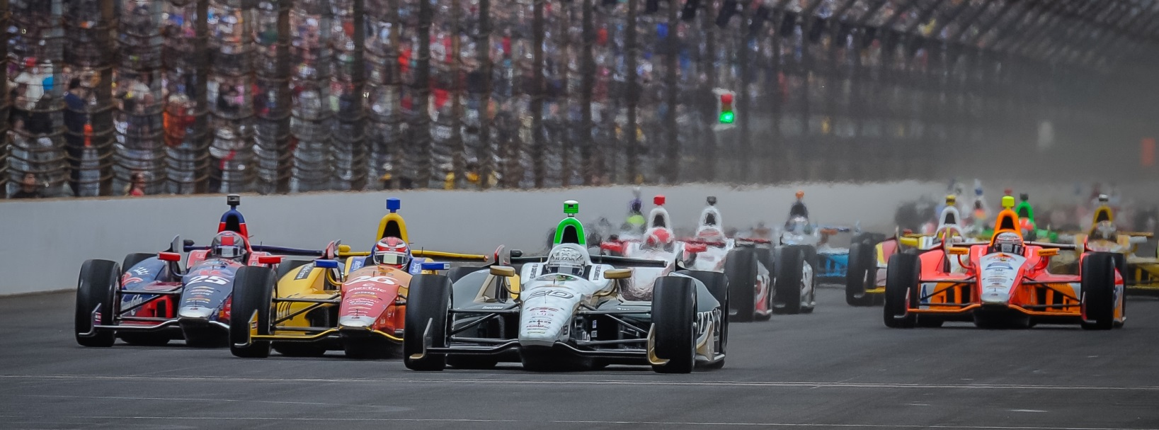

For Immediate Release Contact: Tom Blattler

317-525-5692

**LOCKUP ON 1ST QUALIFYING LAP HURTS CONWAY’S CHANCES TO ADVANCE IN VERIZON INDYCAR SERIES TIME TRIALS SATURDAY**

**Long Beach Champ must now start 21st in Sunday’s 90-lap feature**

**BIRMINGHAM, Ala. (April 26, 2014)** – Mike Conway, winner at Long Beach two weeks ago, will have to come from behind again Sunday at Barber Motorsports Park after a flat-spotted front tire hurt his chances Saturday in qualifications.

Conway, currently second in Verizon IndyCar Series points, suffered a lockup on his No. 20 Fuzzy’s Ultra Premium Vodka Chevrolet’s left front tire in his first hot lap of time trials and caused an unbalanced setup for the remainder of the first qualifying session. Unfortunately, the Ed Carpenter Racing staff said Conway was on an outstanding lap at the time with a possible transfer to the top 12 round.

Conway will start 21st Sunday in the 90-lap Indy Grand Prix of Alabama set for 2:12 pm CDT. The race will be televised live over the NBC Sports Network.

Conway’s speed in qualifying was 118.526 miles per hour, while Will Power took the pole position Saturday with a 121.209 m.p.h. lap in his Chevy-powered Dallara.

“We had a huge lockup with the front tire entering turn five on my first flying lap,” said Conway. “That flat spotted the left front tire and the car wasn’t balanced then. It’s tough for the crew but I know they will fight hard to come back in the race. We have come from behind before and I believe we can do it again. We’ll concentrate to have a good race car now.”

Conway came from 17th in the streets of Long Beach to win his third career IndyCar Series race in dramatic fashion on April 13. It was only Conway’s second race driving for Ed Carpenter Racing.

# # #