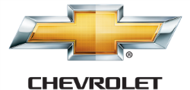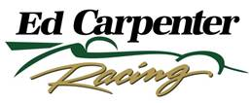

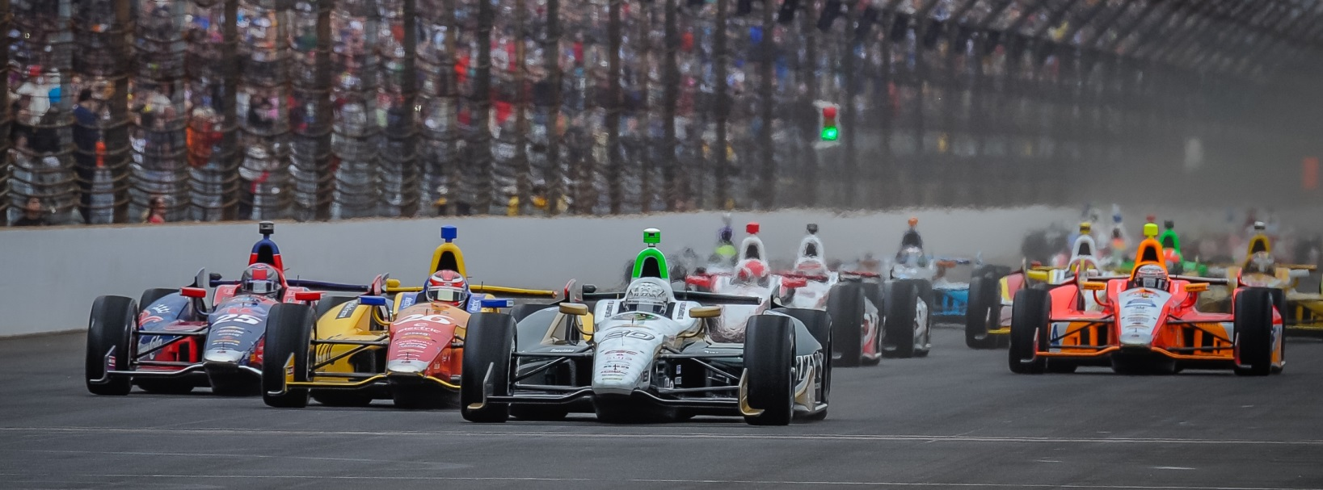

For Immediate Release Contact: Tom Blattler

317-525-5692

**ROLL OF THE DICE DOESN’T PAY OFF FOR CONWAY, ECR**

**SUNDAY AFTER GREAT PERFORMANCE AT SONOMA**

**Mike runs out of fuel on the last lap after stellar run**

**SONOMA, Calif. (August 24, 2014)** – Well, the results sheet won’t show the impressive drive put in by Mike Conway Sunday at Sonoma Raceway. But people who witnessed Conway’s performance in the GoPro Grand Prix of Sonoma have to talk about it.

Conway, this year’s winner at Long Beach and Toronto, led 21 laps at the 2.385-mile, 12-turn permanent road track and held the top spot in the 85-lap feature with just three circuits remaining. But the sensational drive by the 31-year-old Brit veteran fell short when the No. 20 Fuzzy’s Ultra Premium Vodka Chevrolet ran out of fuel on the last lap.

Conway, who started 17th, took the lead from Tony Kanaan on the restart at lap 39 in a brilliant move outside of turn four and stretched his advantage to as much as ten seconds.

On lap 60, Mike made his final pit stop of the race and looked to hold the margin for the last 25 laps. However, Conway had to fight with Graham Rahal, Scott Dixon and Ryan Hunter-Reay in a fuel conservation mode as well as battling for position.

Rahal made a “splash and go” pit stop on lap 83 and Conway regained the lead. But Mike could not hold off a charging Dixon who slid by in turn one on the next lap. In the final lap, Conway’s machine lost second and third to Hunter-Reay and Simon Pagenaud from fuel starvation.

Unfortunately, the Fuzzy’s Vodka Chevy rolled to a stop and Conway finished 14th after his sensational performance Sunday in the 17th race of the 18-event Verizon IndyCar Series.

For Conway, his day started very early when a 6.0 Napa Valley earthquake hit the area at 3:20 a.m. PDT. Mike and his family were forced to evacuate the Westin Hotel and he did his best to get some sleep in his rental car in the hotel parking lot before heading to the track.

-more-

-2-

“I was doing all I could keep Scott (Dixon) and Ryan (Hunter-Reay) behind me,” said Conway after the race. “The team knew that Graham (Rahal) had to pit for fuel. I could see that the boys behind me were a little quicker and I was trying to save as much fuel as possible too. It was tricky but I thought I was making a good job of it. I was hitting my fuel number through the last stint. I thought it would be good but I suppose the lap when I used the overtake button to keep back Scott came back to cost us. There wasn’t much more I could do at that point and I thought I could hang on for a podium finish.

“But when I got to turn 10 on the last lap, the engine just died. It picked up a little into turn 11 but finally just shut off in the corner. It was a tough way to finish the year with the Ed Carpenter Racing team in the Fuzzy’s Vodka car. I really want to thank Ed and his guys, the Fuzzy’s boys, Chevrolet and our suppliers for a great year. We had two wins for me and one for Ed so far. I would love to see Ed win next week in Fontana too.”

Conway’s team owner, Ed Carpenter, felt for Conway after the race and his terrific drive but was pleased with his team’s strategy in Conway’s final 2014 IndyCar Series race.

“We had our strategy down when we made a couple of top off stops in the middle of the race and the yellow fell right for us,” said Carpenter, who’ll return to the cockpit of the Fuzzy’s Vodka Chevy next Saturday night in the season finale at Fontana, Calif. “Then Mike made a great move around TK (Tony Kanaan) and he was saving fuel and stretching the lead.

“At the end, we felt Graham had to pit and we knew that Scott and Ryan were on similar strategy as us. We just missed on the fuel mileage by a little. Maybe the extra overtake pushes might have cost us. It’s hard to say. Scott and Ryan are great in those situations.Mike drove a terrific race today. It was a tough break for Mike and the team not to take home a good finish today.”

The final race of the 2014 Verizon IndyCar Series will be the MAVTV 500 at Auto Club Speedway this Saturday night (Aug. 30) and will be televised on the NBC Sports Network.at 9 p.m. EDT. The 250-lap finale also will be broadcast on the IndyCar Radio Network through its affiliates as well as Sirius 213, XM 209 and [www.indycar.com](http://www.indycar.com).

# # #

