

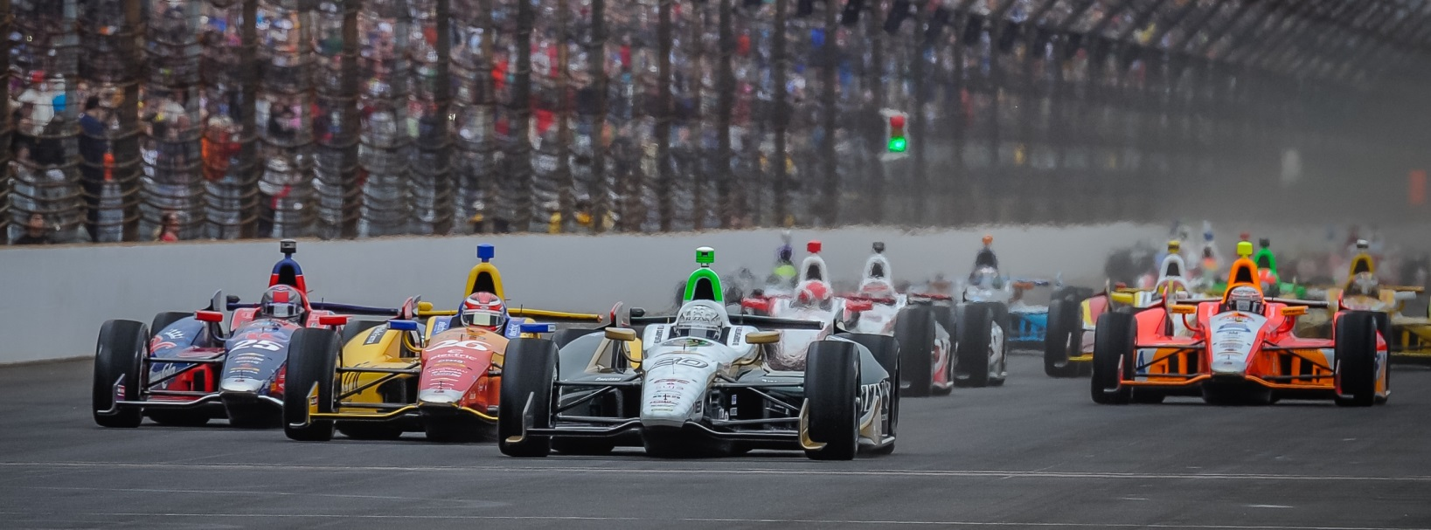

For Immediate Release Contact: Tom Blattler

317-525-5692

**AFTER TEXAS WIN, NO SLOWING DOWN ED CARPENTER RACING**

**AS FUZZY’S CHEVY SQUAD GOES TESTING AT IOWA, MILWAUKEE**

**Carpenter Impressive Saturday in Firestone 600K, Switches Gears for Tests**

**NEWTON, Iowa (June 9, 2014)** – There wasn’t a big celebration Saturday night for Ed Carpenter Racing after Ed Carpenter captured the Firestone 600K at Texas Motor Speedway.

Maybe there was just a little beer consumed on the plane back to Indianapolis for the crew as they landed on the early hours of Sunday morning for the 15-man crew. There wasn’t time to enjoy their sponsor’s product, Fuzzy’s Ultra Premium Vodka.

Truck drivers Matt Giese and Jeff Hughes had already hit the road with the winning No. 20 Fuzzy’s Vodka Chevrolet and headed to Iowa for the Tuesday test day at the Iowa Speedway small oval.

And, by Monday at 6 a.m., Carpenter and his boys were on a tour bus driving to Newton, Iowa for the start of three upcoming tests at Iowa, Milwaukee and Pocono in the next nine days.

“I guess there is no rest for us right now,” said Carpenter, who led 90 laps at Texas in scoring his third Verizon IndyCar Series career win. “We need to use this break to get ready for the next oval races. It’s tough on the whole team after more than a month of work. But that is why we love to go racing.”

The Verizon IndyCar Series calendar included some 30 days straight in the shop or the track for the racing teams and a few days off would be welcomed at this point in the season.

But, after Carpenter’s Texas victory, the ECR/Fuzzy’s contingent know they need to remain on their game with five races coming up in four weeks including the Houston doubleheader (June 28-29), Pocono (July 6), Iowa (July 12) and the Toronto doubleheader (July 19-20).

-more-

-2-

“We prepped the Fuzzy’s car at Iowa on Monday,” said Tim Broyles, general manager for ECR. “Mechanically, from Texas to Iowa to Milwaukee the car is similar. We brought some spare parts with us and the short track wing is already on the truck to make it easier on the guys. Then, any work we need to do for Milwaukee, we’ll do after the Iowa test and drive to Milwaukee on Wednesday for the Thursday test.”

On Thursday night, the tour bus will return to Indianapolis and the crew will get its first three-day weekend since the middle of April. Then, on Monday, the team will prep the Fuzzy;s Chevy for a June 19 test with Carpenter at the 2.5-mile tri-oval at Pocono.

“We’ll test at Pocono on June 19 and fly back to Indy that night,” said Broyles, who serves as Carpenter’s strategist during the race with lead engineer Matt Barnes. “We’ll take another long weekend after the Pocono test to get the guys freshened up and spend time with their families. We want to sure we’re prepared for the next grind ahead of us, four weeks in a row with five races.”

The Verizon IndyCar Series then has a black-out period for testing starting on June 20. The next open testing period is July 21-24, between Toronto and Mid-Ohio races.

“In the testing time right now, we still have people back at the race shop working on the crashed car from the Indy 500,” said Broyles. “We want to get that car back in the mix for the rest of the season. We want everything ready for this next stretch of races.”

After wins at Long Beach (Mike Conway) and Texas (Carpenter), the ECR team has proven that this single-car unit can take on the Penske, Ganassi and Andretti big teams and win.

# # #

