

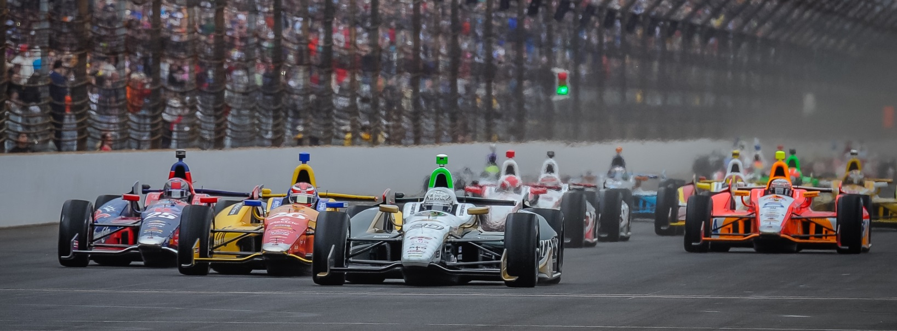

For Immediate Release Contact: Tom Blattler

317-525-5692

**CARPENTER COMES TO TEXAS MOTOR SPEEDWAY WITH DETERMINED ATTITUDE AFTER TOUGH LUCK AT INDY 500**

**2014 Indy 500 Pole Winner Wants Texas Win Now**

**FORT WORTH, Texas (June 3, 2014)** – For the majority of the time, racer Ed Carpenter looks calm and cool around the track.

The 33-year-old Butler University marketing graduate is smart and calculated in his approach to racing and business. He is the only team owner/driver in the Verizon IndyCar Series.

But everyone saw the passion of the Indianapolis driver when he jumped out his crashed race car at this year’s Indy 500. He let his emotions show like no time in his IndyCar career.

“You saw how badly I wanted to win that race,” said Carpenter, who calmly talked to the media some 30 minutes after he was running second in the world’s biggest race and was crashed out. “I have been dreaming of racing in and winning the Indy 500 since I was eight years old. I felt we were in position to contend for the win. And then ‘boom,’ it was over.”

Maybe Carpenter’s emotions came out for several reasons.

After winning back-to-back pole positions at Indy, Carpenter believed his No. 20 Fuzzy’s Ultra Premium Vodka Chevrolet was a car to beat in the 98th running of the “Greatest Spectacle in Racing.” He and his teammate J.R. Hildebrand had worked hard in practice preparing their cars for race conditions and it showed as the 500 came towards a close.

“Even though we won the pole for a second straight year, people don’t realize how much we worked on the race setups,” said Carpenter, who comes to Texas Motor Speedway this Saturday in an effort to win a 2nd 2014 event for Ed Carpenter Racing. “We put in a ton of miles to get a feel for the car in various conditions. We felt we put ourselves in position to challenge for the win. And it all went away quickly.”

-2-

James Hinchcliffe and Townsend Bell sandwiched Carpenter in turn one at Indy on the 175th lap and Ed had nowhere to go. Both he and Hinchcliffe hit the outside wall and Ed let the Canadian know he wasn’t happy with the aggressive move.

“When I walked over to Hinch, he was still in his car and he looked confused,” Carpenter explained. “So I gave him a thumbs-up to make sure he was okay. When he said he is fine, then I let him know I didn’t appreciate the move he made. Three wide at Indy is always trouble.”

Carpenter’s passion for IMS dates back some 25 years when he would play in the giant infield as a youngster. He followed the path of racing ( i.e. sprint car and midgets) that sent Jeff Gordon, Tony Stewart, Ryan Newman, Kasey Kahne and Kyle Larsen to NASCAR and stock cars. But unlike their trek to the full-bodied race cars, Carpenter stayed in the open-wheel competition and it was due to his love for the Indy 500.

“The Indy 500 was the reason I wanted to be a race car driver,” Ed admits. “I didn’t follow the usual path with the other USAC sprint car and midget drivers who went to NASCAR. I was thrilled to race in my first Indy 500 in 2004. Now, this year was my 11th race and I am still looking for that prestigious drink of milk. So, yes, there is a definite passion for the 500.”

But Carpenter has moved on since his disappointment at Indy to focus on the fast Texas Motor Speedway and this weekend’s Firestone 600k. Last year, Carpenter and his Fuzzy’s Vodka Chevy raced with the leaders and finished a fourth, his best Texas placing.

But the father of three (ages 6, 5, and 1) believes he can win this time at Texas. After his close Indy 500 run, he is determined more than ever to reach the coveted TMS victory lane.

“I have always liked racing at Texas Motor Speedway,” said Carpenter. “We have had fast cars the last two years there. We tested there earlier this year and we feel confident that the Fuzzy’s Chevy can race for the win. After Indy, I know the whole ECR team is very determined to pull this one off and shoot those pistols in the winner’s circle. I’m anxious to get back there now.”

A win at Texas for Carpenter wouldn’t make up for the Indy 500 disappointment but it would go a long way to show that his team is a regular winner. The ECR squad won in the streets in Long Beach last April with Mike Conway driving.

Now Carpenter wants to add another trophy to his team’s trophy case this Saturday night.

# # #

