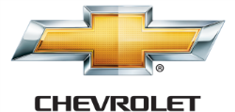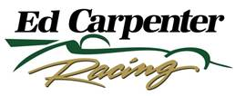

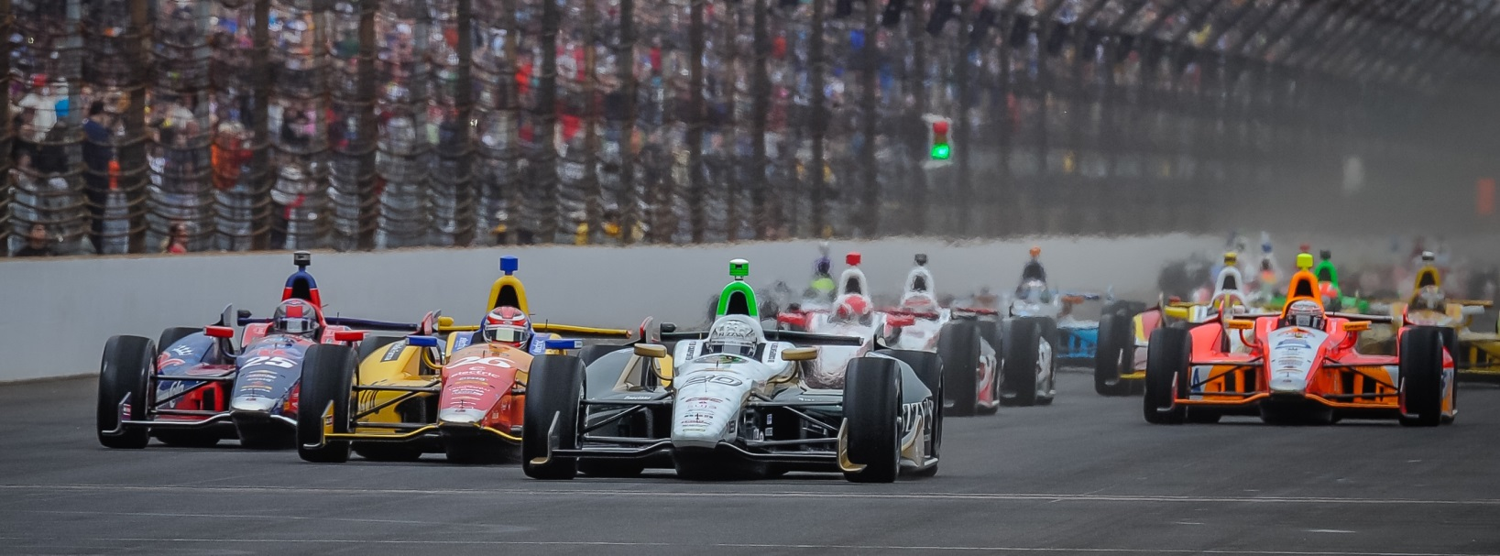

For Immediate Release Contact: Tom Blattler

317-525-5692

**DEFENDING RACE WINNER MIKE CONWAY LOOKS STRONG AGAIN FRIDAY IN CHEVY INDY ‘DUAL IN DETROIT’ PRACTICE**

**Long Beach Winner Takes Fuzzy’s Vodka Chevy to 2nd Friday**

**DETROIT, Mich. (May 30, 2014)** – Defending race winner Mike Conway returned to the picturesque Belle Isle in the Detroit area in fine style Friday in the Free Day at the Chevrolet Indy “Dual in Detroit” doubleheader.

Conway, the 2014 Long Beach champion, dominated action last year on the 2.36-mile, 13-turn street circuit with a victory in Saturday’s 70-lap feature and a third in Sunday’s main event.

And in Friday’s practice rounds for the 2014 Detroit edition, Conway drove the No. 20 Fuzzy’s Ultra Premium Vodka Chevrolet to the second quickest time of the day with a clocking of one minute, 17.714 seconds, just a tick off of Simon Pagenaud’s best of 1:17.65. Conway holds the track record at 1:17.437 set last year.

Conway’s speed of 108.859 miles per hour just missed Pagenaud’s top speed of 108.950 in the two 45-minute practice session under beautiful sunny skies, a complete contrast of last year’s rainy weather in the Motown.

In the morning practice, Conway posted the top time for most of the session at a 1:19.243 before several drivers took on new Firestone rubber late the round to leave Mike sixth at the checkered flag. Conway’s Ed Carpenter Racing team decided to save its second set of Firestones for later in the day.

In the second practice, Conway’s 108.859 m.p.h. run stood atop the speed charts before Pagenaud threw in his fast lap late in the practice.

Following Pagenaud and Conway in Friday’s practice was former Detroit winner Helio Castroneves at 108.856, Will Power at 108.606 and recent Indy 500 champion Ryan Hunter-Reay at 108.229. Twenty-four drivers recorded times Friday at Belle Isle.

-2-

“It felt good to come off the trailer and run well here,” said Conway, who set the fastest lap in both races last year at Belle Isle. “I really like this track and the ECR/Fuzzy’s team has worked hard in the last eight to nine weeks on the engineering program. Ed (Carpenter, team owner and oval driver for ECR) had a very good month at Indy except for the last 25 laps Sunday. We came here with the setup we had at Long Beach when we won. So things have been progressing well with our street program.

“I really like sliding the car around here and it is fun. The surface changing from pavement to concrete makes the car jump around and you really have to be on your toes at all times here at Detroit. It is very encouraging to be in the top six in the first practice and we only ran one set of tires. I think qualifying will be very exciting with the Firestone red tires added to the mix. You could see some low 76s (seconds) laps or quicker on Saturday morning.”

Qualifying for Saturday’s first “Dual in Detroit” race will begin at 8:35 a.m. with the 70-lap contest scheduled to begin at 3:50 p.m. EDT. A similar program is set for Sunday and the second main event. Both “Dual” races will be televised live on ABC-TV starting at 3:30 p.m. EDT.

# # #

