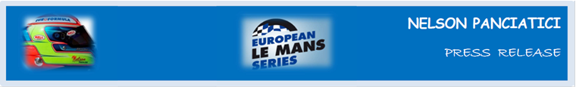

**EUROPEAN LE MANS SERIES 2013 – ROUND 4:**

**3 HOURS OF HUNGARORING (13 & 14 September)**

**SUPERB VICTORY FOR ALPINE AND NELSON PANCIATICI!**

In their comeback to competition after 35 years absence, Alpine re-opened the great book of motorsport history with a spectacular win at the 3 Hours of Hungaroring. Nelson Panciatici was a key player in this historic win which the Signatech-Alpine team achieved thanks in part to a strategy perfectly adapted to the changing conditions of the track and the high performance Michelin tyres.

The Alpine A450 and Nelson Panciatici showed their intentions from the first free practice by putting in the best times, unfortunately the qualifier didn’t go in their favour. Battled out under pouring rain and stopped several times by track exits, the session was more of a lottery, and in these circumstances Nelson finished third in rank.

The race then ran to perfection and Alpine signed its comeback on the highest step of the podium. Philippe Sinault, manager of the Signatech-Alpine team, was very happy with the result which puts them back in the race for the title: “*The team really wanted this win. Everybody worked so hard to accomplish our first goal which was victory, and winning with panache is something that is dialled into Alpine’s DNA. Our strategy paid dividends. We chose rain tyres for the start, even though the track was drying. The overall package was very competitive and our drivers felt confident. Hearing them say that the car was easy to drive was the best reward I could imagine! The last round at Le Castellet won’t be simple, but we will do everything in our power to rise to the challenge successfully!”*

Nelson Panciatici is also very happy: *“I’ve waited a long time for this moment, it feels great to win! Pierre, my co-driver, ran a superb double-relay and I just had to finish the job. To gauge our level of performance compared to our closest rivals I ran several fast laps in case we had a safety-car. I drove carefully after that and was very aware of avoiding all risks in traffic. I am happy for the whole team. My first victory in Endurance and my first victory with Signature. When I start a race I always want to win. Now, I want to show I can do it again on the Castellet Circuit, my home!”*

**The Signatech-Alpine team currently share first place in the European Le Mans Series championship until the final which takes place in France on the Castellet Circuit, September 27 and 28. The battle in LMP2 should enthral the spectators, the enthusiasm will certainly be high!**

For more information on Nelson PANCIATICI, please visit[**www.nelsonpancia.fr**](http://www.nelsonpancia.fr)

[**facebook Join Nelson's Fan Club on Facebook!**](http://www.facebook.com/pages/Nelson-Panciatici/90065452450)